We need to research, the info is below.
Language & Literature 10:
Researching A Major Corporation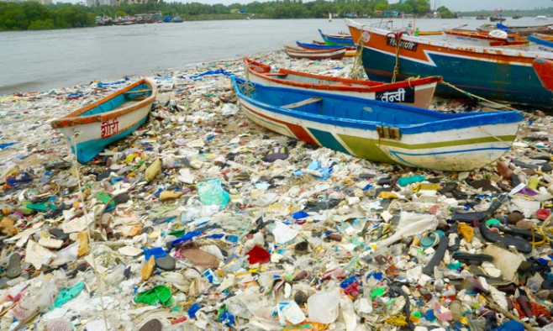
After reading Rick Smith’s article from The Globe and Mail, we have likely developed some thoughts about plastics, but more importantly, about how major corporations/companies contribute to the plastic world we live in. In preparation for your summative assessment, you will conduct some research into a company that contributes to the plastic world. The information that you search will help you to eventually write a business letter to this corporation.
*Note: These contributions might also be positive ones (ie. the compostable plastics) – You will need to choose a direction.
Your research will be in the form of a research document, not in paragraphs. Maybe use an I & S template to help conserve time. You may use bullet points, but you should also revise your work for grammatical/mechanical errors. Some of the points that you find will be directly incorporated into your final letter.
Step 1: Do some research – consult outside sources to find a company and some news stories involving your company. These stories can be either negative or positive. Use reputable, reliable sources. No Wikipedia please.
TIP: Remember to bookmark pages that you visit so you don’t lose any information – You will be required to submit a Works Cited page.
Step 2: Decide on a layout – decide how you will organize your research. Perhaps you will have categories and/or sub-categories. Perhaps you need background information about the company and some links to news articles.
Step 3: Begin research – avoid plagiarism by paraphrasing information and only copying short quotations from your research. Again, your facts and details from your research will be used directly in your letter.
Step 4: Create your Works Cited page – follow MLA formatting for this page and revisit the Owl Purdue link (Here)

Business letter Research Document is below:

Name:

DS

Company and cooperation:

Monster Energy

Topic theme:

TOPIC

How does Monster energy input to the production and consumption of micro plastic and pollution?

Specific Problem or Issue Identified (Explains and justifies the need for a solution to a problem).

EFFECTS

What are the effects of micro plastic pollution and what do the developers of the company do to limit the problem? (what do the developers do to limit the amount of plastic pollution and contribution to micro plastic pollution?)
How do they do it?

Sustainability
- “Waste is a relevant issue for our business and industry. It has risen to the top of sustainability agendas around the world and public awareness is increasing. We are committed to the principles of reduce, reuse and recycle.” -(Monster energy co.)
- Packaging:
- Aluminum: 95.2%
- Glass: 2.6%
- Polyethylene terephthalate (PET): 0.9%
- High density polyethylene (HDPE): 0.3%
- Paper/cardboard and other: 1.0%
How do they take action on the problem of microplastic?
- Aluminum cans are their preferred packaging
- (plastic bottles) light-weighted the plastic bottles used for the products.
- For 750ml bottles, the packaging weight was reduced from 44.7 grams to 38 grams.
- For the 500 and 550 ml bottles, the packaging weight was reduced from 35 grams to 31 and 32 grams
Although monster energy uses Aluminum cans as their primary source, plastic is not out of their product list. They use plastic bottles for certain products like their monster energy Hydro collection.
The way monster energy diverts unnecessary wastes from landfills is they actively engage in recycling efforts. Approximately 98.6% of Monster Energy's packaging is recyclable per FTC guidelines in at least 60% of curbside collection.
- In 2019, Monster Energy conducted an electronic waste collection drive at its corporate headquarters.
- Monster Energy has partnered with Pocono Raceway and NASCAR Green for the "Monster Energy NASCAR Free Friday" program, in which fans receive free access to a day of on-track events at Pocono Raceway in May 2019 by bringing an empty can of Monster Energy to be recycled.

Monster energy's call to action: “At the Monster Beverage Corporation and its subsidiaries (collectively, "Monster Energy"), we are committed to improving sustainability and working to reduce our impact on the environment through certain initiatives and conservation programs. We are investing substantial time, effort and resources toward creating an integrated approach focused on minimizing our environmental impact.”
https://www.monsterbevcorp.com/sr-environmental.php

Rick Smith's article.
Analysis of rick smith's article
https://www.broadbentinstitute.ca/we_are_all_plastic_people_now_in_ways_we_can_t_see_and_can_no_longer_ignore

What did he do?
“Over the course of six days in January, I collected a stool sample from myself each day, and each sample was deposited in a jar with a preservative. The first two samples were from days when I was living and eating as I normally do. On the days I took the next four samples, I did a variety of things to try to crank up my ingestion of plastic microparticles to see whether the effects could be measured.”
- Consumes plastics in plastic packaging
- Wore clothing consisting of microplastics
- Like polyester.

- He analyzed how through a course of time, how much microplastic he was exposed to actually was consumed into him.
- His experiment shows that without notice, we are consuming plastic, just the way we live. We must be mindful as the harms of microplastic are irreversible, to ourselves, and the environment.
How do microplastics affect us?

Researchers have hypothesized that human exposure to microplastics could lead to oxidative stress, DNA damage and inflammation, among other health problems

How do they affect our environment?

Microplastics can even be found in tap water. Moreover, the surfaces of tiny fragments of plastic may carry disease-causing organisms and act as a vector for diseases in the environment.

Monsters Target audience:
- The target audience for Monster energy drinks is teenagers and those in extreme sports, such as motocross. The brand's packaging is the primary appeal to this customer base and has been since its formation in 2002.
- Target audience is primarily a male audience ages 18-34
- Interested in sports, games, motorbikes, and automobiles

Links that can help with research:

https://davidsuzuki.org/story/canadas-plastics-ban-should-include-beverage-containers/

https://www.globalcitizen.org/en/content/microplastics-how-to-avoid-reduce/
https://www.broadbentinstitute.ca/we_are_all_plastic_people_now_in_ways_we_can_t_see_and_can_no_longer_ignore

