This is a 2 part assignment! First write a discussion post answering the question in part 1, then the second part is to write 2 responses to 2 other students ( find them in part 2). For the responses write them directly to them not in 3rd person.
DO NOT FORGET APA style CITATION AND Please read ALL instructions!!!!!

PART 1
According to our text (HBR, 2011), “Blue oceans denote all the industries not in existence today – the unknown market space, unattained by competition. In blue oceans, demand is created rather than fought over. There is ample opportunity for growth that is both profitable and rapid. There are two ways to create blue oceans” (Blue Ocean Strategy chapter, p. 124).
What are those two ways? Use an illustration to explain.
How can your firm create blue oceans?
Reference:
Harvard Business Review Press (2011). HBR's 10 must reads: Strategy. Boston, MA: Harvard Business Press. (ISBN: 9781422157985)

PART 2 write 2 responses to the students discussion posts
Student #1 Gabe
Blue oceans strategy is the creation of demand for an untested or non-existing market, adding value to the company and all their stakeholders and setting the uncontested price and cost by making competition irrelevant. Kim and Renee (2005) explain the origins and the basics of the strategy with a few real-life examples. The reading is indeed a great introduction and they have even expanded their theory on newer editions with newer examples of successful blue oceans strategy implementation (Mebert and Lowe, 2017).
Their theory attracted some criticism. Mebert and Lowe (2017) gathered the responses of some scholars and how the idea isn’t original, making Kim and Reene modify their position to adjust for multiple approaches instead of solely making competition irrelevant (Mebert and Lowe, 2017). They have modified their view towards strategic theory that focuses on fighting the competitor rather than creating new markets. This change seems to appear in 2009 when they admitted that in some cases a competitive approach could be justified (Mebert and Lowe, 2017).
While I was reading the assigned reading for the Harvard Business Review Press (2011), I keep thinking how licensing, patent and such business tools were neglected as a possible short tem micro-Blue oceans within an industry. This a generalization of this strategy as the most important part is a company’s ability and willingness to invest in constant innovation to stay a step ahead and securing a niche or market segment, even if for a given period. This is very visible in the pharmaceutical and steel industry. To consistently creating micro-Blue Oceans, when combined over time; could it be considered as a Blue Ocean strategy as a whole?

Figure 6-1: Kim and Rene, 2015.

Focusing in the steel industry, there are plenty of major players globally that produce commodity grades of steel, where their competitive advantage may be only the consistency of quality, chemistry and physical characteristics and availability for shorter delivery. However, there are a few innovators in the industry that while they still compete on the commodity areas, are always looking for that piece of the market to capture uncontested demand. They can capture this market without any competition by developing a grade for a specific industry, securing a patent and becoming the sole player, hence dictating pricing and demand. A great example is the fertilizer production industry. During the process of producing fertilizer, these production facilities experience high temperature and very high corrosive environments where the commodity steel grades underperform creating high costs in fabrication, maintenance and the money lost during shut downs. Sandvik Materials Technology in Sweden has been the one of the world leading developer of grades for the fertilizer industry creating a value added by better and longer performing products; utilizing the value added to explain for the higher prices and securing that the source of the material, for a least the first 10 years is only from them. Sandvik Materials Technology has been a steel player for over 150 years, and some of the more commodity steel and stainless steel in the market now a day where originally developed by Sandvik. Very frequently, by the time a patent expires, Sandvik has already worked and developed a new grade that provides advantages to the prior grade, once again creating a new demand for a product that poses no competition, even if for a given period depending on the patent. This create a consistent micro-blue oceans decade after decade.

Reference:
Business Review Press, Harvard. ( © 2011).Hbr’s 10 must reads on strategy. [Skillsoft version] Available from <https://cityuseattle.skillport.com/skillportfe/main.action?assetid=45580> Mebert, A., & Lowe, S. (2017). Blue ocean strategy. Retrieved from https://ebookcentral.proquest.com

W. Chan, K., & Mauborgne, R. (2005). Blue Ocean Strategy: FROM THEORY TO PRACTICE. California Management Review, 47(3), 105-121.

Student #2 Corey
According to our readings, the two ways to create a blue ocean are,
: Launch completely new industries, as eBay did with online auctions.
: Or a blue ocean can be created from within a red ocean when a company expands the boundaries of an existing industry. (Chan, Kim W. and Mauborgne, Renee 2011)
It all comes from the mind set of the developer. What product or service can they build off of that competitors aren't offering or what product or service can be created that is unlike anything the competitors offer. In our readings, it was shown that Cirque was building off the same base of a circus theme, but created a new market by focusing on the fun and thrills of a circus as well as the intellectual sophistication and artistic richness of the theater. This was a whole new market strategy that was going after more then just the young children's amusement.
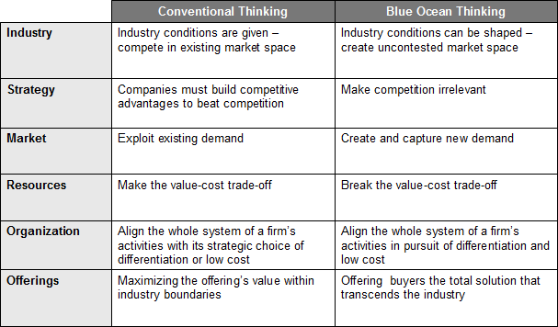

My current company being Boeing, can and has been creating blue oceans in the aerospace industry by bringing in the best talent in engineering to focus on new ways airline companies can separate themselves from the rest of the competition by focusing on customer needs and concerns. Boeing has always been focused on offering the highest quality airplane to their consumers, but have battled market share due to our product coming with a higher price tag. Boeing as been looking at creating ways to improve customer comfort, as well as offering airlines more seating capacity with better fuel mileage. Airline companies can not just look at over profits by creating more seating capacity and lower fuel mileage without capturing the customers needs as well. I for one will spend a few more dollars to have a more comfortable traveling experience, and Boeing knows this, and is continuing to look at ways to better serve both their consumers, as well as the customers.
Refrences-
Blue Ocean Strategy. (n.d.). Retrieved February 13, 2018, from http://flevy.com/blue-ocean-strategy
Mauborgne, W. C., W. Chan Kim Renee Mauborgne, & W. Chan Kim and Renée Mauborgne. (2017, October 03). Blue Ocean Strategy. Retrieved February 13, 2018, from https://hbr.org/2004/10/blue-ocean-strategy

