Emerging Market for Augmented Reality Applications

April 29, 2021

Abstract
From Boeing to DHL to Xerox, augmented reality (AR) has already been solving long-standing issues for enterprises across industries. Other companies follow suit with their efforts, trying to figure out whether AR can also impact their operations effectively. Still, AR hasn’t become ubiquitous yet. There is no tried-and-true roadmap for a given industry or operation at the moment. Therefore, if you are considering to implement augmented reality technology in your business, you will need answers to a long list of questions.
Keywords: Augmented Reality, Virtual Reality, Mixed Reality,
https://www.intellectsoft.net/blog/managers-guide-to-augmented-reality-for-organizations/

The World of Augmented Reality
According to Ronald Azuma (2006), augmented reality “allows the user to see the real world, with virtual objects super-imposed upon or composited with the real world.” It essentially combines the real world with technological enhancements to create new insight and experiences. Porter and Heppelmann (2017) suggest that “AR transforms volumes of data and analytics into images or animations that are overlaid on the real world.” While the technology still faces many challenges, AR remains poised to vastly reshape the current landscape of human life.
https://www.forbes.com/sites/kimberlywhitler/2020/07/04/what-leaders-need-to-know-about-augmented-reality/?sh=38dfdb776cd9

- Yellow highlights mean just giving you the ideas how the thing will work. The sentences are all copied from my article.
- Write “The world of AR” information from my article. All AR information have in my article.
- If you think my article is not have enough information, you can find external sources base on topic. But the article must be the current (up to date, 2021 or 2020), precise & well written article.

Augmented Reality Market Outlook
Augmented reality, and especially mixed reality systems – MR is a form of AR that augments the real world with virtual objects – are poised to become the next computing and communication platforms, replacing the ailing desktops and laptop devices, and even the now aging tablets and smartphones. The augmented reality market is expected to register a CAGR of 152.9% over the forecast period 2021 to 2026. This market was valued at USD 5.35 billion in 2020, and is expected to reach a value of USD 1,332.4 billion by 2026. The mixed reality market was valued at USD 376.1 million in 2020, and is expected to reach a value of USD 3,915.6 million by 2026 with an expected CAGR of 47.9% over the forecast period 2021 to 2026. The world is fully engrossed with the two technologies, Virtual Reality (VR) and Augmented Reality (AR). An incredible merger of these two has come into existence, which is an extended reality, known as mixed reality. It is a seamless intersection between Augmented Reality and Virtual Reality and combines the best of both virtual worlds.
https://www.mordorintelligence.com/industry-reports/augmented-reality-mixed-reality-market

- Yellow highlights mean just giving you the ideas how the thing will work. The sentences are all copied from my article.
- Write “The world of AR” information from my article. All AR information have in my article.
- If you think my article is not have enough information, you can find external sources base on topic. But the article must be the current (up to date, 2021 or 2020), precise & well written article.
Key Components of Augmented Reality (Such as Phone, Applications base, Gaming)

Augmented reality is achieved through a variety of technological innovations; these can be implemented on their own or in conjunction with each other to create augmented reality. They include:
General hardware components – the processor, the display, the sensors and input devices. Typically a smartphone contains a processor, a display, accelerometers, GPS, camera, microphone etc. and contains all the hardware required to be a an AR device.
Displays – while a monitor is perfectly capable of displaying AR data there are other systems such as optical projection systems, head-mounted displays, eyeglasses, contact lenses, the HUD (heads up display), virtual retinal displays, EyeTap (a device which changes the rays of light captured from the environment and substitutes them with computer generated ones),Spatial Augmented Reality (SAR – which uses ordinary projection techniques as a substitute for a display of any kind) and handheld displays.
Sensors and input devices include – GPS, gyroscopes, accelerometers, compasses, RFID, wireless sensors, touch recognition, speech recognition, eye tracking and peripherals.
Software – the majority of development for AR will be in developing further software to take advantage of the hardware capabilities. There is already a an Augmented Reality Markup Language (ARML) which is being used to standardize XML grammar for virtual reality. There are several software development kits (SDK) which also offer simple environments for AR development.
https://www.interaction-design.org/literature/article/augmented-reality-the-past-the-present-and-the-future
- Yellow highlights mean just giving you the ideas how the thing will work. The sentences are all copied from my article.
- Write “The world of AR” information from my article. All AR information have in my article.
- If you think my article is not have enough information, you can find external sources base on topic. But the article must be the current (up to date, 2021 or 2020), precise & well written article.

Value Chain and Key Players
Microsoft – Hololens
Magic Leap One
Focals by North
Epson Moverio
Google Glass Enterprise Edition 2
Vuzix Blade AR
Optinvent Ora-2
Garmin Varia Vision
Everysight Raptor

Source: https://www.tomsguide.com/reference/ar-glasses

Business Applications base

https://perfectial.com/blog/augmented-reality-in-business/
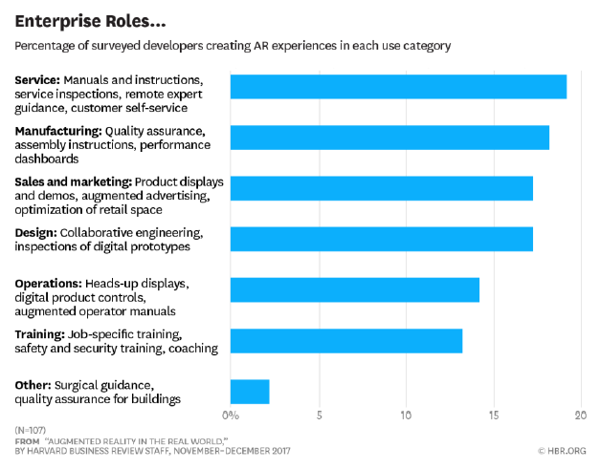

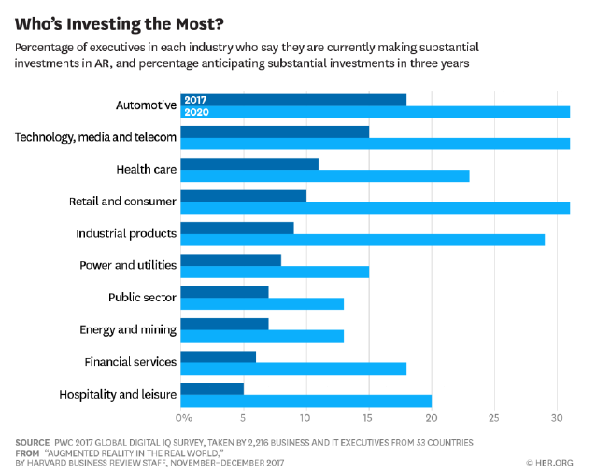

Case Study
https://www.popsci.com/story/technology/microsoft-hololens-supplied-to-us-army/
There is more to know about the world than the human eye can perceive, and the US Army wants soldiers to see more of it. To that end, the Army awarded a contract worth up to $21.88 billion over 10 years to Microsoft for 120,000 augmented-reality headsets. It’s a massive bet on not just the idea of a data-rich environment for future wars, but on making that data useful down to the level of private.
The contract, first reported by CNBC on April 1, is the culmination of a years-long process for Microsoft adapting the HoloLens augmented-reality headset to military purposes. In military use, the headset is called the Integrated Visual Augmentation System (IVAS). It combines a computer, an array of sensors, and a wide lens with internal display to produce, share, and enhance information for the person wearing it.
The Army has refined what it wants from IVAS since at least 2018. This includes adjusting the design based on soldier feedback with prototypes, like scaling back the range of low-light vision from 3,000 feet to 900 feet. That change made the device lighter while matching actual need. The IVAS goggles also expanded the field of vision from 40 to 80 degrees, allowing soldiers using low-light vision to see more of their surroundings.
Another signature feature of IVAS is the ability to see “through” vehicles, by sharing the video recorded on external cameras with the soldier’s headsets. This can let troops riding inside an armored personnel carrier have a better sense of their surroundings while traveling and when dismounting. It also means.

Conclusions

AR or augmented reality has gone from pipe dream to reality in just over a century. There are many AR applications in use or under development today, however – the concept will only take off universally when UX designers think about how they can integrate AR with daily life to improve productivity, efficiency or quality of experiences. There is an unlimited potential for AR, the big question is - how will it be unlocked?
https://www.interaction-design.org/literature/article/augmented-reality-the-past-the-present-and-the-future

References

