Module 3: Critique Documentaries
After watching four documentaries each on race, class and gender, critically review the documentaries by following the guidelines and questions below. (4-5 pages, double spaced, Times news roman, 12)
Things to look for when viewing a documentary for the purpose of critiquing it:
- Find the documentary’s point of view. This is often clearly stated in the introduction or preface section.
- Identify the documentary’s major hypothesis, point, or contention. There may be more than one or there may be a main one accompanied by several lesser but still important hypotheses. Again, most documentaries will state their point or hypothesis in the introduction and the conclusion of their book. Furthermore, if produced for commercial television, they will repeat main points at the commercial breaks.
- What types of evidence does the documentary use?
- Who are the experts or talking heads who are consulted? What are their credentials?
- Are both fringe and mainstream ideas and theory given equal time?
- Do any of the talking heads make assertions that are not supported by evidence?
- How is the book documentary organized to present its argument? Is the organization effective?
- Is the documentary’s point of view appropriate? Is there a discernible bias, is the documentary objective?
- How does the documentary fit in to the existing knowledge on the subject?
- Based on the organization, argumentation, and evidence presented, do you find the documentary contains a convincing argument or not?
THE STRUCTURE OF A DOCUMENTARY CRITIQUE
- Supply a brief summary or overview of the documentary's hypotheses and contents.
- Assess the nature and the quality of the evidence presented.
- Comment on the documentary’s presentation: organization, narrative style, and evidence.
- Conclusion with final assessment and recommendation to readers.
When critiquing a documentary, there are several other key words that can guide your efforts. Ask yourself, what is the documentary’s purpose for investigating this subject. That question encompasses both point of view and hypothesis. Ask yourself, what is thescope of the documentary? That question deals with what the documentary is about. What is its subject (person, time period, place, etc.?
It is also important to know something about the experts interviewed. The keyword for this is authority. What is the expert's authority? Does the expert have expertise or a reputation in the subject?
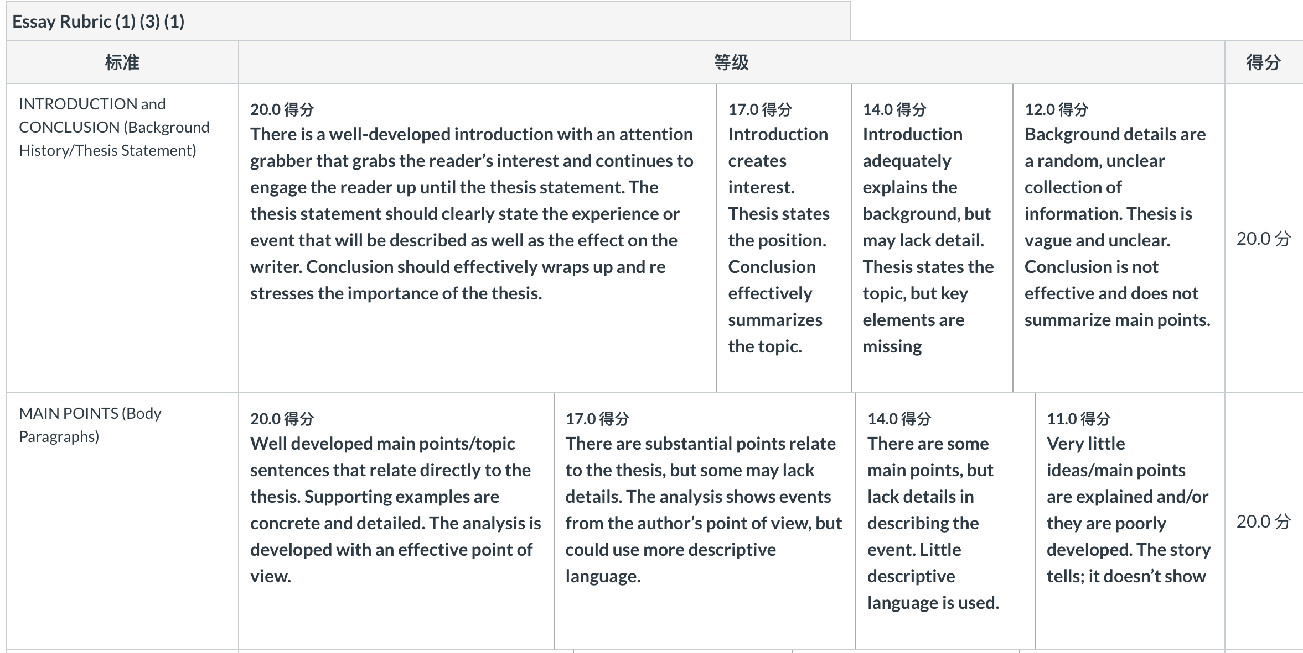
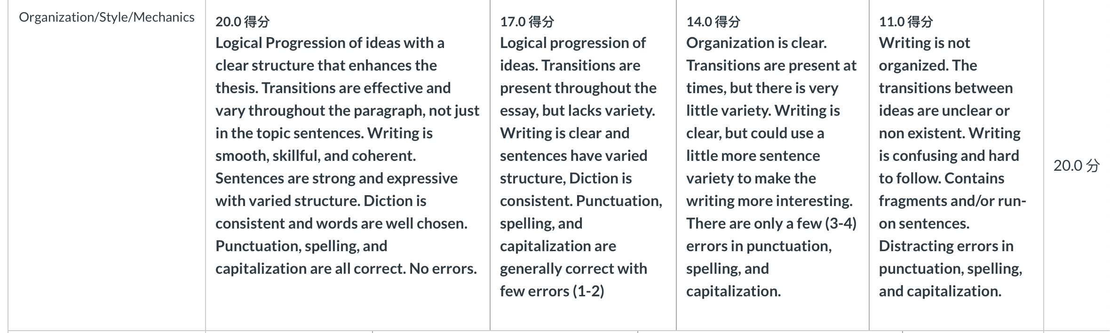
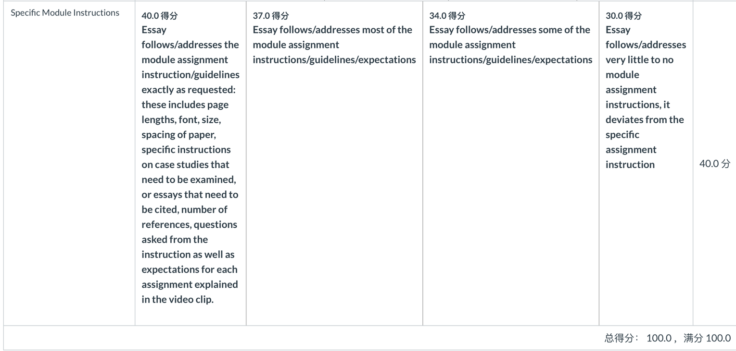

Documentaries
Tough Guise 2: Violence, Manhood & American Culture
In this documentary, Jackson Katz argues that the ongoing epidemic of men's violence in America is rooted in our inability as a society to move beyond outmoded ideals of manhood. In a sweeping analysis that cuts across racial, ethnic, and class lines, Katz examines mass shootings, day-to-day gun violence, violence against women, bullying, gay-bashing, and American militarism against the backdrop of a culture that has normalized violent and regressive forms of masculinity in the face of challenges to traditional male power and authority.
As you watch this documentary, reflect on how manhood is talked about in children’s movies. Focus on what kinds of lessons or ideas about manhood are being taught. Does the film you chose seem to be aware of how narrow ideas about manhood can be damaging to boys? Or does it seem to be oblivious to the dynamics Katz discusses in Tough Guise 2?
https://miamioh.kanopy.com/s?query=tough%20guise

Miss Representation
The documentary, Miss Representation exposes the bold reality of a society that we live in but yet we fail to see. Jennifer Newcom uncovers how the media portrays women in position of power and influence. The film challenges how media sexism plays a part in a women's ability to attain leader roles.
As you watch this documentary, reflect on your personal observation on women in media. Do you think the media portrayal of women has changed, if so how?
https://miamioh.kanopy.com/video/miss-representation-0
Reel Bad Arabs:
This documentary dissects a slanderous aspect of cinematic history that has run virtually unchallenged from the earliest days of silent film to today's biggest Hollywood blockbusters. Featuring acclaimed author Dr. Jack Shaheen, the film explores a long line of degrading images of Arabs--from Bedouin bandits and submissive maidens to sinister sheikhs and gun-wielding "terrorists"--along the way offering devastating insights into the origin of these stereotypic images, their development at key points in U.S. history, and why they matter so much today.
In this documentary, Dr. Shaheen mentions a number of films that he believes do a better job of representing Arabs as complex, diverse people. Can you think of any other examples of films or television shows that challenge stereotypes of Arab people? What about other groups?
https://miamioh.kanopy.com/video/reel-bad-arabs-how-hollywood-vilifies-people (Links to an external site.)

Class Dismissed: How TV Frames the Working Class
This documentary examines television’s portrayal of working class people, from early images of the late 1940s to those on display in recent situation comedies, dramas, and “reality” programs. The film focuses primarily on two issues—television’s under-representation of working-class people and their concerns, and the stereotypes that are used when they are represented at all. Class Dismissed argues that television misrepresentations and stereotypes help to both create and reinforce negative perceptions of the working class. To provide support for this contention, the video presents historical evidence in the form of clips culled from decades of popular television programming, accompanied by analysis offered by scholars and writers such as Herman Gray, Robin Kelley, Stanley Aronowitz, Barbara Ehrenreich, and others.
As you watch this video, think about how class is defined in a various way.
https://miamioh.kanopy.com/video/class-dismissed-0 (Links to an external site.)

