CHAPTER 14: ENTERTAINMENT AND VISUAL CULTURE – QUIZ 5
***DUE: Tuesday, May 10 @ Midnight***
Manage your own time to your own efficiency.
I need the Finals @ Midnight on Tuesday, the 17th
Any missed assignments must be in by then
QUIZ 5: Includes-
Chapter 13: NATURE, KNOWLEDGE, AND TECHNOLOGY
Chapter 14: ENTERAINMENT AND VISUAL CULTURE
Chapter 15: ART IN YOUR LIFE
The answers to these questions are worth 7 points each. You MUST discuss the works IN the Book.

- Describe the work The Social Mirror by Mierle Laderman Ukeles – and how it functions socio-politically.

- Explain the symbolic use of elephant dung in Chris Ofili’s painting – Monkey Magic.

- Explain the specific sequence of events as occurred in Allan Kaprow’s improvisational “Happening” (performance art) entitled “Household” - and then tell me your thoughts about it. (Keep in mind that he sets up the situation, but does not tell them what to do. What “happens” is Impromptu: done without being planned or rehearsed)

- Explain the purpose and structure of “Fallen Star” by Do Ho SUH - explaining the conceptual theme behind this work, including exactly where it is located and how it is positioned.

The answers to these questions are worth 3 points each.
- Julie Taymor was the Designer and Director of the Lion King on Broadway. Which of these art forms was NOT part of her background?
Indonesian Masked Dance Western Opera Japanese Kobuki Bunraku Puppetry

- The first Animation was directly inspired by:
Computer Programs Flip Books Clay puppets Video Games

- A technical/visual device used to organize elements of Northwest Coast art is called:
formline design potlatch elliptical spots stylized manner

- Hanuman is a:
thunderbird dog eagle monkey

- The cascading vaults of the Sydney Opera House suggest:
the theatron classical heritage billowing sailboats predetermined order

- What other country (besides America) is mentioned in your book as having experienced a “Golden Age” of Cinema in the 1930/40’s.
Mexico France Sweden India

- This Relief Sculpture was made by what culture?
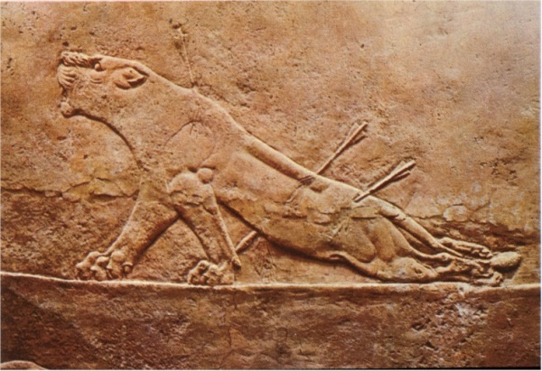

Assyrian, Iraq Classic Period, Mexico Western Libya Aboriginal Australia

This is the work of TONY OURSLER:
TONY OURSLER (including the movement the book cannot show you)
https://www.youtube.com/watch?v=5HjR1X0a4e4
https://www.youtube.com/watch?v=OzcuLP2vkWg
(watch them both)
Discuss “innovation” in this work. When I see it, I think “there is always a new idea that takes the older ones to a new dimension/idea”. It just requires that VISION which an innovator has. Each time a new Technology is available, it changes everything.
10 lines of type = 20 points

Read this short article:

Do Not Pass “Bo”: Archaeologists Unearth 2,300-Year-Old Board Game in China
- by Laura C. Mallonee on November 25, 2015
http://hyperallergic.com/255411/do-not-pass-bo-archaeologists-unearth-2300-year-old-board-game-in-china/?ref=featured
I have a theory about GAMES and Culture. Not only do certain Games come OUT of a Culture – Monopoly/Capitalism (for instance) – but they also feed INTO a Culture and perpetuate certain ideas and mental structures. I remember my Grandson at age 5 beating the Computer at Ping/Pong. It had developed his Hand/Eye coordination to an amazing degree. Most always, a game will involve Mathematics and Geometry. That is one reason I find this article fascinating. I am completely moved by the schematic for the 14 sided polygon and – of course – the structure itself.
What does the structure of this polygon say about the culture that developed this game?
What does this polygon remind YOU of?
What are your favorite games?
How have the games you play changed since you were a child? How are they different?
Discuss how the Internet has changed the rules of (the) game and Gaming.
How have games changed in the last 2300 years?
Here are 6 questions to help yourself write a ¾ page on the subject of “Gaming in My 21st Century Life”!
18 lines of type = 29 points

This is just interesting : FYI: Transformers made of Trash
https://www.theatlantic.com/video/index/580648/building-robots/

