Introduction
For many decades, climate change has been a debated topic. Although there are efforts that indicate a positive impact on reducing carbon emissions or the leading greenhouse gases, there is a long way to address this problem. Since its inception, nations are facing the challenge to reconcile diverse and conflicting interests to converge to a common ground where the issue can be addressed. Countries are on different viewpoints on what they are doing right or wrong because a particular view may disadvantage them in one way or another. Throughout the world, many groups have allocated significant resources and time to lobby political leaders to control greenhouse gas emissions without success (DiMento and Doughman 7). The continued failures are mainly from the hard decisions that come with losing part of what has been for a long time a benefit for some parties. Besides, the play between politics and power has further complicated the consensus process. All these activities affect global business operations, and it is no longer business as usual. On the one hand, insurance companies have to worry about increasing claims over stronger tornadoes and hurricanes in recent times. On the other hand, both producers and consumers of fossil fuels have to worry about the high costs for programs to reduce greenhouse gas emissions and the responsibilities tagged to them.
Overall, the list of worries that are tagged to climate change is endless because people’s lifestyles and continuous human-made activities in the modern world negatively impact the ecosystem. Deforestation, farming operations, and burning fossil fuels are but a few social events that affects climate change in both developing and developed countries. Whether knowingly or unknowingly, our everyday activities affect the world’s climate in many ways. A look at the challenges of the twenty-first century, climate change proves the biggest and unprecedented global challenge. Scholars and scientists concur that it is vital to address this issue because it is happening right now. It is alarming is how the temperatures are rising; rainfall patterns have changed, the frequency of wildfires is increasing, glaciers and snow continue to melt, and the world sea level is rising, which increases the risk of floods.

- What is it?
Different scholars have defined climate change differently but allude to the same meaning. According to Maslin (8), it refers to any significant change in climate measures over a while. His view includes substantial changes in precipitation, temperature, and wind patterns that continue over a long period. On the other hand, Bowen (20) defines it as the gradual change in the standard weather conditions of a region over a decade or so. Also, Professor Arnell defines climate change as a change in weather and climate statistical properties at a place in terms of average, variability, or both (Arnell 15). Thus, the phrase ‘climate change’ represents changes to the climate over time.
Following this line of argument, climate change takes time before its effects are felt. Most scholars agree that the current climate change effects emanate from climate changes that occurred a long time ago (Bowen 30; Arnell 14; Maslin 11). Most of the activities that set climate change in motion are linked to industrialization. Bowen (22) asserts that since the industrial revolution started around the eighteenth and nineteenth centuries, manufacturing occurred in the cities, and a drastic increase in the burning of fuels was noted. Since this time, as Arnell (5) notes, carbon dioxide in the atmosphere has increased as well, but it was misinterpreted as usual because it is a naturally occurring component of the atmosphere. At that time, they believed that human activities could not cause any measurable change in atmospheric carbon dioxide. However, scientists argued that the burning of wood and fossil fuels interfered with the standard carbon cycle by increasing atmospheric carbon dioxide levels. Modern scientists are convinced that carbon dioxide is a greenhouse gas that reflects the sun’s rays to the earth’s surface, thus trapping the heat. Consequently, the earth’s temperature increases and effects are naturally occurring events like rainfall patterns. In turn, it affects food production and reproduction of species that rely on weather signals.
Climate change is best known by first looking at gases emitted into the atmosphere. DiMento and Doughman (12) observe that climate change is understood through the release of toxic gases to the atmosphere and destruction of the natural ecosystem as people create land farming activities. They note that for many years focus has been on the direct and visible environmental implications of climate change with a little emphasis on the indirect social, economic and political impact that leaves far fetching effects on nations and their people. Arnell (7) supports DiMento and Doughman (36) that the indirect consequences of climate change affect the more impoverished countries than wealthy nations. They also concur that if nothing significant comes out of the current efforts to address the issue, human suffering will increase in the future as more climatic changes take place. Further, they note that as time goes by, it will be difficult and costly to deal with it.
Throughout the years, climate change has been debated among global issues, global poverty, environmental degradation, population growth, and global security. It questions the essence of modernity and ethics (Bowen, 83). It sets the politicians arguing, sets nations against each other, and questions lifestyle choices and the relationship between humanity and the planet in general. According to the intergovernmental panel on climate change, the global mean surface temperature is bound to rise to 5.4 degrees Celsius by the end of the twenty-first century if greenhouse gas emissions are not controlled. Global sea levels could rise to 98cm at the same time. It will also increase misery for many people worldwide (Maslin 10). Thus, climate change could be known by the adverse changes it causes to the atmosphere primarily via a rise in sea levels.
From a general stance, climate change is associated with a difference in the earth’s climate patterns that are related to increasing carbon dioxide in the atmosphere. Most scholars attribute this increase to the consumption of fossil fuels. The change mentioned above is significant if extended over time ranging from a few decades to millions of years for both the short and long term. Maslin (12) and Bowen (138) observe that over the years, altitude, latitude, ocean currents, proximity to large water bodies, topography, and seasonal winds affect temperature. They also note that human beings are affecting climate and temperature through human-made deforestation, farming activities, and burning fossil fuels. The current lifestyle choices are also a leading cause of climate change, and that is why many nations are coming up with laws and policies to protect the environment. These activities increase greenhouse gas emissions to the atmosphere, thus increasing the greenhouse effect and, consequently, global warming. Given the above, the world has to join efforts and forge a way forward to ensure a secure environment for our future generation.
Thus, the definition of climate changes all centers around two things; emission of greenhouse gases and pollution of the environment. When talking about carbon dioxide, scholars cite the increased discharge as a source of worry. Similarly, when talking about greenhouse gases, scholars mention the increased emission of industrious gases. Hence, climate change is the effect of interference that arises when there is an imbalance within the atmospheric conditions caused by increased carbon dioxide emission of greenhouse gases—the resultant changes in meteorological phenomena such as the rise in sea level influence people’s lives. Thus, climate change hurts nature and people.

- Why does it matter?
Climatic change has been a global issue that has created a lot of controversies. Over the last two hundred years, the world’s climate has become more unpredictable with increased natural calamities. While the majority of people agree that climatic changes have been detrimental to society, some of the people have been denying the impact created by the climate. People denying the change have argued that climatic change is a natural phenomenon and it has been experienced over human history and as such there should be no cause for alarm. However, some factors have proven the importance of human intervention as far as climatic changes are concerned. Some of the factors include the extinction of some flora and fauna, the occurrence of harsh climatic conditions, and the endangerment of human lives. It has been generally accepted that businesses have had a big role to play in creating the current climatic changes and therefore they should implement strategies that seek to reduce the adverse climatic changes. Some of the ways through which this is possible are by minimizing the energy used and using sustainable resources in the production process (Lilkov 2018). In this report, we will explain more about the factors that prove it is an issue and then suggest some business strategies that can improve the situation.
Key Factors Involving the Climatic Change
One of the reasons proving the importance of being concerned about climatic change especially for businesses is the increased risk caused by extreme weather as shown in the image below. 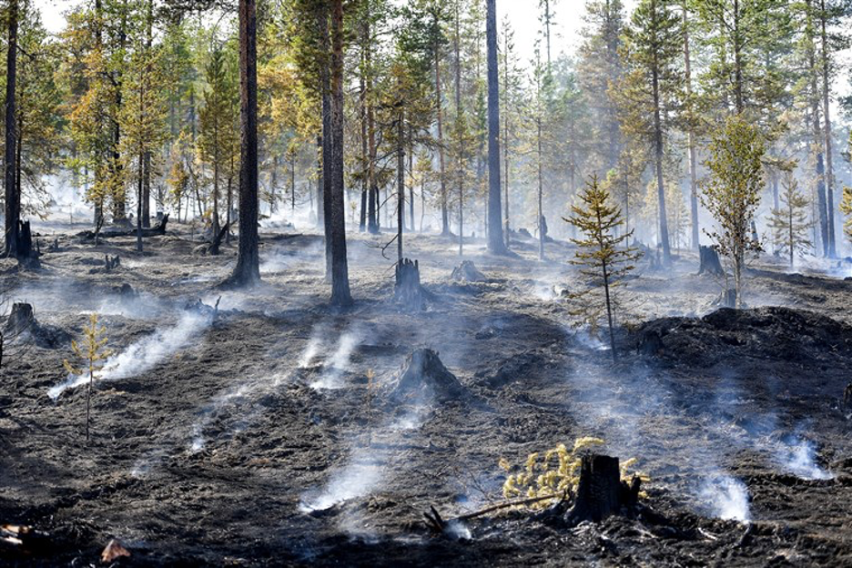
Figure 1: Source: https://www.nbcnews.com/news/us-news/global-warming-can-make-extreme-weather-worse-now-scientists-can-n901751
Research has proven that climatic changes have been the cause of extreme weather such as heatwaves, storms, and floods. These events have been on the increase as climatic changes are continually experienced. This depicts that in the future it is likely that these events will cause more disruptions to businesses and even cause physical damage that will lead to losses for the businesses (Henderson et al., 2018). When this happens the insurance costs of the business might increase and some businesses, especially those without insurance, might be destroyed completely hence affecting the cash flow of the owners.
Another factor that businesses should consider as far as climatic changes are concerned is the changes in the cost of resources and their availability. The extreme weather being experienced will adversely affect supply chains, especially where the raw materials for business are natural. For instance, through flooding, drought, and unpredictable weather patterns, there can be a shortage of crops that are used to make processed food and other natural resources that are used to make products such as clothes. These will affect the productivity of the company in the long run. The changes in climatic changes will also lead to harsher working conditions for the employees. For instance, a company that needs its employees to work outdoors will have a hard time when the harsh weather conditions catch up with the employees (Henderson et al., 2018). Moreover, the increased climatic changes might take a toll on the employees’ health and this will increase the insurance costs of the company.
Companies have also suffered a change in demand for their products. For instance, companies that manufactured items that cautioned against extreme weather such as winter might go out of business as winters are becoming smaller and more unpredictable. Due to changed regulations, companies can also go out of business as governments are putting up more regulations to combat the negative climatic changes being experienced (Shrestha, 2014). Moreover, businesses that are considered to be detrimental to the environment and climate, in general, are having a lot of pressure from the public to either close down or increase sustainability in their businesses. It is therefore crucial for businesses to devise strategies that will contribute to the management of climatic changes.
Proposed Business Strategies to Deal with The Issues
One strategy that businesses can incorporate to contribute positively to combating negative climate change in determining their greenhouse gas emissions. Notably, the current changes in climate are attributed to global warming which is caused by industries across the world. Industries whose output is greenhouse gases are considered to be dangerous to the current efforts being made to combat climatic changes. With this in mind, companies must analyze their current emissions, something that can be possible through private companies that are carbon footprint certified. After this analysis, a company will be in a good position in measuring its contribution to global warming.
Another strategy that companies should incorporate is reducing their energy consumption. The level of energy consumed by a company affects the climatic conditions. Companies using a lot of energy release a lot of heat to the atmosphere and this contributed to global warming (Lilkov 2018). Through actions such as turning off lights and unplugging devices that are not in use, it can be possible for companies to ensure good use of energy. 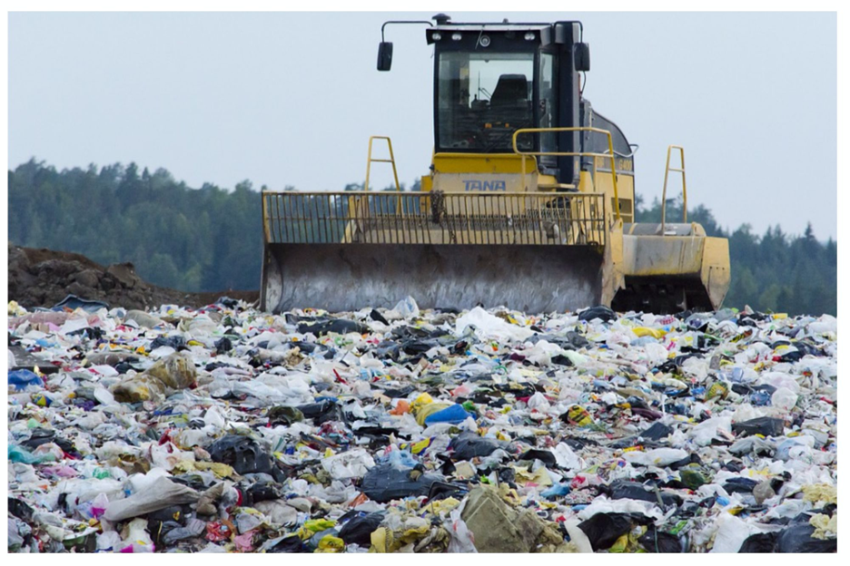
Figure 2: Source: https://www.entrepreneur.com/article/327714
It is also important for companies to reduce the amount of waste created when running businesses. The figure above is an example of waste produced by companies. Notably, most of the waste used by companies are not recyclable and they increase risks to the environment. The only way that those waste materials are disposed of is by burning and this has been hazardous not only to the climate but also to the people living around the area. Therefore, companies should seek to reduce the waste produced by using natural raw materials whenever necessary. Moreover, in cases where it is impossible to use natural raw materials, companies can have a waste processor which does not release hazardous waste to the environment.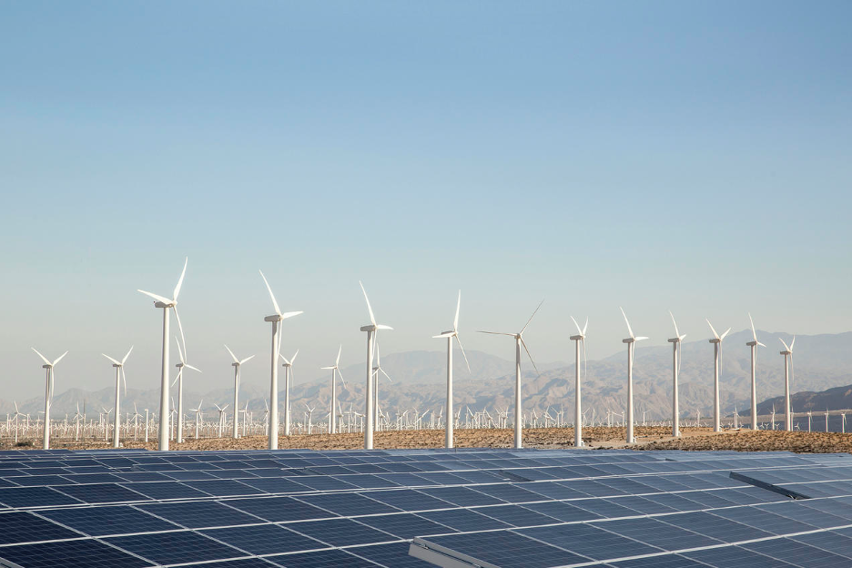
Figure 3: Source: https://www.nrdc.org/stories/renewable-energy-clean-facts
Companies should also incorporate renewable sources of energy such as the one in the above image. Currently, most major companies are using fossil fuel and coal and this has increased the greenhouse effect in the atmosphere. Renewable sources of energy such as solar systems will have no adverse effect on the environment and will also ensure that companies cut their energy consumption costs. While companies can't move from unsustainable sources to sustainable ones overnight, choosing greener infrastructure can be possible. For instance, companies should invest in electric vehicles and use materials that are the most energy-efficient. Moreover, companies can encourage sustainability by preferring suppliers who usually make eco friendly choices. Companies can identify such suppliers by getting the company’s sustainability reports and observing the public perception of such companies. It is also important for companies to take part in environmental initiatives such as climate awareness campaigns (Esty & Bell, 2018). Companies can also choose to sponsor sustainability initiatives in their area of operation.

- What can a global business (manager) do about it?
With the changes in weather patterns and extreme climate incidents across the globe, climate change has emerged as a serious issue in contemporary society. Countries across the globe are experiencing warmer winters and unprecedented weather conditions that are not only harming the health of citizens but also impacting the economy. As such countries are constantly looking for ways to reduce their level of carbon emission which has been established to be the major cause of carbon emission. While it is the responsibility of a country to ensure that climate change does not affect its economy and citizens negatively, this responsibility does not lie solely on the government. Businesses who are significantly responsible for climate change should also take responsibility in the fight in the fight against climate change. Through their activities, businesses are contributing to climate change via their carbon emission. There is no single best approach to dealing with climate change (Harvard Business Review, 2007). The approach of each company varies depending on their business. Nevertheless, every organization should incorporate initiatives to prevent climate-linked risks and costs in its value chain. Business leaders should treat carbon emission as a cost to both their business and the society at large. This paper will highlight some of the tactics and strategies that global business managers can adopt to mitigate, solve, and address the impact of climate change.
Measure Carbon Footprint
Business managers can address climate change by measuring their carbon footprints. Businesses should measure the amount of greenhouse gas emissions that their businesses produce every year. Once an organization establishes a business as a usual benchmark, it can put in place measures to minimize its carbon footprint from its current level.
Several organizations assist businesses with their carbon accounting such as CDP (Mainwaring, 2018). The organization is prominent in the business community for its accountable and transparent carbon measurement. As such businesses can rely on it to measure their carbon footprint and implement measures to reduce their carbon footprint. Also to ensure that an organization maintains credibility in how it measures its carbon footprint, it should carry out a third-party audit that will create a clear picture of its contribution to climate change.
Create a Climate Action Plan
Once an organization determines its level of carbon emission, it has to create a climate action plan. The action plan should include the activities that contribute to greenhouse gas emission and how it can minimize the emission. Some of the major areas that businesses should focus on are:
Supply chain
Emission from the company supply chain is accountable for most corporate carbon emissions. However, reducing carbon emission in the supply chain is challenging since it involves changing how materials are sourced and occasionally suppliers. Nevertheless, this is necessary and possible. A suitable example of an organization that is taking on the issue of emission in its supply chain is the toy making company LEGO (Mainwaring, 2018). Recently the organization unveiled its use of a bio-based material and its dedication to replacing its primarily plastic-based building blocks with plant-based ones. Changing the supply change will have a lot of impact on the carbon emission of your business. Therefore to reduce supply chain-related emission as well as protect your price and quality benchmark you should begin with a trial project and change over time.
Energy
Cooling, heating, and electricity are mainstream carbon emission sources (Mainwaring, 2018). Thus, enhancing energy efficiency is a great way of minimizing your level of carbon emission. As a strategy of addressing climate change organizations should pay close attention to facilities in their whole value chain including factories, storefronts, third party warehouses, and corporate offices. Reducing energy use in the outlined areas enables an organization to minimize its carbon footprint.
Transportation
Fulfillment routes and logistics are major target areas for reducing emissions. Businesses can minimize the travel distance of their products significantly by using local warehouses. Further logistic emissions can be reduced by allowing sufficient shipping time through sea freight as opposed to air. Other than fulfillment and logistics businesses can also use incentives to encourage their workers to travel sustainably. They can achieve this by replacing businesses owned vehicles with an all-electric fleet. Alternatively, you can provide company transportation in the residential areas where the majority of the company employees reside. Also, an organization can facilitate eco-transportation by giving employees loans to acquire electric vehicles and giving incentives to employees who commute through public transport, carpool, or bicycle.
Food
Though not apparent, the food that people consume has a significant effect on the level of greenhouse emission. Agriculture is accountable for up to a third of the global greenhouse emission (Gilbert, 2012). Moreover, animal-based food products are more carbon-intensive than plant-based food products. Production of dairy and red meat in particular is significantly carbon-intensive.
As such if an organization offers catering services or company lunches it can minimize its level of carbon emission by offering plant-based food products and avoiding dairy and beef-based food products.
Establish emission reduction targets
An organization can address climate change by enhancing its understanding of key sources of emission and measures it can pursue to minimize emissions. To make changes that are measurable an organization has to establish time and quantitative targets for reducing emission. Quantifying a business’s level of emission reduction involves establishing an internal price on carbon. Businesses should acquire cost estimates for measures in their climate action initiatives so that they can determine the time and cost needed to reduce emissions before starting. Once the targets are set, an organization should monitor its progress. This, it can achieve by enlisting a third party consultant organization to measure its actual footprint. Assessing progress allows organizations to identify areas of improvement.
Supporting politics that is climate-smart
Government policies are a powerful tool in facilitating a carbon-free future but majorities of companies tend to distance themselves from politics. However, when it comes to the fight against climate change, businesses must support politicians and policies that are geared towards reducing emissions. Climate change policies such as incentives for renewable energy, electric vehicle rebate, and Clean Air Act can be made successful by businesses that advocate for them (Environmental Protection Agency, 2019). Also using their lobbying influence they can compel politicians to pursue climate policies that are progressive thereby contributing to the fight against climate change.
That said, it is pertinent to assert that corporate business managers should address climate change for the benefit of their business, citizens, and the planet at large. This they can achieve by measuring their level of emission, creating targets for reducing emission, supporting policies geared towards mitigating climate change, and creating a climate change action plan. Through the illustrated measures businesses can reduce their level of carbon emission, motivate other businesses to reduce their carbon emission, and encourage governments to seriously consider the threat that climate change poses. Failure to take action on the other hand will depict businesses as ignoring the threat of climate change and will ultimately hurt the business.

Work cited
Arnell, Nigel. A Short Guide to Climate Change Risk. Ashgate Publishing, Ltd., 2015
Bowen, Alex et al. The Global Development of Policy Regimes to Combat Climate Change. World Scientific, 2014.
DiMento, Joseph and Doughman, Pamela. Climate Change: What It Means for Us, Our Children, and Our Grandchildren. MIT Press, 2014.
Maslin, Mark. Climate Change: A Very Short Introduction. Oxford University Press, 2014.
Esty, D. C., & Bell, M. L. (2018). Business leadership in global climate change responses. American journal of public health, 108(S2), S80-S84.
Lilkov, D. (2018). Dealing with climate change: A European centre–right perspective. European View, 17(2), 172-180.
Henderson, R. M., Reinert, S. A., Dekhtyar, P., & Migdal, A. (2015). Climate change in 2018: Implications for business. risk, 1.
Shrestha, D. (2014). The Impacts of Climate Change on Business. Crossing the Border: International Journal of Interdisciplinary Studies, 2(1), 93-112
Environmental Protection Agency. (2019). Summary of the Clean Air Act. Retrieved from: https://www.epa.gov/laws-regulations/summary-clean-air-act

Gilbert, N. (2012). One-third of our greenhouse gas emissions come from agriculture. Retrieved from: https://www.nature.com/news/one-third-of-our-greenhouse-gas-emissions-come- from-agriculture-1.11708

Harvard Business Review. (2007). Climate Business | Business Climate. Retrieved from: https://hbr.org/2007/10/climate-business-_-business-climate

