Instructions
Answer all 3 questions in APA format with at least 1200 words total. I would shoot for 300 per, but it does not have to be equal… just need 1200 total. Also, need three references in total. Use the unit 2 PDF for one source as it is attached to the assignment as well. Its reference is
Reference for unit 2 is below… use this for one reference
Nassar, N.S. (2007). Bethel University, College of Professional Studies. (Savant Learning Systems) Retrieved from Bethel University, College of Professional Studies: htts://www.betheluniversityonline.net/cps

->Start by placing your organization in the center oval.
->Identify specific organizations that may affect the structure or performance of yours, list the nature of the connections, and place them in the in the boxes as you label them (suppliers, distributors, competitors, government agencies, etc.). Place those that affect you in the blue boxes and those that you affect in the red boxes.
->Rank the relevance of each connection on a scale of 1 - 5 (5 being most relevant).

1. Using the numbers in the spaces, type your answer out and place the number next to that answer to justify which block the answer goes into.
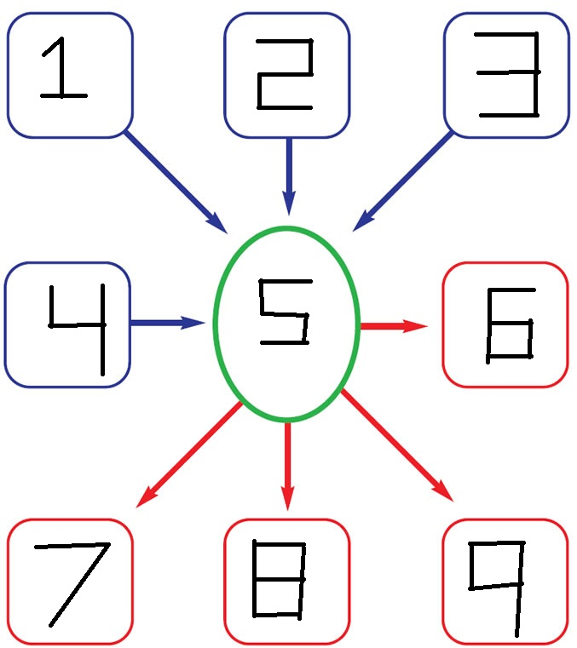

>Start by placing your industry in the center oval.
->Identify general industries within the economy that may affect your industry and list the nature of the relationships connecting them to yours. Place those affecting you in the blue boxes and those that you affect in the red boxes.
->Rank the relevance of each connection on a scale of 1 - 5 (5 being most relevant).

2. Using the numbers in the spaces, type your answer out and place the number next to that answer to justify which block the answer goes into.

Visit your local retail supercenter to discover where your everyday items are made.
3. At a local retail store (Walmart, Kmart, Target, etc.), log 15 items randomly. List the name of the product, its country of origin, and the price.

