Jillian Maybee
COM-263
22 April, 2018
Rae Thompson
Non Verbal Communication in Latin America: A Training Guide

When we deliver messages verbally we are conveying the literal meaning of the words we are speaking. In intercultural settings, non verbal communication is critical in providing context on how that verbal message is understood. If nonverbal cues are used properly they will clarify the message, if used improperly, they can cause offense or confusion. Depending on the culture, non verbal cues can have different meanings and several non verbal cues can be relayed at the same time. There are specific rules that should be considered, including gender, relational distance and socioeconomic status to name a few. Latin culture is very different from American culture and understanding the non verbal cues within the Latin culture is paramount to assimilating to their way of life and gaining trust and respect. This training guide will assist you in understanding the nonverbal cues in Spanish culture.
How body motions are interpreted such as gestures and movement of any body part is called Kinesics. In Latin culture hand gestures mean specific things. A great example of this is the hand gesture Americans use to signal someone to come closer. Typically Americans turn their palm upwards and extend and curl their index finger several times. In Spanish countries this gesture is considered sexual in nature and can be considered as soliciting someone for sex.
How humans use space around them and the effects it has on their communication is referred to as Proxemics. The personal space Americans keep around themselves when communicating with others can clash with other cultures. Typically Americans keep approximately an arms length distance when conversing with others and if someone gets too close, this can be perceived as an aggressive action. For Latinos it is very much the opposite, they tend to stand much closer to each other when speaking and if someone maintains a distance that can be considered rude.
The way people communicate by touch is called Haptic communication. Generally Americans limit touching to a handshake, especially with strangers and hugs and other intimate touching is reserved for family members and loved ones. Latinos tend to be more personal with their greetings. Kisses on the cheek and hugs are common in Latin culture and not just for loved ones but to anyone they want to extend a welcome.
When speaking, the tone of your voice as well as the inflection, rhythm and pitch while communicating is called Paralinguistics. Latinos typically speak faster and louder than other cultures. To other cultures the speaking patterns of Latinos can be misinterpreted as an argument or a deeply emotional conversation. Also, frequent interruptions by others can be considered rude in many cultures but that is not the case in Latin culture as it is considered normal and not at all invasive.
Americans rely on schedules and time is very important in the American culture. It is considered rude to be late or to miss an appointment. The study of how time is perceived in communication is called Chronemics. Latinos tend to have a much more relaxed approach to the scheduling and management of time. This type of relaxed attitude about the use of time makes Latin culture a Polychronic culture, meaning that their perception of time is very informal, and they are not driven by any type of schedule or time constraints.
Physical appearance and dress within the Latin culture can relay regional differences, education and political affiliation, which is much more complex than that of other cultures. Similar to the Caste systems of India, attire can be indicative of where exactly a person is from and how wealthy they are. Spanish natives can also distinguish physical features of people that come from a specific country within the Latino community.
Eye contact in any culture can mean various things. In American culture eye contact is perceived as respectful and can be interpreted as someone who is honest and trustworthy. In Latin cultures, direct eye contact is considered threatening and rude. Eye contact in intimate settings or with close family and friends is considered acceptable, however making eye contact with strangers while walking down the street, for example, is not acceptable.
Olfactics is the study of smells and how they are perceived by others. In Latin culture odor is used to communicate. Many Latinos use fragrances to convey their personality and sometimes smell is used to show love of their family. Fragrances are used to communicate something about the person, their hygiene, their affluence, etc. Latinos also tend to use very fragrant cleaning products to communicate to others that they keep a clean house, office, etc., and can effectively take care of their house and family.
In conclusion, non verbal cues are very important within the Latin culture and understanding the meaning of these cues will make your experience a good one, where you can feel accepted and understand what is going on around you. If you are ever in doubt, please ask someone. Latinos are very accepting of other cultures and they are happy to help you understand their way of communicating.

Here is an infographic that can assist you when traveling to Latin countries:
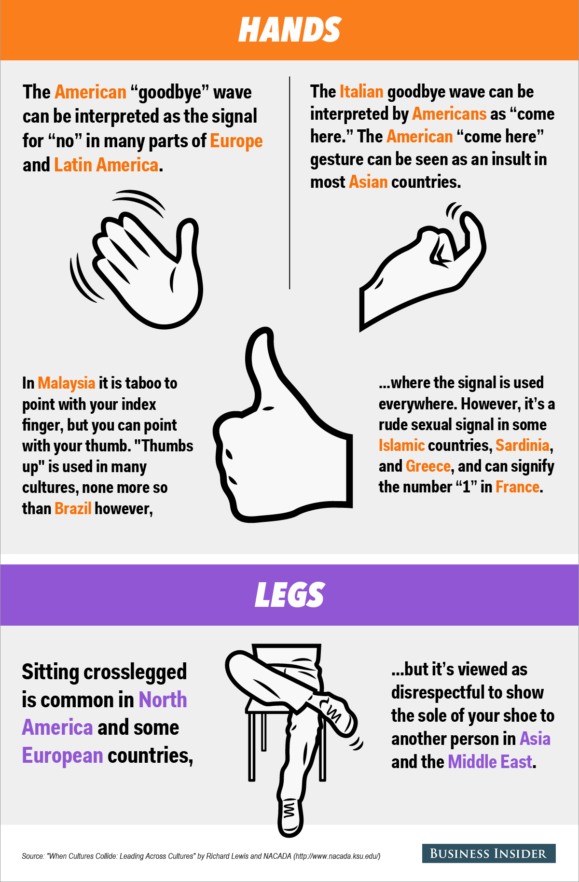

References

Non-verbal Communication. (2016). Imgur. Retrieved 23 April 2018, from https://imgur.com/gallery/fY3z4

Nonverbal Communication. (2018). Rpi.edu. Retrieved 22 April 2018, from https://www.rpi.edu/dept/advising/american_culture/social_skills/nonverbal_communication/reading_exercise.htm

Spanish culture and nonverbal communication. (2018). Spanishprograms.com. Retrieved 23 April 2018, from http://www.spanishprograms.com/spanish-culture.htm

