Come and Go
A dramaticule by Samuel Beckett

Sitting center side by side stage right to left FLO, VI and RU.
Very erect, facing front, hands clasped in laps.
Silence.
VI: When did we three last meet?
RU: Let us not speak.
Silence.
Exit VI right.
Silence.
FLO: Ru.
RU: Yes.
FLO: What do you think of Vi?
RU: I see little change.
FLO moves to center seat, whispers in RU's ear. Appalled.
Oh!
They look at each other. FLO puts her finger to her lips.
Does she not realize?
FLO: God grant not.
Enter VI. FLO and RU turn back front, resume pose.
VI sits right.
Silence.
Just sit together as we used to, in the playground at
Miss Wade's.
RU: On the log.
Silence.
Exit FLO left.
Silence.
Vi.
VI: Yes.
RU: How do you find FLO?
VI: She seems much the same.
RU moves to center seat, whispers in VI's ear. Appalled.
Oh!
They look at each other. RU puts her finger to her lips.
Has she not been told?

RU: God forbid.
Enter FLO.
RU and VI turn back front, resume pose.
FLO sits left.
Holding hands . . . that way.
FLO: Dreaming of . . . love.
Silence.
Exit RU right.
Silence.
VI: Flo.
FLO: Yes.
VI: How do you think Ru is looking?
FLO: One sees little in this light.
VI moves center seat, whispers in FLO's ear. Appalled.
Oh!
They look at each other. VI puts her finger to her lips.
Does she not know?
VI: Please God not.
Enter RU.
VI and FLO turn back front, resume pose.
RU sits right.
Silence.
May we not speak of the old days?
Silence.
Of what came after?
Silence.
Shall we hold hands in the old way?
After a moment they join hands as follows: VI's right hand with RU's right hand. VI's left hand with FLO's left hand, FLO's right hand with RU's left hand, VI's arms being above RU's left arm and FLO's right arm. The three pairs of clasped hands rest on the three laps.
Silence.
FLO: I can feel the rings.
Silence.
CURTAIN

NOTES

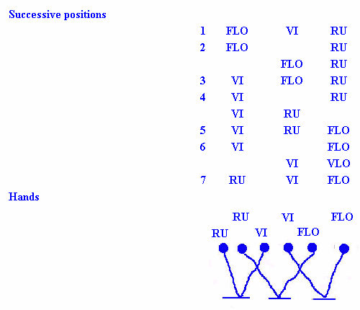
Lighting
Soft, from above only and concentrated on playing area.
Rest of stage as dark as possible.
Costume
Full-length coats, buttoned high, dull violet (RU), dull red (Vi),
dull yellow (Flo). Drab nondescript hats with enough brim to
shade faces. Apart from color differentiation three figures as
alike as possible. Light shoes with rubber soles. Hands made up
to be as visible as possible. No rings apparent.
Seat
Narrow bench-like seat, without back, just long enough to
accommodate three figures almost touching. As little visible as
possible. It should not be clear what they are sitting on.

Exits
The figures are not seen to go off stage. They should disappear a
few steps from lit area. If dark not sufficient to allow this,
recourse should be had to screens or drapes as little visible
as possible. Exits and entrances slow, without sound of feet.
Obs
Three very different sounds.
Voices
As low as compatible with audibility. Colorless except for
three 'ohs' and two lines following.

Written in English early in 1965. First published in French by Editions de Minuit, Paris, in 1966. First published in English by Calder and Boyars, London, in 1967. First produced as Kommen und Gehen, translated by Elmar Tophoven, at the Schiller-Theater Werkstatt, Berlin, on 14 January 1966. First performed in English at the Peacock Theatre, Dublin, on 28 February 1968 and subsequently at the Royal Festival Hall, London, on 9 December 1968.

Originally at http://www.drama21c.net/text/come&go.htm

