To: Miranda Priestley
From: NINGXI HE
Email: nh7669a@american.edu
Date: 9/15/2019
Subject: The Soft Drink Analysis Paper

The soft drink market is the largest group in the more significant beverage industries. The industry’s average profit, defined as earnings before interest and taxes, accounts for an estimated 19.5% in 2019, a considerable increase from 15.2% in 2014 (IBISWorld,2019) Therefore, the analysis of the market is crucial, because it allows management to better understand its internal and external environment, potential positioning, and customer target strategy, as well as its advantages and disadvantages. This paper analyzes the soft drink industry in the United States. The first part of the market analysis shows that the internal and external environment is critical to the soft drink industry's success in the United States, as it determines various political, economic, social and technical factors that affect the company's product operations and sales.

Part 1: Market Analysis: Soft Drink (Non-Alcohol beverage)

In recent years, more people start to stop drinking Soft Drink because they are starting to focus on health issues, and think Soft Drink has too much sugar and too many artificial ingredients. “Over the five years to 2019, falling per capita soft drink consumption significantly affected industry performance. Demand for both regular and diet carbonated soft drinks has declined as more consumers turn to healthier beverages to quench their thirst” (IBISWorld, 2019). Both internal and external environment contains different forces, which may contribute to the operation of the Soft Drink industry. Political, economic, social and technical factors play a vital role in the success of various brand marketing strategies.

Environmental Scan
A PESTEL analysis can help to understand various external factors affecting the soft drink industry.

Political
The level of the soft drink industry's regulation is medium. A sales tax applies to soft drinks in most states, which are implemented to discourage consumers from drinking an excessive volume of sugary drinks (IBISWorld, 2019). Due to consumers' price sensitivity and highly competitive within the industry, these taxes reduce the profitability of the industry. In November 2016, Boulder residents voted to impose a 2-cent per ounce tax on sugary drinks, effective July 1, 2017. In 2016, residents of Cook County, Illinois (which includes Chicago), San Francisco, Oakland and Albany, California, also voted to tax sugary drinks. In February 2017, the city of Philadelphia introduced a tax on sweetened beverages, a tax on soda sold per ounce. In January 2018, Seattle, Washington, joined the ranks by imposing a 1.75 cent per ounce tax on carbonated drinks (IBISWorld,2019). Besides, energy drink makers have faced increasing regulation in recent years. Officials have proposed legislation to limit consumption amid rising concerns about the safety of caffeinated drinks aimed at teenagers and children (IBISWorld,2019). As these policies are passed at the city, state, and federal levels, they are likely to hamper the growth of energy drink consumption and the revenue growth from the sale of these products. In general, these policies are bad for soft drinks companies, because they increase the cost of soft drinks. It also limits the market for teenagers, since many schools have been unable to pass restrictions on the sale of soft drinks on campus.

Economic
The economic forces in the United States are important to the operations of soft drink. Although the soft drinks industry experienced a market shock during the recession, as long as companies want, the soft drinks industry will continue to make money.

The Figure 5 shows the per capita consumption of soft drinks in the U.S. from 2010 to 2018.
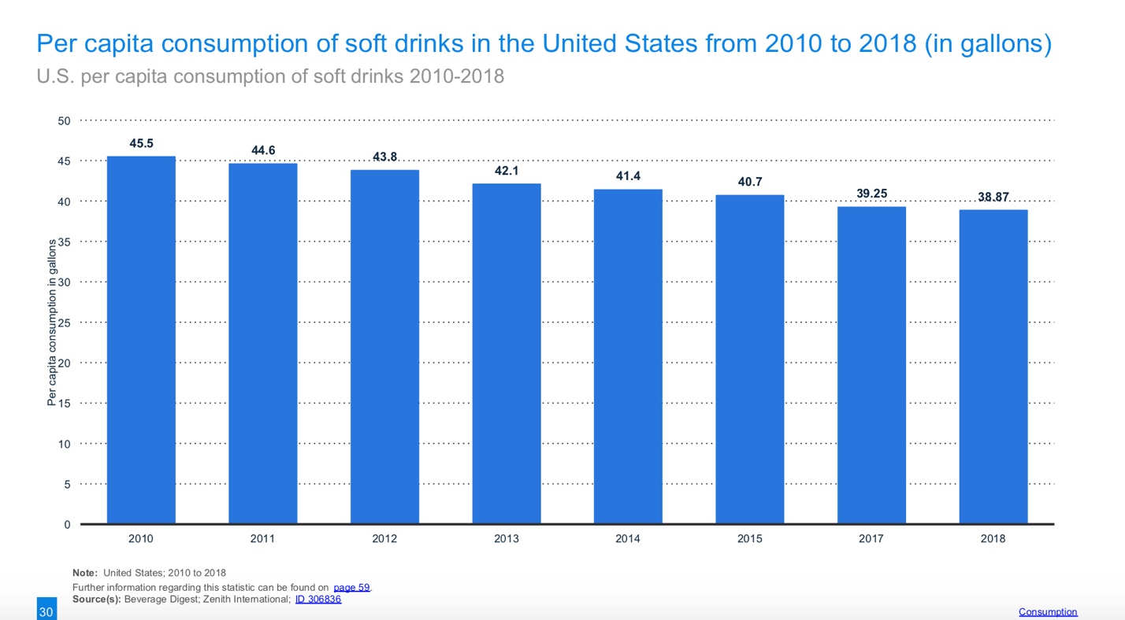
Since 2008, the soft drink industry has struggled to regain its previous market strength. From 2011, per capita consumption of soft drinks began to decline. Until 2018, has fallen from 45.5 in 2010 gallons, down to 38.87 gallons (Statista, 2019).

Social
Socio-cultural forces deeply influence the soft drink industry, and the industry has to adapt to these forces. The innovation of the product is essential and caring about the changing preferences of people. For different age groups, their choices are also different. For example, maybe the older generation tends to consider nutritional factors between products (diet or zero-calorie options). Meanwhile, the younger generation tends to be more interested in fun and new product.

Technological
Due to the saturation of the soft drink market, having unique technology is crucial, and the high cost of new technologies can be a barrier to entry for new competitors. Automation is already a ubiquitous technology category for the soft drink industry, and new technological advances in manufacturing and quality improvement concepts are improving the efficiency of bottling operations (Soft Drink Industry SAR). High production requires a high level of manufacturing automation. If the industry can upgrade the technology and then further enhance the effectiveness of the employees and capital, productivity will increase dramatically.

Environment
There are five impacts the soft drinks industry has on the environment, including growing and processing fruit and sugar, packaging materials, refrigeration of goods, supply chain waste production and water scarcity (Environmental Leader, 2013). At present, most state governments tend to be environmentally friendly, so soft drink companies need to pay attention to these environmental impacts and try to stay as environmentally friendly as possible. Coca-Cola, for example, encourages customers to recycle bottles.

Legal
For soft drink companies, the formula is the core. Not every country's legal framework and institutions are robust enough to protect an organization's intellectual property. Therefore, the soft drink industry must consider relevant laws to protect its intellectual property, such as Copyright and discrimination Law. Equally important are Consumer protection, Employment law and Health and safety law.

Industry Analysis (Five Forces)

Figure 1 below illustrates the market value of the industry for the years 2011-2023.

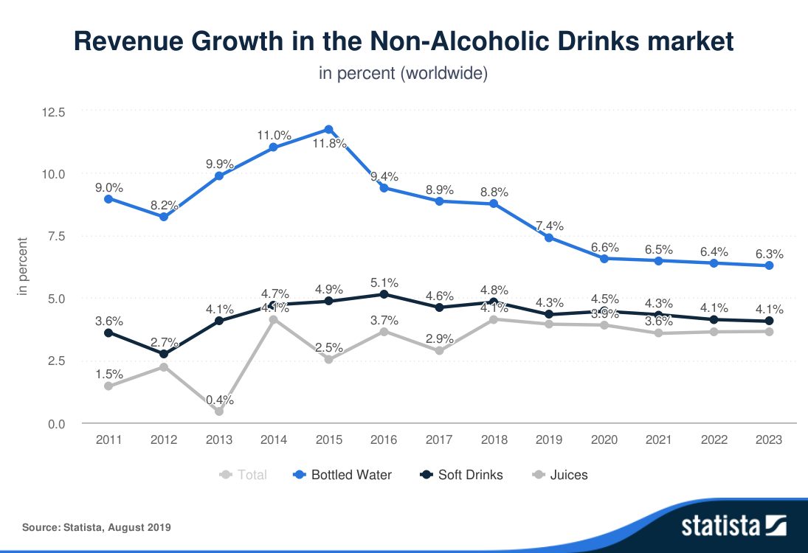

It is obvious that the market value of soft drinks has been rising slowly since 2013, although the market value of soft drinks has fluctuated slightly in recent years. The non-alcoholic beverage market is expected to grow by 5.0% by 2020 (Statista, 2019). In other words, the soft drink market is relatively stable.

Figure 2 shows the major products and services in this industry, and segmentation.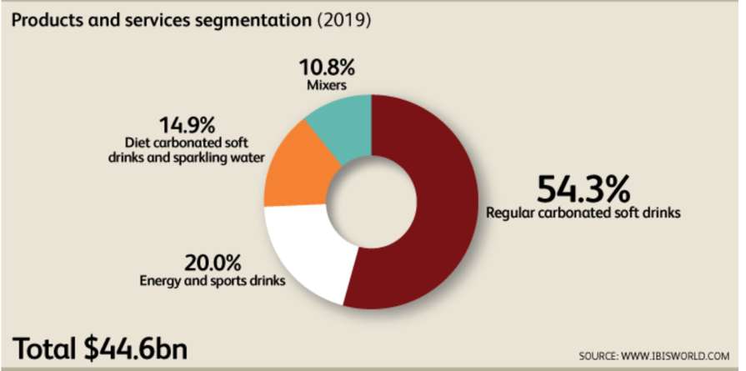

Regular carbonated soft drinks share over than half the market. The popularity of energy drinks has exploded in recent years, driven by factors such as the overall growth of functional foods and beverages and targeted marketing. Energy and sports drinks as a potential product, it is expected to account for 20.0% of industry revenue in 2019. Although growth in energy drinks has slowed over the past five years, demand is growing and helping drive growth. As demand for carbonated soft drinks continues to fall, this segment's revenue share is expected to expand over the next five years (IBISWorld, 2019). Diet carbonated soft drinks and sparkling water is a controversial product because artificial sweeteners, as well as artificially carbonated water, are included in the product. While sales of diet CSDs increased in the early 2000s, helped by popular dietary trends, sales of diet CSDs have declined over the past five years as consumers have become more cautious about the health effects of consuming artificial sweeteners. By 2019, this segment is expected to account for 14.9 percent of the industry's revenue (IBISWorld, 2019). Mixer can include juice carbonated drinks, often used for cocktails. Since millennials increasingly prefer to mix their own individualized cocktails, this segment has grown in popularity. In 2019, mixers are expected to generate 10.8% of industry revenue (IBISWorld, 2019).

Macro Analysis

A 5 forces analysis can help to understand various external factors affecting the Non-Alcohol beverage industry, and it’s pertinent to highlight size, profit, and growth.

The threat of entry:
There are high and steady barriers to entry into the Soft drink Production industry, including excessive initial capital investment, market saturation, industry concentration, and declining Soda demand. However, since Energy drink and other soft drinks are still in the growth stage of the life cycle, it might have better opportunities for new entrants. (IBISWorld, 2019). In general, buying or renting facilities to produce soft drinks and expensive machinery requires significant capital investment. In addition, new entrants must be able to offer differentiated products that either taste significantly better than those already on the market or invest heavily in marketing to position and promote their brand. The soft drinks market is heavily saturated, take carbonated drinks as an example. The big four soda makers are expected to account for more than 53.7 percent of industry revenue in 2019 (IBISWorld, 2019). This also means that it is not friendly to potential manufacturers because these brands have high brand loyalty among consumers.

Bargaining Power of Suppliers:
The power of the supplier is moderate within the Soft Drink industry in the United States.
Supply industries for Soft drink production in the US are majorly glass product manufacturing, metal can & container manufacturing, plastic bottle manufacturing, seasoning, sauce and condiment production, sugar processing, and syrup & flavoring production (IBISWorld,2019). Suppliers are not centralized or differentiated, which reduces their bargaining power. Product innovation is to meet the needs of buyers of a variety of tastes. Every company is trying to create the best product, so the specific materials they put in are very different. There is no doubt that brands will choose suppliers with lower price and better quality. Companies can switch quickly and easily from supplier to supplier because there is not much competition in the soft drink industry.

Bargaining Power of Buyer:
The primary buyers of Soft Drink industries are wholesalers, retailers, Vending Machine Operators, and regular costumers (IBISWorld,2019). Wholesalers and large retailers, such as Walmart have bargaining power because of large orders. Customers are highly sensitive to the price of soft drinks and are willing to change brands if one becomes much more expensive than the other (IBISWorld, 2019). Although customers may choose other brands because of the price, people are very loyal to the product they choose. If the product is unique enough, buyers will have less bargaining power.

Threat of substitutes:
There is medium to high pressure from substitutes in the soft drink industry. An alternative product is one that provides a company with the same or similar benefits as other industrial products. The threat of substitutes refers to the level of risk a company faces when alternatives replace it. For more generic, undifferentiated products, the danger is always greater than from more unique products. Because of the homogeneity of soft drink, when the retail price of branded products rises, many consumers will choose more affordable branded products or switch to generic brands (IBISWorld, 2019). For many people, soft drink is an interchangeable product, which means the soft drinks industry faces intense competition from within the industry and from alternatives. Substitutes can include water or even coffee or tea as a source of caffeine.

The Figure 3 shows the sales volume growth of liquid refreshment beverages in the United States from 2016 to 2017.
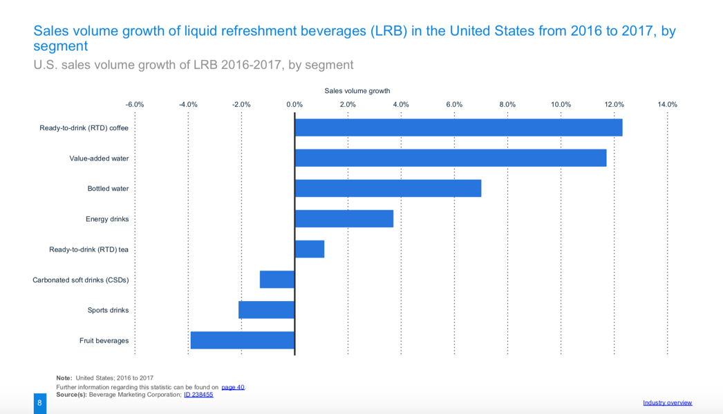
From the data from 2016 to 2017, it can be clearly seen that Carbonated soft drink, Sports Drinks, and Fruit beverage sales decreased significantly, and more customers seemed to prefer RTD coffee, water, and energy drinks more in recent years.

Competitive rivalry:
There is high competition in soft drink industry. Competition in the soft drinks industry is based on several factors, including price level, product range offered product innovation, and marketing. Although soft drinks are cheap for consumers, they are still a discretionary commodity and consumption depends on income level. Producers have temporarily cut prices in downstream markets to boost demand as overall consumption falls and health concerns intensify, reducing demand for industrial goods (IBISWorld,2019). Therefore, improving customer loyalty becomes a great way to stand out from competitors. Leading soda, energy drink, and sports drink brands have invested heavily in marketing and promotions to boost consumer loyalty further.

The Figure 4 shows the worldwide revenue in the non-alcoholic drinks market from 2010 to 2023
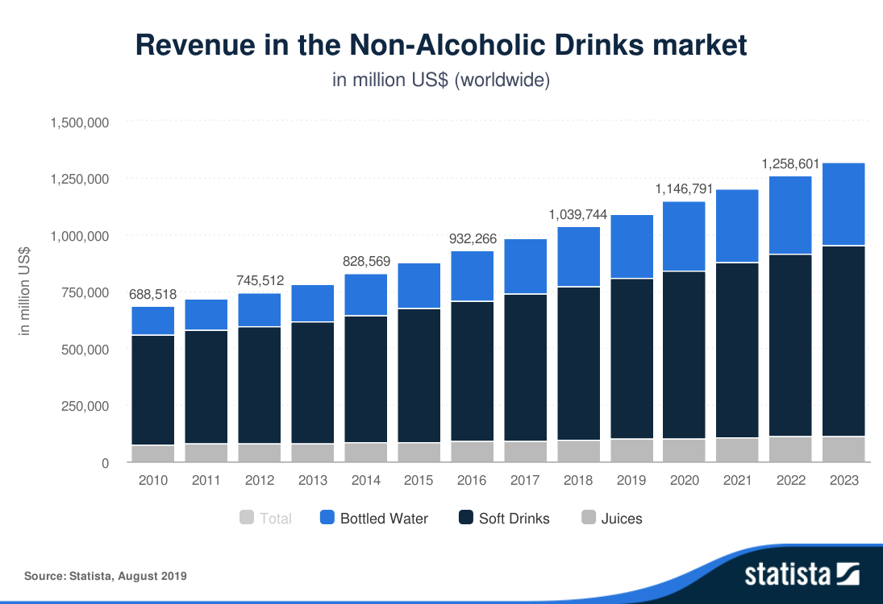

The result can be seen from the chart. Although competition in the soft drink industry is fierce, and consumer demand for water is increasing every year, the soft drink trade is relatively stable.

Conclusion
The soft drink industry in the United States is affected by several external factors that can be grouped into political, economic, social, and technological. Consumer’s tasting is always change and soft drink industry must be able to meet the new demands. Political interference and differences in tax systems may affect the sale of product. As mentioned above, the CSD type of drinks will be more restricted. The soft drinks market as a whole is relatively stable, but if not the leading companies, competition is great.

Reference
Mintel, (2019).Carbonated soft drinks report.
Retrieved from https://academic-mintel-com.proxyau.wrlc.org/display/952314/
http://clients1.ibisworld.com.proxyau.wrlc.org/reports/us/industry/majorcompanies.aspx?entid=285
Sharon, B. (November 20, 2018). Soft drink industry now looking to still beverages to boost sales. Retrieved from
https://articles2.marketrealist.com/2014/11/soft-drink-industry-now-looking-still-beverages-boost-sales/
Statista, (September 18, 2019). Non-Alcoholic Drinks - worldwide. (n.d.).
Retrieved from https://www-statista-com.proxyau.wrlc.org/outlook/20000000/100/non-alcoholic-drinks/worldwide
Lucas, P., Haley, P., Daigneault, J., & Scofield, C. (n.d.). 2.4 - Technological Factors –
Soft Drink Industry SAR Analysis. Retrieved from https://sites.google.com/site/softdrinkindustrysaranalysis/2-pest-analysis/political-factors
Korosec, K. (2013, July 1). Coca-Cola, Britvic Join Soft Drink Sustainability Roadmap.
Retrieved from https://www.environmentalleader.com/2013/07/coca-cola-britvic-join-soft-drink-sustainability-roadmap/
IBISWorld, (September 13 ,2019). IBISWorld Industry Report 31211a-Soda Production in the US.
Retrieved from http://clients1.ibisworld.com.proxyau.wrlc.org/reports/us/industry/default.aspx?entid=285

