Sofiya Rubenova
First Session Entry
Tuesday, April 16th

Challenges and Triumphs

On Tuesday, April 16th, I gathered my first small group of students for an introductory interest meeting on my research project. A week in advance, I had already posted on as many social media sites as I could, and spread the information through friends regarding the meeting and a brief overview of my topic. Gathering a substantial group of students was challenging, as many have not heard of the Refusenik movement and hence, their attention was not captured. I was still determined to hold an introductory meeting because I believed that my if I at least share my topic with one person, it would have been one more person that is now aware of something they wouldn’t have otherwise learned. The meeting was held on April 16th, to which four students showed up for breakfast at Bits n Bytes Café. They were eager to find out details about a movement they have never heard of or learned about at school. I began by describing a bit of my background and what influenced me to do research on this topic. As a student of Jewish background, I had always questioned my identity, especially having parents of mixed religion and cultural background. Coupled with my passion for human rights, it seemed like the perfect opportunity to not only further research Jewish history, but to also examine underlying political and social factors in the Soviet Union that made the violation of Jewish human rights possible. As I explained this to the students, I was interrupted by a rather confident claim by a student who said that the movement never existed. I was drawn aback for a few moments, because I thought I had said something wrong. “Maybe I’m mispronouncing something” I thought to myself, until the student continued to tell me that “this wasn’t a movement. Its when the Jews realized that they could make an excuse to claim Israel as their land” The moment I was dreading happened; at the beginning of my research I was afraid that people would make the Jewish people synonymous to the political tensions surrounding Israel today. This moment also challenged me as someone who Is passionate about the education component of this project, as it was now my job to try to explain to the student why they were misunderstanding the movement, and that it in fact existed. I tried to explain that my research is focusing on the common thread of oppression of a people, and how the Refusenik movement highlights such systems – similar to those institutions in the United States and the treatment of African Americans. The student then asked me how Jewish human rights were violated, and before I could answer, said that Jews have always been the ones to oppress other people. In response, I gave the example of Jews being enslaved in Egypt to show that the roots of hatred for a people are long standing. The student then seemed to mock my comparison, laughed and responded “so what? Jews want to claim the pyramids now as their reparations?” This interaction made me realize a few things. The first is that students are unaware of some of histories trying moments; they have never learned or heard of the Refusenik movement and maybe would have continued to not be aware of it. Second, my fear of the synonymous comparison of Jewish people to Israel as a political actor was further reinforced. Israel as a state plays a very miniscule role in my research, and the idea that hearing “jew’ triggers an automatic aversion to the whole group of people was saddening. Third, I realized that I needed to take a more basic approach to introducing a topic that was far more foreign than I had anticipated. Therefore, I created a simplified lesson plan for the next ‘official’ meeting that was held on Friday, April 19th.
Sofiya Rubenova
Second Session Entry
Friday, April 19th

For my second meeting, I decided to start off with basic elements that contribute to larger themes in my research such as human rights and identity. I reached out to a non-profit organization that runs The Refusenik Project, and they directed me to several Jewry packets they specially created to educate people on the topic in a more understandable way. They recommended for me to take a look at their lesson topics, and suggested that I try a particular exercise with the students, which I implemented during this session. I handed out blank paper to the students, and asked them to divide them into 4 quadrants. In each quadrant, I asked them to write down one thing that contributes to their identity. The purpose of this exercise was to show students that the many factors that contribute to their identity were taken away from Jews under the Soviet Union. When students did this exercise, many wrote down that religion, language and a strong sense of a nation contributed to their identity. These were all wonderful responses, as it created a Segway for me to give a bit of information on who the Refusenik’s were and why this movement was influential. To convey this, I showed pictures of protesters holding up signs in Russian that read various things such as “Human Rights!”, “We are Prisoners” “We are unhappy with Soviet Power” and “Because I am still here [SU], that means that all the talk on freedom is simply just words”. A personal take-away I had from this exercise myself was recognizing my language capability, and that ironically, the forcing of my parents to learn Russian in their Soviet schools, has passed down to me a unique quality. Once these responses were shared, I handed out a primary source; this was a poem written by Felix Kendel titled “And again they are beating us”. The purpose of handing out this poem was to create a shocking effect from discussing rights or daily activities that all of us enjoy, to reading a poem about the beating of Jews. Some students were confused about the style of the poem, which was written by a Jew, because it referred to Jews as “Kikes” and advocated for the beating and the burial of Jewish people. I explained that the stylist approach the author took was meant to show a struggling identity. Under the Soviet State, Jews were not allowed to identify as a religion or ethnic group, but were rather forced to see themselves as “Soviets”. This was a mechanism through which Jews experienced a fading of identity. On the one hand, Jews wanted to piece together their culture, on the other, they placed faith in the government system that promised to create an equal state under a socialist government. The poem was also difficult to read because it was composed on a type writer, which added a ‘vintage’ feel to the poem. I am attaching it to the next page.

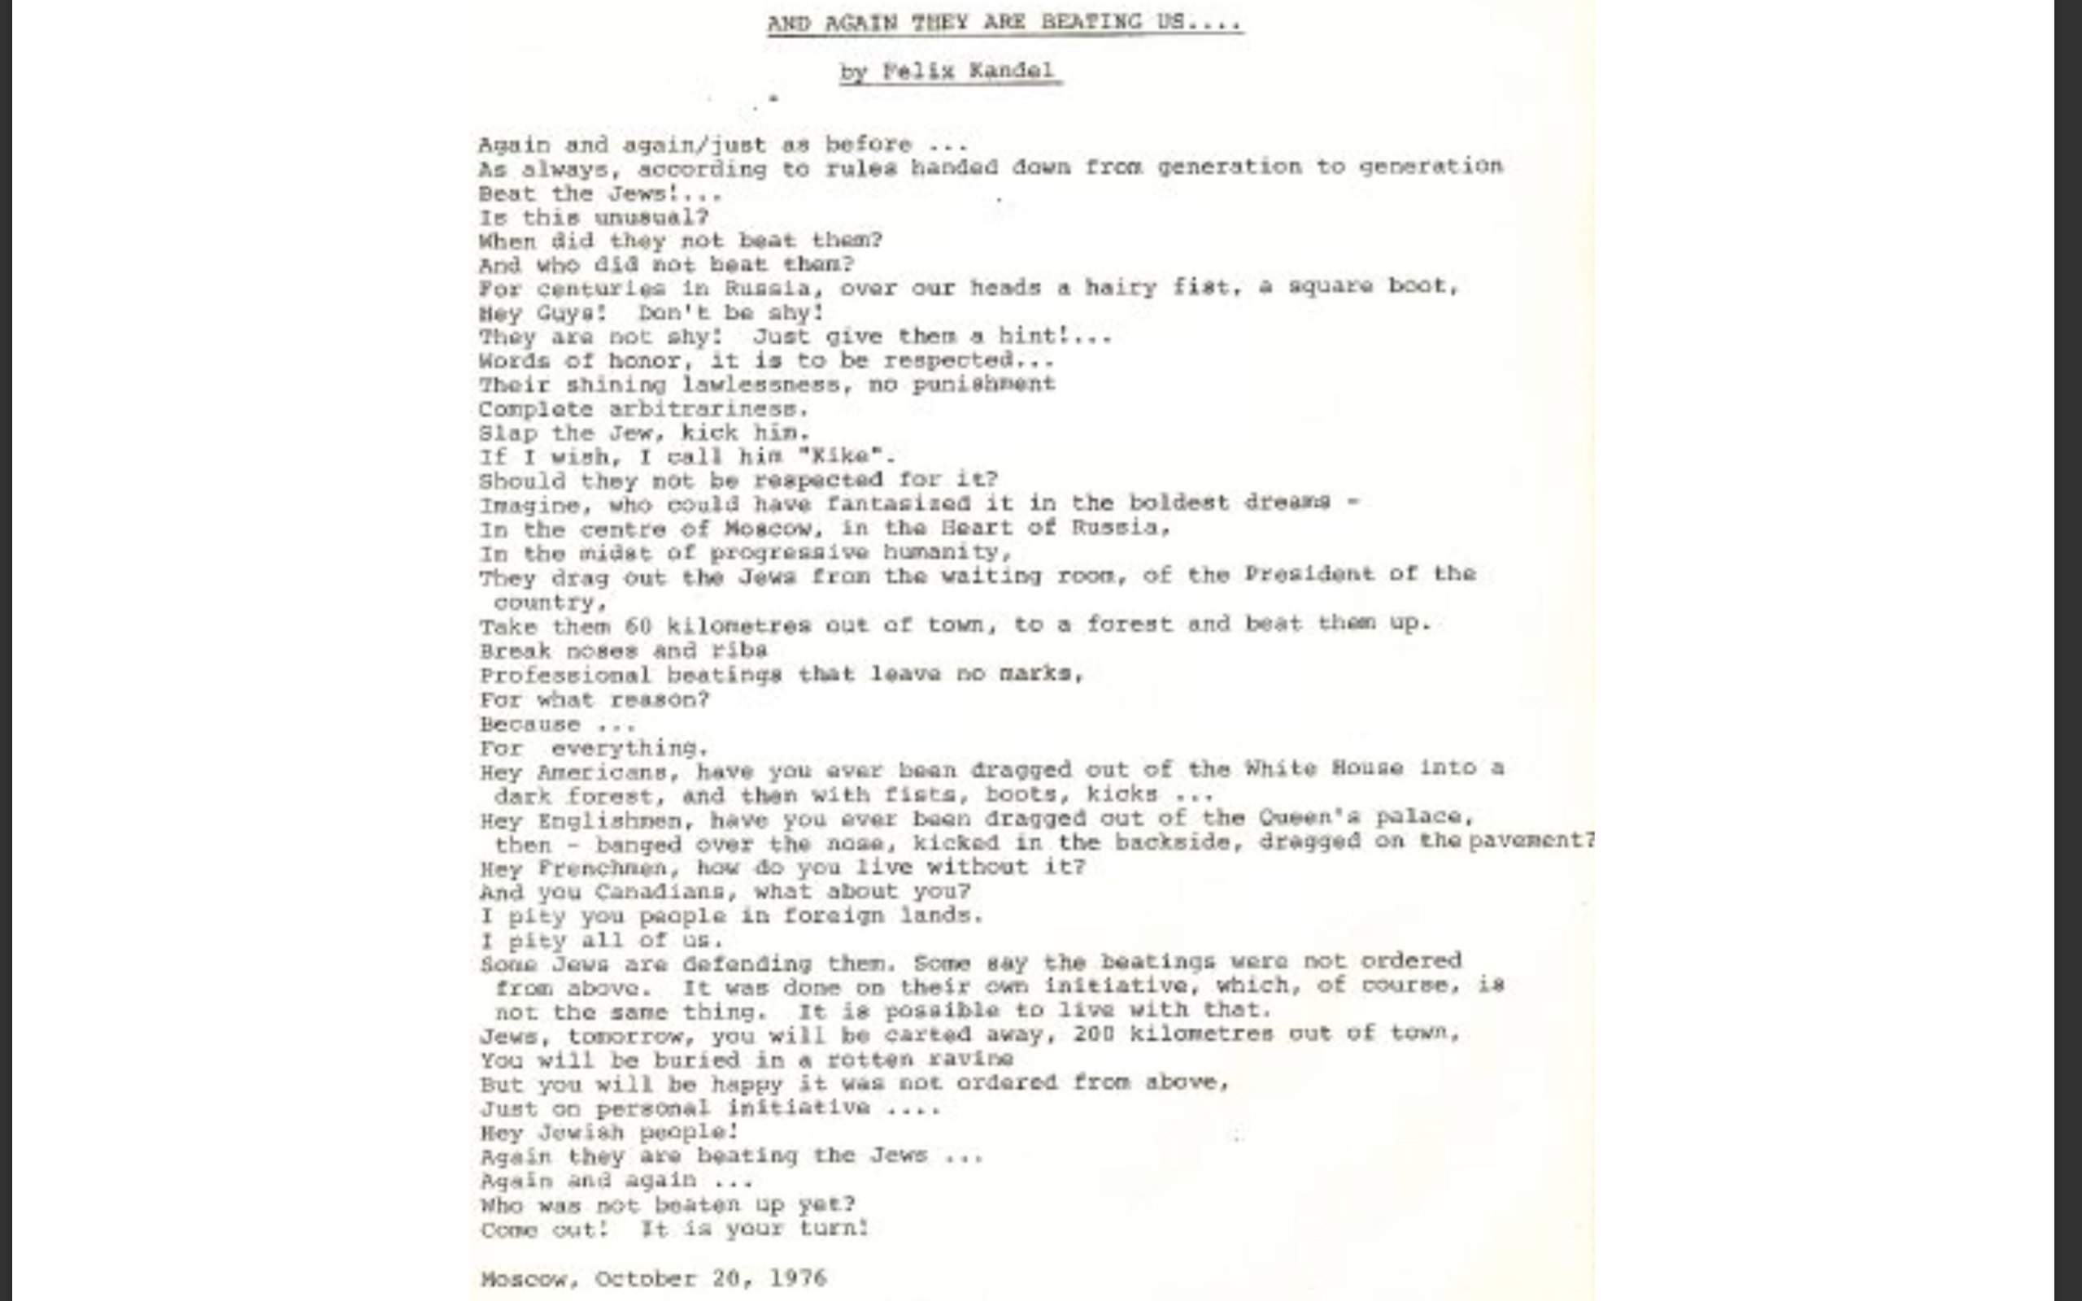
One of the striking features of the poem that students pointed out was the date on which it was composed: 1976. As a reflection to the whole movement, this poem was meant to be striking. However, on a historical timeline, 1976 is really not that far from today. I then presented a powerpoint presentation, in which I mapped out a bit of Russia and its history. I included a map of Russia to show its vast territory and its 12 time zones. I pointed out the major cities of Moscow and St. Petersburg, along with cities that were further away. I used this as a basis to show the difficulty with which Jews had to create ‘under ground’ communities, and run from city to city just to learn how to speak Hebrew without being penalized by the government. A student raised their hand and expressed confusion as to why the Jews had to struggle so much in a state where they would expect to be protected. This student outlined: “Werent the Russian fighting against Hitler?” another student questioned “If the Russians hated the Jews so much, why didn’t they just let them leave? Why would they want a people they hate in their country anyway?” To answer that, I gave them an outline of the rise of Soviet power, and how key events, such as the annexation of Poland and the Baltic regions after the Holocaust impacted the number of Jews living in Russia. Moreover, I explained the political structure that made this possible. When the USSR started growing its power in 1922, the state was consolidating power; this meant the creation of political, economic and social institutions that inherently granted power to the government as opposed to the people. Particularly in the case of religion, state atheism was adopted, and was used as a ploy to promote the appearance of equality. Once the people placed trust in the state, the underlying oppressive roots of the system strengthened, manipulation grew, and identity began to fade. I continued this explanation in the next session I held, which was on April 24th.

Sofiya Rubenova
Sessions 3 &4

On April 24th, Rabbi Dave helped me gather an even bigger group of students, so much so that I divided my presentation into a morning and an afternoon session. Typically, during Wednesday mornings, I attend the Jewish Learning Fellowship in which I and a group of about 15 students learn about Jewish identity, history and what it means to be Jewish. I thought this would be the perfect platform to present my topic and engage a group of students that had some background understanding of the oppressive history of the Jews. I implemented a similar activity as before, except this time, I divided a large poster paper in 4 sections: “Home” “School” “Culture” “Hobbies”. These four quadrants gave students more room to write and encourage them to think deeper about what contributes to their identity or what their favorite activities are within those quadrants (Rabbi Dave has photos of these that he will be sending to me). What I found interesting was how applicable all of these quadrants were to the rights that were taken away from the Jews. It was incredible to the students and to myself, to visibly see up to 50 words (activities, hobbies, traditions etc) written on the paper – in a sense, it made the understanding of human rights violations a bit more tangible. One student in particular wrote under “Hobbies” that she enjoys going to the movies and to the theatre to watch plays. Coincidentally, I had a quote from Anna Vinogradova’s book “Religion and Nationality: The Transformation of Jewish Identity in the Soviet Union” The quote that I picked out stated: “One night in January, 1935, the curtain closed on the dark stage of the Bolshoi theater as Solomon Mikhoels and his Moscow State Yiddish theater finished a performance for a gala event. It was a night of optimism and triumph for the proponents of the new, revolutionary, Bolshevik-approved, Soviet Yiddish culture. Stalin himself led a standing ovation for Mikhoels.1 No one in that theater could have guessed that by 1949, Stalin would have murdered the actors in the troupe and Hitler would have murdered most of the Jews in the audience. “ I could how this resonated with the student, as every single one of them closed their eyes for a moment and took a deep breath. This was the same reaction I got from both the morning and the afternoon presentation I gave, which I hope sparked a better feeling of understanding (separate from the misinformation that a student had in my very first session). Next, I gave an explanation of the political and social structure of the Soviet Union, which ultimately allowed for the violation of human rights. What is unique in the case of the Soviet Union is that Jews were not just discriminated against in their daily lives; the political and social conditions made it impossible for their lives to even exist in a normal condition. For example, religious practice wasn’t just frowned upon, but key religious leaders in the community were killed, leaving temples and Jewish community organizations disorganized. Hebrew was banned as a language, which made it difficult for communication or a sense of attachment to a culture. This resonated with me personally, as my grandparents lived in the Soviet Union, and while I do not have Russian blood, my family speaks Russian because my grandparents were once forced to learn Russian in their school. Additionally, Jews were cut off from attaining proper education or entering into fields such as becoming professors. A common thread that students realized was that Jews were cut off from positions in which they could mobilize (such as large temple communities) or spread knowledge (professors, doctors). Moreover, economic conditions such as the prohibition of owning any property or working stable jobs put the Jewish people in vulnerable positions. The discussion of political, social and economic systems went on for quite a while, as students discussed and compared the African American experience in the United States, and that while slavery formerly ended, it has become institutionalized so much so that it still exists in modern forms today. Therefore, it allowed them to draw a clearer connection between the underlying causes that contributed/ served as a catalyst for this movement.

