EL 3: Social Media Analysis

Social media, specifically instagram is often blamed as the reason so many people are hiking on closed hikes these day. Social media can definitely advertise scenic location and make people want to find them. But perhaps even more important, social media normalizing hiking in closed areas, they remove the social stigma attached to trespassing. Both the advertising and the socializing effect of social media sites needs to be analyzed to understand the ways that digital public spaces of the internet can impact the real physical places in Hawaii. Because these technologies are new and rapidly changing, it is important to analyze them and then adapt to their impact in terms of land management.
Students are particularly well suited to this research because younger students are digital natives, and are familiar and comfortable using these social media platforms in their own lives. To conduct this research student can pick a instagram account, a blog, a youtube channel or a hashtag and then follow a specific protocol to examine the content. This analysis will examine and code the content for gender, age, and race of people in the images as well as examining the natural content. We will also explore the interaction, through comments and likes, that different images generate and what that interaction tells us about social media and itʻs relation to public spaces.

Our Central Research Questions are:
- Why are mountain hikes routinely closed while beaches are kept open?
- Why are liability laws so different for the beaches and the mountains?
- Why are more people are visiting the mountains now? What is changing culturally? Who is visiting trails more often now? (visitors vs residents, age, gender, etc)
- Why doesnʻt the state maintain its parks and trails? How can we better manage and maintain state trails?

Step 1: Pick an instagram account, youtube channel, blog, or hashtag about nature, hiking, or the beach in Hawaii. Try to find accounts that have a lot of followers. Do a little bit of background research on the author to see what you can find about them. Here is a short list of some possibilities but feel free to expand beyond this list.

Instagram | YouTube | Blogs
Unreal Hawaii  Brooklynhawaii  Threeifbysea  Chelseakauai  Randomrob  nolank808  Hawaiimagazine  ambermozo | NOT so good hikers  Tale of Sam  JZ Hawaii Hiking  Gabriel Traveler | Unreal Hawaii  Trail Blazer Hawaii  Island Trails  Exploration Hawaii  Morgan Hiking in Hawaii  Hiking Trails in Hawaii  DGCʻs Hawaii Hiking Tales
STEP 2: Analyze the social media account. We want to understand how nature in Hawaii is being depicted and the relationship between people and nature in these photos.

Instagram
Quantitative Analysis.
First, look at the last 30 instagram posts. This will insure an even sample size for each account.
How many depict the beach? How many depict the mountains?
How many have people of them have people in the photos? How many men? Women? Both? What ages are the people? race?

Qualitative Analysis
Is there a difference in the way that mountains and beaches are depicted? What is it?
Are the mountains depicted as more dangerous?
Is a specific gender associated with a specific environment? Are there more pictures of women on the beach and men in the mountains of vice versa?
What do these pictures communicate about these places? What kind of experiences are depicted?
How do these posts teach us to interact with and experience nature?
What do these photos teach us about Hawaii?

Social Interaction
What are the comments like for these posts?
What do people connect with?
What are the five most popular photos of the last 50 (include a copy of them)
Why are these the post popular?
Is there a discussion of danger, liability, access, or conservation in the comments?

Blogs/Youtube Channels
Examine the 10 most recent blog posts/5 most recent videos.
What kinds of activities or hikes are they describing? What kinds of experience is communicated? How many of them are illegal?
Do they describe the dangers of the activity?
Do they discuss conservation or access?
What is the purpose of these posts? What are they trying to communicate?
What do we learn about the mountains or beaches in Hawaii?
How do these posts teach us to interact with and experience nature?
Are they depicted differently?
What do these photos teach us about Hawaii?

Social Interaction
What are the comments like for these posts?
What do people connect with?
What is the most popular post of the last 10?
Why is this the post popular?
Is there a discussion of danger, liability, access, or conservation in the comments?

STEP 3: Write a 3-5 page (750-1300 words) paper that describes the social media account and the types of images it includes. Then analyze the social media account, keeping in mind our central research questions about how cultural ideas about mountains and beaches has changed over time, the differences between mountains and beaches, and the how social media has impacted these changes. Include some particularly meaningful images that help to illustrate your ideas.

GRADING AND RUBRIC
Description (5 pts)
Is there some background on the author?
Do you adequately describe the kinds of photos? Their purpose?
Analysis (10 pts)
Do you discuss the different representations of mountains and beaches?
Do you discuss the role of gender in the photos?
Do you discuss the experiences and interactions with nature depicted in the photos?
Is the social media account connected to the central research questions around access, danger, and liability of public space in Hawaii? Explain how.
Writing (5 pts)
Did your observations and analysis help to discuss our central research questions?
Was the writing clear, well-written, and sufficiently explained?

EXAMPLE of EL2: Social Media
By Christian Palmer

Instagram Account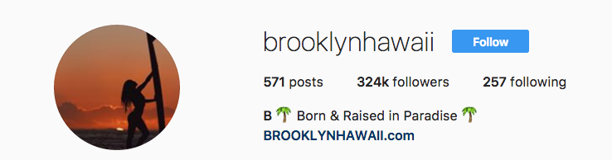
I am analysing the instagram account of brooklynhawaii. Based on information from her webpage, brooklynhawaii.com, she is photographer who does freelance photography and social media marketing based on the North Shore of Oahu. Her instagram has over 324k followers and her description is, “Born and Raised in Paradise.” Her account focuses on beautiful beaches, women in bikinis, and lifestyle photography around a surfing and beach lifestyle.
Of the last 30 photos, 16 included women and only 1 included a mixed group with men in it and they were far away. In a sense, the women are part of the beautiful beach scenery whereas men are not. Generally women are associated with nature whereas men are associated with culture, making women’s bodies as part of the beach scenery is a typical visual presentation in our culture. In most of these photos women are in bikinis and are turned away from the camera, highlighting their role as objects to be viewed. Only two of the women are looking directly at the camera and one of these is wearing sunglasses so we can’t be sure where she is looking. This seems to indicate that we are looking at the scene as an outsider looking in, not participating in it. The also means that the women aren’t really granted agency because we can’t see who they are as individuals. Several of the photos of herself are selfies but with the camera pointing down at her own body, emphasizing her body over her face. Many of this follows conventions of fashion photography that objectifies women by focusing on their bodies instead of their individuality (visible/expressed in their faces). However, in 13 of the 30 photos, women are surfing, swimming, or doing something active which makes them agents. In this sense there are elements of these photos which portray women as objects, like nature and the beach, to be seen and admired by others, and other elements in the photos which portray women as real people, alive and engaged in doing things. Grappling with these contradictions is essential to understanding the role of social media in generating specific kinds of relationships between people and nature.
Brooke is not white, similar to most people from Hawaii. Her models are similar racially diverse. Social media, by allowing people to gain exposure and followers outside of the traditional corporate media sphere, can open space for a more diverse media representations. This diversity of social media self representation can be seen as a democratization and opening up of the media landscape in positive ways allowing more women and more non-white participants.
The three photos which has significantly more like than the others (around 17-18k) includes a selfie of Brooklyn sitting on her surfboard in Indonesia with the camera getting her profile and body, another of her surfing with a group of friend at Waikiki from a similar angle, and a pulled back picture of her (maybe) floating on her back in the water with the Na Pali cliffs of Kauai in the background. All of these pictures depict beautiful people living a beautiful beach lifestyle which is the overall feel of her account. They are all include her, which possibly indicates that people who are following her are as interested in learning about her and her life as much as seeing her pictures of other models. Part of what she is advertising is her own life and experiences.
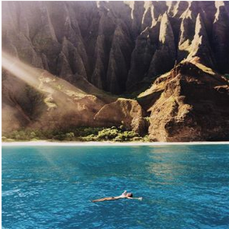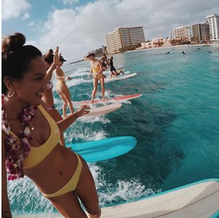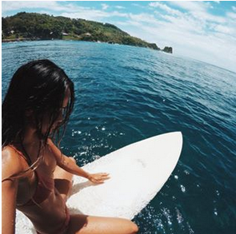
The comments on these photos, usually around a 100 for each photos corroborates this interpretation. Most of the comments are emojis, comments on the beautiful photography (“Wow, Amazing picture”), comments on the experience (“You are so lucky”), and aspirational comments that indicate that people want to participate in the experience themselves (“Oh my...I want to explore too!”,”On my bucket list”). These comments are mainly by women. This seems to indicate that while many of the images seem to follow conventions of fashion photography that objectify and sexualize women for male viewers, many of the viewers are women who identify with, idealize, and seek to emulate the lifestyle. While there may be male viewers, they are not commenting and interacting with the posts in the same way as the female viewers. Female viewers, on the other hand, could see this account as example of feminine freedom to travel, explore, and live a carefree live connected to nature. There is no discussion of the work of photography, travel, or marketing that make this life possible. This self-identification makes the role of social media influencers even more pronounced.
Finally, how is nature depicted in these pictures. 26 of the photos included the ocean and beach and only one included the ocean and mountains with Na Pali cliffs of Kauai in the background. The beach is portrayed as a site of relaxation, play, and leisure. There is no element of fear or danger associated with the beach. Even the images of surfing are all of surfing small, playful waves on longboards. Longboards, because they are more buoyant, are generally used to surf small waves and are sometimes stereotypically associated with women, beginners, or older surfers. Even the potentially adventurous activity of surfing is more focused around playful fun rather than adrenaline producing extreme adventure. The beach is a site of play and fun,
In this depiction the beach and its associations with unclothed female bodies is a site of sensual pleasure, relaxation, and play. Beaches, because of their association with the swimming and the water, but also vacationing and leisure, are some of the few sites where it is socially acceptable for men and women to wear less clothes. This makes beaches also associated with sexuality and a relaxation of social norms and practices. In some instances, beaches have become sites for counter-culture movements and youth culture like the development of surf culture in the 1960s. In this sense, the instagram accounts that celebrate the beach are rejecting certain elements of modern society, like 9-5 jobs that constrain your leisure time and ability to travel. They can also be seen as a rejection of gendered norms that limit women’s role to travel, especially by themselves.
In conclusion, Brooklyn instagram account illustrates a specific feminine relationship to the beach and what is represents that both challenges and reinforces dominant gender norms in our society. It reaffirms that women should have fit, tanned, beautiful bodies that are willing put on display through certain kinds of staged pictures. At the same time, women are the one that are driving this process through creating the photography, consuming the images, and living an ideal, free, and unconstrained lifestyle.

Word Count 1101

