Welcome!
Welcome to Padgett-Beale! We are excited to have you join us as a management intern and hope that your participation in our virtual / online program will be beneficial for both you and our company. This year, our management interns will have the opportunity to participate in Padgett-Beale’s pervasive cybersecurity initiative. This initiative is designed to help our employees and managers better understand and address the cybersecurity problems that our company is facing. These problems include a host of privacy related concerns, intellectual property protection issues, and the appropriate use of information technology resources. Since you are joining us as a management intern, you will also be participating in our internal training program: Cybersecurity for Leaders and Managers. During this eight- week program, you will have an opportunity to participate in a number of management and leadership activities and assessments related to cybersecurity.
As you move through this program, we hope that you and your peers will take advantage of the numerous communication channels made available to you via our internal Websites and discussion forums. We are truly interested in learning from you and hearing your thoughts on the management and leadership issues that you encounter during your time with us.
Finally, our goal is to help you find opportunities to take what you learn here and apply it to your future studies and career. We hope that you, in turn, will help us by providing feedback during and at the end of this program. Thank you for your participation and, again, Welcome!
Sincerely,
Edwina L. Beale
Edwina L. Beale Chief of Staff and Manager, Internship Programs

Padgett-Beale Organization Chart -- 2017
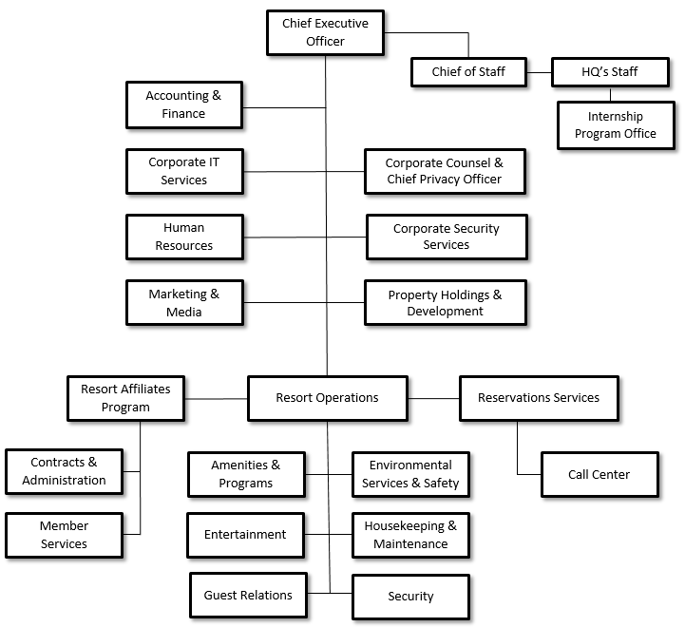
Figure 1. Padgett-Beale, Inc. Organization Chart

Company History
Elmer and Robenia Padgett’s first hotel, Robenia’s Guest House, opened in 1925 with six family suites (two per floor), a tea room, and a formal dining room. The guest house primarily served wealthy families who relocated to the seashore for the summer to escape the heat in New York City. This property provided amenities and services matching those of rival long- stay hotels in major cities along the East Coast. The second and third properties, Padgett’s Hotel and Padgett’s Beach House, were acquired in 1935. Flintom’s Tavern, a landmark restaurant and entertainment venue, was added to the Padgett properties portfolio in 1940.
Periodic resurgences in popularity of the seashore as a vacation destination occurred over the next fifty years (1940-1990) as bridges were built, roads were improved, and regional economies strengthened. These resurgences brought additional competition as new motels and resorts operated by national chains entered the seashore vacations market. Major weather events in the 1970’s resulted in damage to both Padgett’s Beach House and Flintom’s Tavern causing both to close for an extended period of renovations. The Padgett family’s brand remained strong, despite these setbacks, as members of the family took a personal interest in the day-to-day operations and management of the company.
Padgett’s was not an early adopter of computers and information technology. But, over time and as younger family members entered the business, computers began a slow march into the company’s offices in the form of personal computers with word processing, spreadsheets, and database systems. Personal computers also made their way into manager’s offices in the hotel properties where spreadsheets proved valuable in tracking revenues and expenses. In 1982, an embezzlement scandal at Flintom’s Tavern forced the company to adopt computer-based point of sale (POS) systems throughout the company for all cash handling functions (hotel front desks and restaurants). A benefit of the POS systems were the built-in reporting functions, which enabled the company to more closely track cash and credit sales by property. By 1995, the company had fully integrated custom hotel management software into its operations. This software and the associated databases were hosted on company owned / operated mainframe computer systems. By the end of the decade, information technologies were in use to support all aspects of the company’s internal operations (accounting, customer service, property management, and reservations).
At the beginning of the new century, the company adopted its first strategic plan with a heavy emphasis upon growth and expansion. Under this plan, the company branched out and began offering hotel and resort management services to other hoteliers and property owners. Advanced telephony services and implementation of custom software allowed Padgett’s to offer one of the first centralized reservations management services. The company also leveraged the Internet and World Wide Web to launch a resort affiliates program, which provided a menu of business related services to member properties. These services included: online advertising and promotions, architecture and design assistance, business operations consulting, group business insurance, and guest loyalty programs. The hotel and resort management services business area continues to be the major source of revenues and profits for the company and its owners.
As part of Padgett’s expansion plan, the company purchased Beale Realty Holdings in 2001 and formed Padgett-Beale, Inc. (PBI). Shortly thereafter, PBI embarked on a series of real- estate acquisition activities, which led to the purchase of several large tracts of prime Eastern Shore waterfront property. The company’s long-term plan was to hold the properties as real estate investments and, when market demand rose sufficiently, expand into development, sales, and management of condominiums and vacation time-share properties. The focus on long term investment was a wise choice as this particular market segment was adversely impacted by the housing boom/bust in the mid 2000’s.
At the time of purchase, the waterfront properties were in use as campgrounds and resorts for tent-campers, travel-trailers, and motorhomes. These camping facilities were allowed to continue their existing operations with minimal investment and oversight for the next 15 years (2002 – 2017). During this laissez-faire management period, some campground managers modernized their camp offices and stores by purchasing computer-based point of sale systems that allowed them to accept credit and debit cards. Most of these managers also outsourced their reservations management to a third party online reservations system, which provided a customized website to advertise each park and provide access to the online reservations system. A few campgrounds did not modernize beyond setting up a simple website with contact information and a few photographs. These facilities continue to use a mail or telephone-based reservation process with a “cash only” payment policy.
In 2015, the day-to-day operations and management of PBI was transitioned to a new leadership team recruited from leading hotel and resort management companies. The new leadership team includes the Chief Executive Officer, Chief Financial Officer, Chief Operating Officer / Director for Resort Operations, and the Corporate Counsel (attorney) who is also dual-hatted as the Chief Privacy Officer. Under this new leadership, the company was reorganized to better focus on the three most profitable business areas: Resort Operations, Reservations Services, and Resort Affiliates. Management and daily operations for the three company owned hotel properties (Robenia’s Guest House, Padgett’s Hotel, and Padgett’s Beach House), Flintom’s Tavern, and the campgrounds / trailer parks were transferred to the newly formed Property Holdings and Development division.
Building a strong management and leadership team is a priority for both the new CEO and the current chair of the PBI Board of Directors. In 2017, these two leaders developed and launched a management internship program whose participants were recruited from a select group of colleges and universities. The next class of management interns has just started in program and will soon find out where their first assignment will take them within the company.
Industry Overview
Padgett-Beale, Inc. (PBI) operates in the Hotels, Motels, & Resorts industry (NAICS Codes 721110 and SIC Codes 7011) (First Research, 2017a). Hotels, motels, and resorts provide short-term housing and lodging for travelers and visitors. Related services offered by companies in this industry include: catering and meals, conferences and event hosting, entertainment, resort amenities (golf, swimming, spa, etc.), etc. The company also operates in the Recreational Vehicle Parks industry (NAICS Codes 721211; SIC Codes 7033) as both an owner/operator and as a management and operations partner providing specialty services to member and affiliate RV parks.

Hotels, Motels, and Resorts
Leading firms in this industry include Marriott International, Inc., Hilton Worldwide Holdings, Inc., and Starwood Hotels & Resorts Worldwide, LLC (First Research, 2017a). On an annual basis, this global industry generates over $500 billion in revenue. The U.S. segment of this industry generates approximately $175 billion in revenues each year. These revenues may be generated directly from operation and management of company owned properties. Or, revenues may be generated through franchising arrangements or through fees generated in conjunction with property management / hotel operations services provided to other property owners.
Demand for products and services in this industry is driven by two primary factors: (a) business travel and (b) vacation or tourist travel (First Research, 2017a). Both of these factors are highly sensitive to the health of regional, national, and global economies. Financial analysts estimate that 75% of industry revenues result from fees for overnight lodging. The remaining 25% of revenues result from sales of related products and services (e.g. meals, beverages, etc.). Labor is the most significant source of expenses.
This industry uses information technology and the Internet in a variety of ways. First, most brands use the Internet and social media to support their marketing efforts. Second, all but the smallest of properties / brands use information technologies and the Internet to support reservation call center operations. Third, information technologies are used in the daily operations of facilities (front and back of house) and in support of corporate business processes and functions. These technologies include Point of Sale systems for handling customer financial transactions, housekeeping and maintenance management systems, card key access systems for guest rooms and restricted areas, scheduling and timekeeping systems for personnel, and building / facilities management systems that control and monitor energy using systems such as lighting and heating/ventilation/cooling (HVAC) systems. Information technologies are also used to provide physical security in such forms as video surveillance and recording, access controls for equipment and control zones (key pads, badge readers, password controlled logins), and automated access logs which record identity information along with timestamped entry/exit for controlled zones.

Recreational Vehicle Parks
Leading firms in this industry include Thousand Trails (owned by Equity LifeStyle Properties), and Kampgrounds of America (KOA) (First Research, 2017b). Each of these companies has a slightly different business model. Thousand Trails is an owner/operator for RV Parks (First Research, 2017b). KOA sells franchises to owner/operators of privately owned RV Parks and provides brand related services such as marketing, park design and management consulting, and reservations management. A third company, Good Sam Enterprises, markets and sells RV travel related services to individual travelers (“members”) and provides marketing and sales support to member parks (Good Sam Club, 2017). All three firms provide online guidebooks (some with reviews, inspection reports, and ratings), which include information about individual parks and their amenities. In addition to these three firms, there are thousands of smaller owner/operators of RV parks in the United States. These RV parks range in size from 10 – 100 acres with a capacity of 150 to 2,000 or more RV, tent, and rental cabin sites.
Demand for products and services in this industry is driven by vacation or tourist travel (First Research, 2017). Sales and revenues are highly seasonal as preferred destinations change with the weather and with the usual and customary vacation periods (summer, holidays, school breaks, etc.). Rental fees for overnight stays are the largest source of revenues for individual RV Parks. Additional revenue sources include: camp store and gift shop operations, restaurants and snack bars, fuel sales (propane), and sales of RV parts and accessories. Major areas of expenses are: utilities (water, electric, sewer, cable TV, and Internet service), park maintenance (including roads and buildings), vehicles, property taxes, and operating expenses for amenities such as laundry facilities, bath houses, swimming pools, playgrounds, etc. Insurance coverage for park operations is also a major area of expense and may include additional coverage for cybersecurity liability (Philadelphia Consolidated Holding Company, 2017).
This industry uses information technology and the Internet in a variety of ways. First, many RV parks maintain a Website to advertise the park (First Research, 2017b). They may also use social media to attract visitors to their Website and to the RV park. They may also depend upon Websites operated by third parties such as RV Park Reviews, Trip Advisor, and Good Sam Club to attract the attention of individuals who are planning trips or vacations. Second, all but the smallest of properties use an online reservation management system that allows travelers to search for available sites by date(s) and by required or desired amenities (electric, water, sewer, cable, pet friendly, etc.). Larger operators and networks of parks may also use a telephone call centers for reservations management. These call centers depend upon computer applications to route and manage calls. Reservation management systems also depend upon databases and database servers to store and process customer information. Third, information technologies are used in the daily operations of some facilities. Such uses include guest check-in/check-out, cash and credit card transaction management (payments & refunds), maintenance records, camp store / gift-shop inventory and sales, and bookkeeping / reporting (revenue tracking). Some RV parks also use computer-based systems for video and audio surveillance, automated vehicle entry/exit, and energy usage monitoring.

