Sources:

Why some K-12 schools (or organizations) choose to encourage and/or produce high quality online classes (trainings) for their students (or employees) and why some K-12 schools (or organizations) do NOT choose to encourage and/or produce high quality online classes (trainings) for their students (employees).
Https://spencerauthor.com/ten-reasons-new-teachers-arent-using/
why so many new teachers are so resistant to using the current available technology:
1. They are worried about classroom management.
2. They view it as a consumer device. view technology as shallow and addicting.
3. They believe technology is unreliable.
4. They tend to teach the way they were taught. There is a comfortable, “it worked for me” element, that dominates lesson planning.
5. They’ve experienced bad technology integration.
6. Techies have done a bad job admitting what isn’t working.
7. We need to change assessment practices.
8. Schools reward compliance.
9. They still don’t have access.
10.They aren’t connected.

https://trainingindustry.com/articles/content-development/4-reasons-not-to-start-training-online/

1. The skills are not relevant on a strategic level.
2. There are no verifiable training goals.
3. Training is voluntary
Making online training compulsory may sound childish. However, e-learning often comes with meager participation. On the day of an in-person course, everyone is present. The flexibility and relative newness of online training are both an advantage and a disadvantage.
4. Learners are unmotivated.

https://edly.io/blog/how-to-motivate-learners-in-an-online-learning-environment/
Why some K-12 schools (or organizations) choose to encourage and/or produce high quality online classes (trainings) for their students (or employees) and why some K-12 schools (or organizations) do NOT choose to encourage and/or produce high quality online classes (trainings) for their students (employees).
Https://spencerauthor.com/ten-reasons-new-teachers-arent-using/
why so many new teachers are so resistant to using the current available technology:
1. They are worried about classroom management.
2. They view it as a consumer device. view technology as shallow and addicting.
3. They believe technology is unreliable.
4. They tend to teach the way they were taught. There is a comfortable, “it worked for me” element, that dominates lesson planning.
5. They’ve experienced bad technology integration.
6. Techies have done a bad job admitting what isn’t working.
7. We need to change assessment practices.
8. Schools reward compliance.
9. They still don’t have access.
10.They aren’t connected.

https://trainingindustry.com/articles/content-development/4-reasons-not-to-start-training-online/

1. The skills are not relevant on a strategic level.
2. There are no verifiable training goals.
3. Training is voluntary
Making online training compulsory may sound childish. However, e-learning often comes with meager participation. On the day of an in-person course, everyone is present. The flexibility and relative newness of online training are both an advantage and a disadvantage.
4. Learners are unmotivated.

https://edly.io/blog/how-to-motivate-learners-in-an-online-learning-environment/

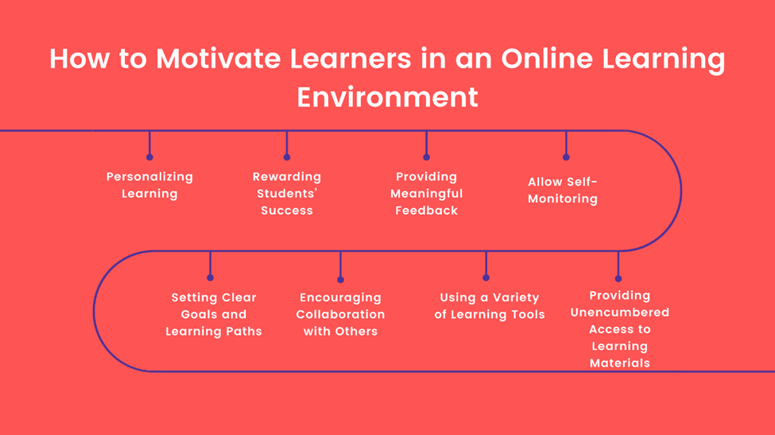

https://www.teachaway.com/blog/increase-engagement-in-online-classroom

Here are the 8 best tips that will help you learn how to make lessons fun and engaging in an online classroom:
1. Present your best (online) self
2. Use technology to your advantage
3. Find what inspires your students
4. Set goals and help students stick to them
5. Keep it interactive
6. Break down the lessons and make it digestible
7. Make your students feel valued
8. Be patient with your students

https://www.teachaway.com/blog/increase-engagement-in-online-classroom

Here are the 8 best tips that will help you learn how to make lessons fun and engaging in an online classroom:
1. Present your best (online) self
2. Use technology to your advantage
3. Find what inspires your students
4. Set goals and help students stick to them
5. Keep it interactive
6. Break down the lessons and make it digestible
7. Make your students feel valued
8. Be patient with your students

