Assignment task
Analyse the implementation of organisational change in a case study of your choice using either “conversational” or a “contextual” conceptual framework. Then, critically reflect on (a) the strengths and weaknesses of your analysis, (b) your own experience/s of organisational change, (c) and how your learning on the module will inform your future practice.

Analysing organisational change (2,000 words)
Analyse the implementation of organisational change in a case study of your choice using either a “conversational” or a “contextual” conceptual framework. To do this, you must critically evaluate both the organisational change and the academic ideas (e.g. theories, models, and frameworks) used in your analysis.
- “conversational” conceptual framework – engaging with ongoing organisational interactions – recognising how managing organisational change might need a sense of direction – academic ideas around resistance, communication, and leadership
- “contextual” conceptual framework – acknowledging an organisation’s unique situation – recognising how managing organisational change might need a firm grasp of the detail – academic ideas around culture, substance, and politics
- relevant to both frameworks: sensemaking, and emotional responses to organisational change

Reflecting on its implications (1,000 words)
Reflect on the implications of your analysis by responding to three questions.
- What are the strengths and weakness of your analysis (including how a different conceptual framework might have given a different understanding)?
- How has your analysis enabled you to reflect on your own experiences of organisational change?
- How has your learning about organisational change given you new ways to think about your future practice?
Key to successful reflection:
- demonstrate personal learning (e.g. by reflecting on analysis, experience/s, and future practice)
- build on academic ideas (e.g. theories, models, and frameworks) and use relevant literature

Structure of assignment
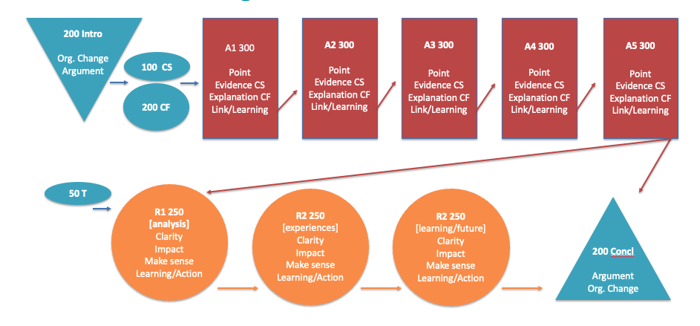
First half:

First blue triangle (200 words): need to introduce what I need to do for the whole article, just a general explanation, whether I want to do a contextual frame or a dialogue frame, and which case study to do．

Blue circle (100 words): a very short discussion of the chosen article．

Blue Circle (200 words): Explain for this article why you chose contextual or conversational．

Red squares (five total, 300 words each): You have to find 12345 examples of what you are going to do, or the five points you are going to make about the chosen case study． (Not questions that answer the article)

Bottom half:

Blue circles (50 words): a simple little transition paragraph that then moves to the reflective part of the essay.

Yellow circle 1 (250 words): In this section talk about your analysis first, explaining the choice of a conversational approach or the use of a contextual approach. Either a contextual approach or a conversational approach can be used to explain what happened in the case study.

Yellow circle 2 (250 words): Then comes experience, in this section need to discuss about combining your own experience with the essay, experience circle is to talk about your own experience of change, whether in a club or an organization, or your work. How well does it fit with the theory? Was the theory actually confirmed, or was it completely different from what you expected?

Yellow Circle 3 (250 words): Finally, how do you plan to use these learnings and the future? So when you consider when you enter the world of work, if you are faced with a change, what would you do differently based on what you have learned from analyzing this case study?

Blue Triangle (200 words): Make a conclusion

