https://www.sciencedirect.com/science/article/abs/pii/S0168900205022679
- inspired by simple model of how the brain works in nature:
  - a neuron”fires” if the stimuli received from other neurons exceed a certain threshold
  - described by:
    - g(t) is a sigmoid
      - 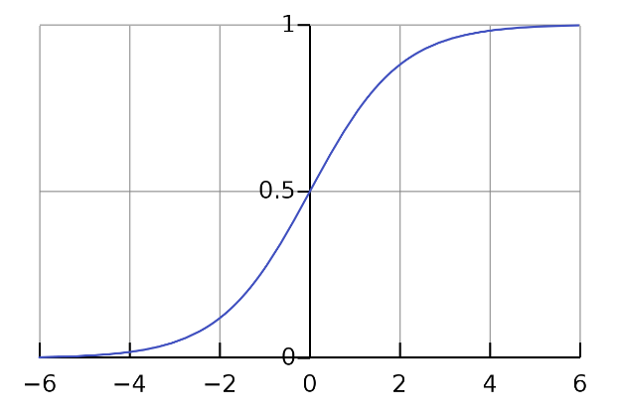
      - ^sigmoid
    - determines the threshold
    - node j in layer n is given by the weighted sum of all nodes in layer n-1
    - network training is minimising a loss function by adjusint the weights such that the deviation of the actual network output from the desired output is minimized
    - popular loss functions: sum of quadratic deviations or a measure of the entropy
  - do not require that all input variables are filled for eachevent
  - able to learn correlations between the input variables
  - can incorporate information from quality variables
https://machinelearningmastery.com/neural-networks-crash-course/
- Multi-Layer Perceptrons
  - perceptron=single neuron model that was a precursor to larger neural networks
  - simple models of biological brains can be used to solve difficult computalional tasks ie machine learning
  - learn the representation in training data and how to best relate it to the output variable you want to predict
    - neural networks learn mapping
- neurons
  - 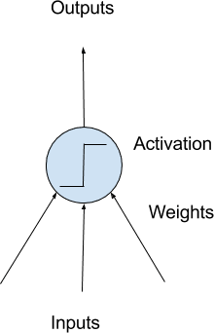
  - have weighted input signals and produce an output signal using an activation function
- neuron weights
  - each neuron has a bias, thought of as an input that always has a value of 1.0 and must be weighted
  - 2 input=3 weights
    - one for each input and one for the bias
  - weights often intialized to small random values (such as values from range 0 to 0.3)
  - larger weights indicate increased complexity and fragility
- activation
  - weighted inputs summed and passed through an activation function (sometimes called a transfer function)
  - activation function
    - mapping of summed weighted input to the output of the neuron
    - governs the threshold at which the neuron is activated and strength of the output signal
  - non-linear functions called the sigmoid function used that output a value between 0 and 1 with a s-shaped distribution
- network of neurons
  - neurons arranged in network
  - row of neurons=layer
  - network can have multiple layers
  - architecture of the neurons called the network topology
  - 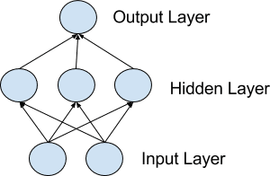
- input or visible layers
  - bottom layer that takes the input from the data set
  - exposed part of the netowork
  - pass the input value through to the next layer
- hidden layers
  - not directly exposed to the input
- output layer
  - ouput a value or vector of values
  - choice of activation function in the output layer is constrained by the type of problem being modeled
    - “A binary classification problem may have a single output neuron and use a sigmoid activation function to output a value between 0 and 1 to represent the probability of predicting a value for the class 1. This can be turned into a crisp class value by using a threshold of 0.5 and snap values less than the threshold to 0 otherwise to 1.”

https://www.sciencedirect.com/topics/computer-science/multilayer-perceptron
multilayer perceptron
- supplement of feed forward neural network
- 3 types of layers:
  - input layer, output layer, hidden layer
- input layer recieves the input signal
- prediction and classification performed by the output layer
- arbitrary number of hidden layers are placed between the input and output layer
- neurons trained with the back propagation learning algorithm
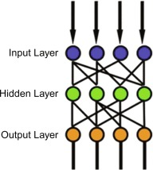
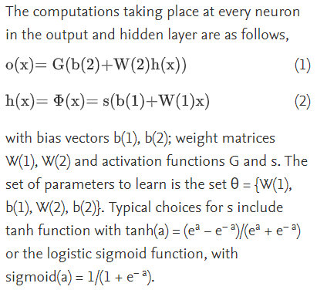
https://deepai.org/machine-learning-glossary-and-terms/backpropagation
backpropagation
- backward propagation of errors
- calculating derivatives inside deep feedforward neural networks
- calculate the gradient of the loss function with respect to each of the weights of the network
- enables every weight to be updated individually to gradually reduce the loss function
- calculation of the gradient proceeding backwards through the feedforward network from the last layer through to the first
- to calculate the gradient of a layer, the gradients of all following layers are combined via the chain rule (of calculus)
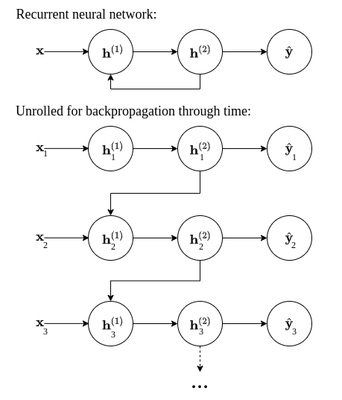

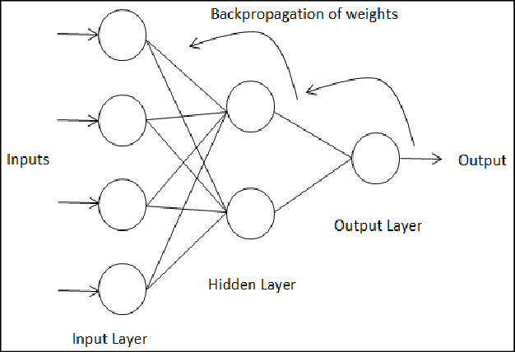

https://deepai.org/machine-learning-glossary-and-terms/hidden-layer-machine-learning#:~:text=Hidden%20layers%2C%20simply%20put%2C%20are,specific%20to%20an%20intended%20result.&text=Hidden%20layers%20allow%20for%20the,to%20produce%20a%20defined%20output.
hidden layer
- provides nonlinear transofmrations of the inputs entered into the network
- vary depending on the function of the neural network
- vary depending on their associated weights
- layers of mathematical functions each designed to produce an output specific to an intended result
- allow for the function of a neural network to be broken down into specifc transformation of the data

videos
- ANNS capable of learning
  - use experience to improve performance
- neurons connected by weighted links passing signals from one neuron to another
- each neuron recieves a number of input signals through its connections, only produces a single output signal

