Unit 1: An Introduction to Religion
On the surface, the world’s religions may appear alike, especially those systems practicing syncretism—a mixture of faiths, but you will learn that religions and spiritualties are both extremely varied and uniquely beautiful. When applicable, you will learn about each religion’s deity distinction, major concepts, holy texts and tenets, and rituals and festivals. You will see these topics presented in almost every unit because the world religions share these commonalities. But, as you will discover, many differences emerge amongst these groups. In this course, you will learn many aspects of several different families of faith:
- Indigenous Religions: African, American, and Australian beliefs.
- East Asian Religions: Taoism/Daoism and Confucianism and Shinto.
- Abrahamic Religions: Judaism, Christianity, and Islam.
- Yogic Religions: Hinduism and Buddhism.
The graph in Figure 1 depicts the impact of religion in the world and how many people believe and/or at some level practice their faiths.
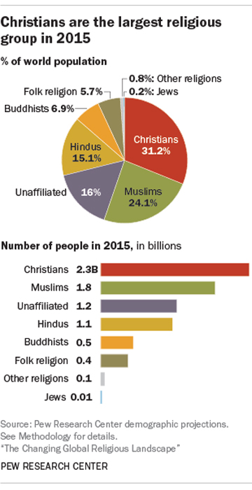Fig. 1: The Changing Global Religious Landscape (Pew Research Center) (2015)
Through reading religious texts (full texts and excerpts), watching documentaries, viewing TED Talks, writing essays, and participating in weekly discussions, you will navigate the world of religion and gain a better understanding of specific faith systems and their relationship with each other.
When approaching the course content and constructing discussion posts, use a respectful tone. When it comes to religion, you must be mindful that you will most likely encounter people who do not believe the same things as you. You will not be debating, though; rather, this course will broaden your worldview, inform your artistic practice, and teach you critical thinking skills through investigation of the human experience.

1. Defining Religion and Other Key Terms
For centuries religion has shaped lives, cultures, and laws. Religion can take many forms, but overall the term is defined as the belief and act of worship of a deity or deities or sharing a relational bond with God, gods, goddesses, a higher power, or an ultimate reality. There are different belief systems surrounding religion, as defined below.
- Monotheism: Belief in one god.
- Polytheism: Belief in more than one god.
- Pantheism: God and the universe are one.
- Atheism: Disbelief in a god or gods.
- Agnosticism: Belief in the existence of God or gods is unknowable.
In addition, the word religion can also refer to a community of believers sharing the same belief system, doctrines, holy scripture, and tenets.
There is a difference between the act of religion and the practice of spirituality. Spirituality focuses on the individual’s spirit and/or soul and how that person uniquely approaches the concept of deity or ultimate reality and the practices that emerge from that personal philosophy.
While the concepts of religion and spirituality are related and certain elements may overlap—as depicted in Figure 2—they are each distinct:
- Religion is communal (we): The community decides upon definitive truths, rituals, and doctrines.
- Spirituality is individual (I): How do I connect?
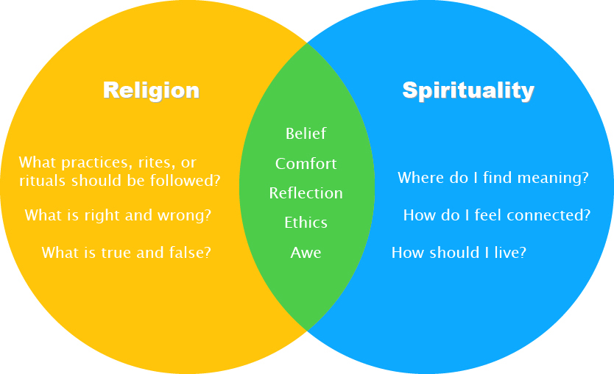Fig. 2: Religion and Spirituality: Similarities and Differences
Both religion and spirituality are rooted in what is called the numen, an undefined presence that inspires reverence (deep respect) and awe (feelings of wonder, admiration, fear, and/or respect produced from something that is powerful, sublime, or grand). In Clara Sarrocco’s article, “Surprised by Awe,” which you will be reading, the numen is defined as “the object of religious search.”[1] Individuals search for the numen to have an experience in which they feel reverence and awe, one that allows them to recognizie how truly small they are compared to the universe. This experience is referred to as numinous because the presence you’re looking for is existing, communicating with you, inspiring you, etc.
The numen is a spiritual experience rooted in feelings, whereas a theophany is when a god(s) appears to a human. Seeing a god or gods can be an event involving one or more individuals. For example, a theophany would be Krishna appearing to a Hindu or Jesus Christ appearing to a group of Christians.
Whether or not an individual has a numinous experience or a theophany, the individual can still have faith. Faith is an acceptance of something (deity or deities, doctrine, human religious commitment) as true—with or without evidence.
Another expression of religion is a miracle. Miracles are significantly religious, deity-connected, defy natural law, and exceed human expectation and control. Natural law is defined as the unchanging principles and laws related to natural phenomena. What you learn in biology, geology, physics, geometry, etc. all deal with natural law. For example, death is the permanent end to someone’s biological functions, and death is accepted as natural law. Christians believe that Jesus Christ was resurrected from the dead, and this act would be considered a miracle because it defies natural law. Similarly, the Jewish religion recognizes that their god Yahweh parted the Red Sea so that the Israelites could cross dry ground and escape the Egyptian pharaoh. This complete exertion of control over the ocean defies natural law as well.
Some categories of miracles include:
- Material Miracles: Substance creation, multiplication, or transformation; bilocation; supernatural signs.
- Biological Miracles: Healing; raising the dead; extraordinary childbirth.
- Mental Miracles: Supernatural perception; apparition; telepathy; clairvoyance; retro- and precognition; exorcism.

2. The Importance of Studying Religions
As you just read, religions vary immensely—from person to person, group to group, and even among people who practice the same religion. There is no one-way, one-size fits all approach to religion.
A great deal of knowledge and enlightenment can be gained from studying religions, and within an academic context, there are many benefits, as outlined below.
- Learning about religion will inform your artistic practice. World religions have inspired artists since the dawn of civilization. As scholar-artists, you will observe the beauty of religion in this course. Used ethically and appropriately—laws exist in some countries regarding this issue—some aspects can be richly incorporated into your artistic projects.
- Studying world religions will add to the breadth and depth of your liberal arts education. A course like this one is situated within the humanities, a field of study devoted to teaching critical thinking skills through investigation of the human experience. If you can think and write critically, you will be more comfortable approaching a subject like religion with other people.
- With regard to others, learning about world religions will help you learn about different types of people. SCAD, in particular, serves a global student population, and a course such as this will help you make meaningful connections with your peers. You can gain insight into their lives and faith practices, thus opening opportunities for meaningful, civil discourse.

3. Indigenous Religion in Africa

Deity Distinction
The formation of religion begins with experience. Indigenous religions, also known as traditional or primal religions, are rooted in a supernatural experience with deities, spirits, ancestors, and nature. Although many tribal peoples worship numerous spirits, deities, and ancestors, there exists a distinct, supreme spirit above all others. This Great Spirit (known by various names) can be male, female, or genderless. The Great Mother, for example, represents the giver of all life; for this reason, many tribal communities remain matriarchal as opposed to patriarchal. The Mother spirit can represent birth, goddess, and/or earth.
Worship of deities and ancestors varies from group to group and depends upon the region and historical familial community. A crucial truth in one group may not be the same in another group. So, even though you will encounter similarities between groups—for example, the Great Mother deity—not all of these groups will worship her in the exact same way(s).

Major Concepts
Many indigenous groups around the globe use the circle as a symbol for understanding life. For these groups, time is cyclical, meaning that time is not divided into beginning and end. Just like time, human life (birth, maturation into adulthood, death, postdeath), seasons, and celestial movements of planets are all cyclical phenomena. A relationship with these cycles and spirits helps keep balance in the universe.
Most indigenous religions understand they are the stewards of the world around them because their world is the Great Mother. This type of caretaking implies a close relationship between people and Mother Earth. In a familial context, all things—animate (humans, animals) and inanimate (rocks, waterfalls)—are considered part of the same family.
This kind of kinship helps to define animism, a belief that all things are animated or possess a spirit. Animism requires the believer to maintain a respectful relationship with all beings, as these spirits are always working in the world in both negative and positive ways. Animism is to believe that all things are alive and indwelled with a spirit.
Engaging with God or spirits in a meaningful and impactful way is defined as a primal experience and occurs when a person is connecting with one or more deities or connecting with other higher or past spirits. This primal experience usually creates a life-altering experience such as going from nonbelief to belief or gaining clarity or discernment.
Aspects of relationship with the spirit world include ancestor worship, attention to natural creation or the cosmos, and animism. Again, while there are strands of similarities, indigenous communities tend to follow their own individual rituals, practices, and ancestor worship.
Ancestors serve as integral parts of indigenous religions. The dead are viewed like community caretakers; they are not feared as evil forces, as might be in the case with some religions. Because of their postdeath roles in the community, ancestors are not to be forgotten; if they are, these relatives can disrupt the society in a variety of ways, including causing illness or death to an individual or afflicting an entire community. For this reason, the role of the shaman and medicine people as mediators is crucial to the survival and well-being of the community—these mystical intermediaries need to know how to communicate with the ancestors for the community to remain at peace.
A shaman (also known by other names, depending on the group) mediates between humans and the spirit world. His or her function in the supernatural relationship is to serve the needs of the community such as harvests, hunts, and healings. A shaman is either born into the societal role or, if the individual’s gifts are recognized, may be chosen for the sacred role.
A medicine person possesses special healing talents and skills. These practitioners work with the health of the entire person: physical, psychological, and spiritual. Traditional healers employ a variety of techniques—from herbs and massage to ceremony and divination—in order to connect with the spirits and heal the afflicted individual.
These mystical intermediaries possess skills to access different realities and move between spiritual realms. Spirits can enter and enliven these intercessors, causing states of spiritual ecstasy as well as deathlike trances. The end goal is to ultimately serve the community.

Sacred Rituals and Festivals
Indigenous or aboriginal rituals and ceremonial events encompass an extremely large scope because many groups do not adhere to the same practices. This course will specifically focus on three groups: Fon, Yoruba, and Zulu.

Fon
The Fon people of West Africa believe in Mawu (also spelled Mahu), a female divine creator. Her twin Lisa (a male) represents the sun, while Mawu represents the moon. Though there is no permanent site of worship, the Fon people pray to Mawu/Lisa.
Because this is a matriarchal religion, a Queen Mother presides over all communal ceremonial events, such as marriages and funerals.
The Fon practice vodun (spirit), more commonly known as vodou or voodoo in other parts of the world. Some better-known ritualist objects used for healing and spiritual growth are spirit-inhabited objects or talismans (known as fetishes) comprised of animal or human parts (Figure 3).
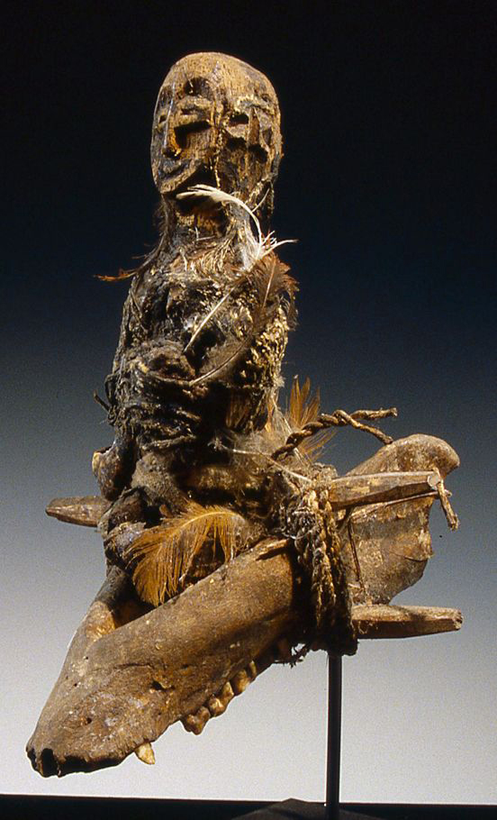Fig. 3: Talisman Amulet Seal Juju Medicine Naija Jaz (Babalawo Orisha)

Yoruba
Regional neighbors of the Fon and believers of reincarnation of the familial line, the Yoruba believe in Olorun (Olodumare), their divine creator with which they will eventually unite through prayer and transcendence of the Iwa (personal character). An orisha is a deity possessing a specific attribute of Olorun, the supreme god. Some of the more prominent orisha include Yemoja, associated with the female protective mother and nature; Oshun, attributed with beauty and fertility; Shango, associated with virility and natural elements, like stones and fire; Eshu, associated with evil and trickery; and Orunmila, charged with the priesthood of overseeing Ifa, or the source of knowledge of humanity, illness, and purity.
Yoruba Babalawos (priests) function to assist believers in developing their Iwa (character) in order to grow spiritually, ultimately uniting with Olorun. These practitioners may use palm or kola nuts and cowrie shells as part of the divination process. The cowrie shell divination process involves invoking the orisha with any question before casting anywhere from 8 to 21 shells on a mat or the ground. The priest then interprets the pattern in order to answer the question.
The Yoruba have several festivals; the two that this course will delve into are the Yoruba Epa Masquerade and Gelede. The Yoruba Epa Masquerade involves participants wearing carved masks paying homage to important ancestors in their society. Masks depict figures from mothers and farmers to kings and priests. Gelede is an annual festival celebrating ancestral mothers, female deities, and elderly women in the community. This ceremony includes men wearing costumes and masks (Figures 4 and 5), playing music, dancing, and singing in order to appease and please the mothers so that they use their power for the positive good of the community.
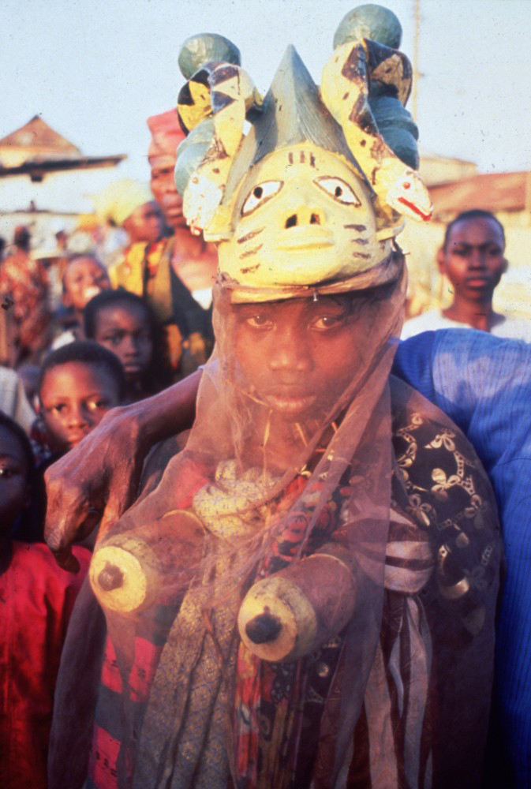Fig. 4: H.J. Drewal and M. T. Drewal, Yoruba Gelede Mask, Nigeria (1977) (University of Iowa) 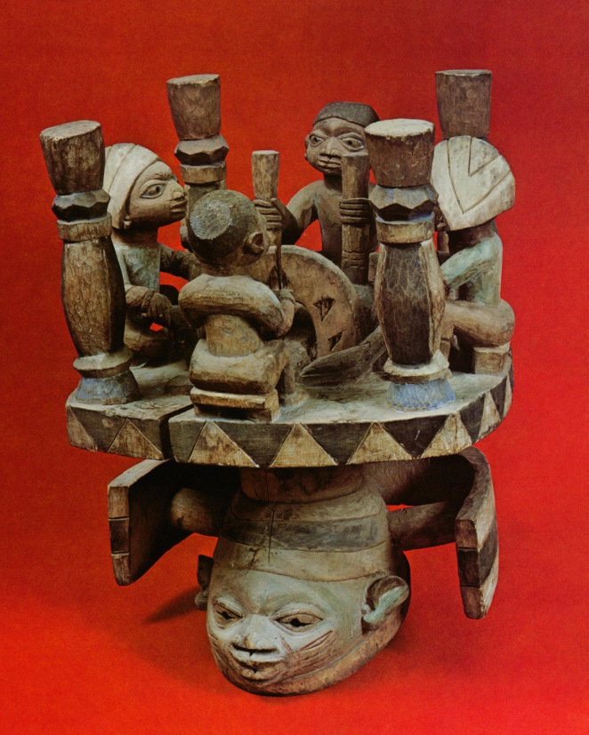Fig. 5: Larry Dupont, Gelede Mask (Omo Kerin)

Zulu
The Zulu, or “the people/children of the heavens,” comprise 10 million believers, the largest tribal group in South Africa. Like the West African Fon and Yoruba, the Zulu practice ancestor worship. The Zulu believe in unKulunkulu, the first man or possibly the creator god. Their worship includes animal sacrifices as well as drink offerings, particularly homemade beer. In return, the ancestor helps guide or bless the person who made the offer. Ancestors are known to manifest during times of illness or even in animal forms, such as snakes. If evil spirits cause problems in the community, the healer, known as a sangoma, will communicate with the ancestors using prayer or magic to remedy the issue.
Traditionally, the Zulu were buried, and this act is very significant to the Zulu. If incorrectly buried, the spirits of Zulu individuals may wander. The burial process for some regional peoples includes animal sacrifice and supplementing the burial with personal effects for the journey.

Citations
- [1] Clara Sarrocco, “Surprised by Awe,” Touchstone Magazine, May/June 2011, 38

Readings for Discussions

To Do” List

Required Readings
Begin reading your required text The Sacred Pipe in its entirety. You will finish reading this text in Unit 2.
Please also read the following:
Clara Sarrocco, “Surprised by Awe: C.S. Lewis & Rudolf Otto’s The Idea of the Holy” https://www.touchstonemag.com/archives/article.php?id=24-03-036-f
- M.Y. Nabofa, "Blood Symbolism in African Religions" (Reading available in Course Supplements).
Please watch the following videos:
- CNN, “In traditional South African healing, the physical, spiri…” https://youtu.be/gMQoPhF5T84
- Stephen Bailey, “Incredible Video of Voodoo Culture in Benin” https://youtu.be/1ovbd_dceWo
- Media India Group, “The Zulu People of South Africa.” https://youtu.be/wt3qSqPeTmE

Suggested Resources
- Rudolf Otto, The Idea of the Holy: An Inquiry into the Non-rational Factor in the Idea of the Divine and Its Relation to the Rational
- C.S. Lewis, The Problem of Pain
- Siyabona Africa, “Zulu” http://www.krugerpark.co.za/africa_zulu.html
- Planet Doc Full Documentaries, “Zulu African Tribe. Polygamy” https://youtu.be/XxVY1VZ4Az8
- Answers Africa, “Top 10 Most Famous African Tribes” https://answersafrica.com/african-tribes.html

Discussions

Making Connections: “Surprised by Awe” and “Blood Symbolism in African Religion”
- Discuss two ways that Rudolf Otto’s explanation of the numinous in Clara Sarrocco’s article “Surprised by Awe: C.S. Lewis & Rudolf Otto’s The Idea of the Holy” relates to the videos assigned for this unit. Develop your ideas using one paragraph for each way. Using MLA, cite from Sarrocco’s article, and reference at least two of the videos.
- Discuss one aspect in Nabofa’s article that intrigues you. Relate it to either one of the videos or Sarrocco’s article. Using MLA, cite from Nabofa’s article, and refer to at least one video or Sarrocco’s article.
- Choose one common aspect that you observed in these readings and/or videos, and discuss how the communities either practice or view that aspect uniquely. Please cite your sources using MLA citation style.

