Chapter 6 Pages 148-156: Value and how to calculate GDP problems. Study these pages carefully to solve the following problems:

1) A farmer buys seed for 20 cents that is used to grow wheat. The farmer sells the wheat to the miller for 35 cents, and the miller makes flour, which is then sold to the baker for 55 cents. The baker makes bread and sells it to the grocer for 80 cents, and the grocer sells the bread to a family for $1. What is the value added of the baker and what is the sum of the value added at each stage of production?

A) 80 cents; $1
B) 80 cents; $2.90
C) 25 cents; $2.90
D) 25 cents; $1

2) The farmer pays 15 cents for wheat seeds. When the wheat is grown and harvested, the farmer sells it to the miller for 30 cents, who makes flour and sells the flour to the baker for 60 cents. The baker makes bread and sells it to the grocer for 90 cents, and the grocer sells it to a family for $1.25. The contribution to GDP is
A) 35 cents.
B) $1.25.
C) $1.95.
D) $3.20.

3) The two principle methods of measuring Gross Domestic Product are the
A) flow approach and the stock approach.
B) expenditures approach and the income approach.
C) intermediate approach and the value-added approach.
D) domestic approach and the international approach.

4) Suppose that for the economy of Springfield, we have the following information for 2010: consumption expenditures = $4,000; wages = $3,500; gross private domestic investment = $1,300; government expenditures = $2,000; exports = $900; imports = $1,100. Using the expenditure approach what would the Gross Domestic Product (GDP) be for Springfield in 2010?
A) $6,200
B) $7,100
C) $7,500
D) $10,600
E) $12,800

5) 31) If Gross Domestic Product (GDP) equals $1 trillion, gross private investment expenditures are $200 billion, exports equal imports, and government spending is $400 billion, then
A) consumption expenditures are $200 billion.
B) consumption expenditures are $400 billion.
C) spending on consumer durables must be $400 million.
D) we cannot determine what expenditures on consumption are without more information.

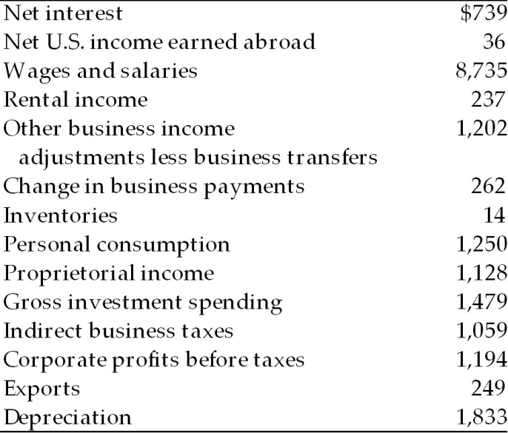

6) According to the above table, Gross Domestic Product as calculated by the income approach is
A) $10,121 billion.
B) $10,646 billion.
C) $14,925 billion.
D) $15,619 billion.

7) According to the above table, net domestic product is
A) $8,813 billion.
B) $12,603 billion.
C) $13,092 billion.
D) $13,750 billion.

8) According to the above table, national income is
A) $13,271 billion.
B) $11,917 billion.
C) $10,770 billion.
D) $10,646 billion.

9. A firm produces a good and generates $5 million in receipts. Wages are $3 million, rent is
$500,000, and interest payments are $1 million. Then
A) profits are $500,000, the cost of production is $4.5 million, and households receive income
equal to $4.5 million.
B) profits are $500,000, the cost of production is $5 million, and households receive income
equal to $4.5 million.
C) profits are $500,000, the cost of production is $5 million, and households receive income
equal to $5 million.
D) profits are $500,000, the cost of production is $5 million, and households receive income
equal to $3.5 million.

10.
_________________________________________________________
Consumption expenditures on goods and services $1,500
Total government spending on goods and services 590
Gross private domestic investment 355
Imports 50
Exports 70
Depreciation (capital consumption allowance) 200
Net U.S. income earned abroad -75
_____________________________________________________
According to the above table, Gross Domestic Product (GDP) is
- $2,190. B) $2,840. C) $2,465. D) $2,750.

