The effects of Recession on Change in Bitcoin Value

Intro
Bitcoin is quite a new cryptocurrency that was to eliminate intermediaries and to enable online transactions to be direct without going through the financial institutions. Bitcoin first trade on the stock market was in 2014. Here, we will find out how recession Affects Bitcoin value, hence define when to invest in bitcoin. Recession can occur due to several reasons, including Unemployment rate and money stock in the general public. In this paper I will analyze the variables to see whether they have a positive correlation with bitcoin.
Literature Review
When studying the effects of variables on the bitcoin value, a literature review was done to scrutinize how the unemployment rate and money stock affect the bitcoin value and vice versa. There have many studies investigating the relationship between money stock and bitcoin value.
This paper shows that money stock and unemployment rate have an insignificant effect on the bitcoin value.

Data
I have information about daily opening and closing prices of Bitcoin and the volume, captured from April 1, 2020 to April 1, 2021. I have 366 observations collected in a time series. The data houses the global public and was composed from yahoo finance, which gives precise and authentic Bitcoin prices. The data had four missing values, which were replaced using the values of the previous date. The frequency of the data was changed to monthly from the default, which was on a daily interval. The observations changed to 12 after changing the frequency to monthly. Other variables that were not required in this research were dropped. I created a variable called btc which is the difference between close and open variables. They portray the change in value of bitcoin prices during the period under observation.
The independent variables money stock and unemployment rate were also obtained from yahoo finance. I also changed the frequency to monthly.
Below are the descriptive statistics for the data described above.
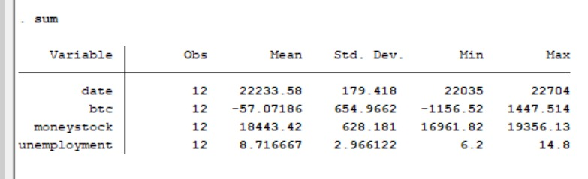
The average of money stock and unemployment rate variables are 18443 and 8.7 with standard deviations of 628 and 2.97 respectively, which implies that money stock is more spread out whereas unemployment rate is less spread out.

Methodology
In this paper, I try to use money stock, unemployment rate and time to predict the effect of recession on the value of Bitcoin, which is the variable called btc. I have done log transformations to money stock and unemployment variables to enable me make better predictions of my data. I have also generated time series and used in my regression.
The regression model I am trying to evaluate is as shown below:
Btc = β₀ + β₁*money stock + β₂*unemployment rate + β₃*Time Trend + Error term
I believe the following to be true:
Change in Bitcoin value, shown by the variable btc, trends downwards with time, so the coefficient should be less than zero and significantly different from zero.
H₀:β₃ ≥ 0
H₁:β₃ < 0

Change in Bitcoin value increases with money stock, so I expect the coefficient to be positive.
H₀:β₁ ≤ 0
H₁:β₁ > 0
Since I am working with time series data, I have concerns about autocorrelation. It seems like seasonal variations and the coronavirus pandemic are affecting the data. I test for autocorrelation using Durbin Watson Test. I also have concerns that money stock is heteroscedastic.
Results
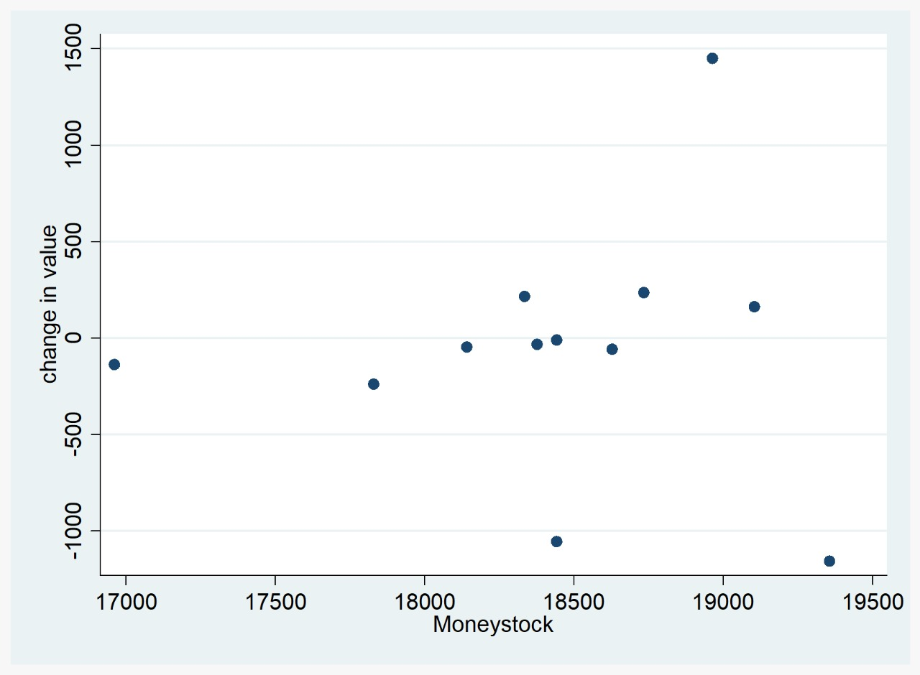
In the scatter plot above, the correlation between money stock and change in bitcoin value is evident. I believe the graph is heteroscedastic.
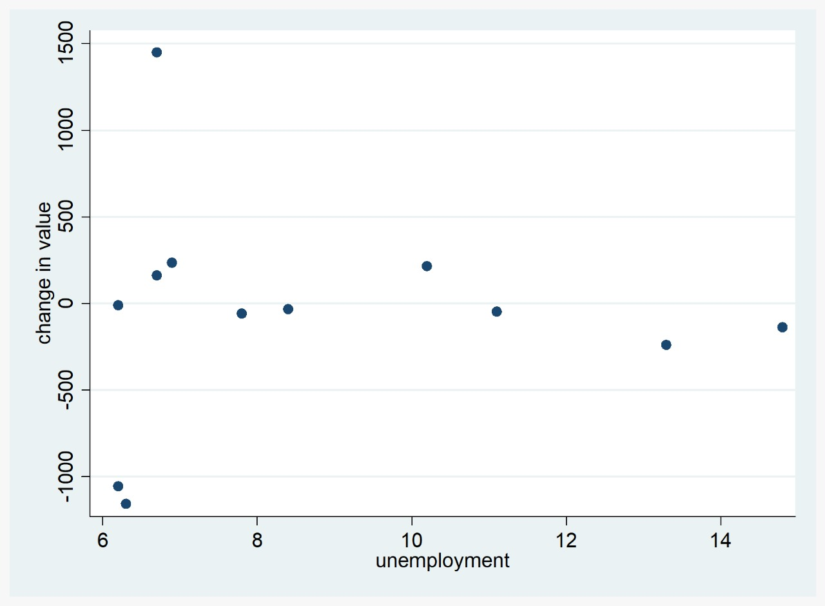
In the scatter plot above, the correlation between unemployment rate and change in bitcoin value can be seen. The graph is not linear as the line of best fit is not straight.

I have taken logs of Bitcoin, unemployment rate and money stock.
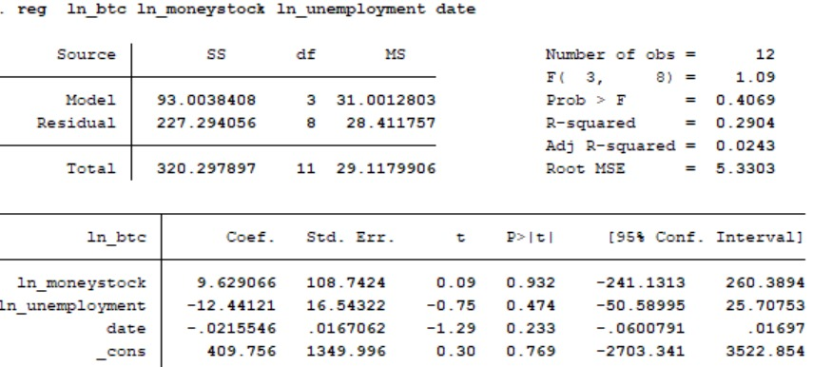
I found that the time trend is negative but is insignificant in our model due to its p value.
This analysis supported my first hypothesis test. The marginal effect of an increase in time by one more month will lead to a decrease in bitcoin value by 0.02 . I also found the coefficient of unemployment rate to be -12.44 which means that one unit change in unemployment range will lead to 12.44 decrease in the bitcoin value. Unlike unemployment rate and date, money stock’s coefficient is positive hence has a direct relationship with a one unit change in money stock leading to 9.62 increase in bitcoin value.
It appears that my initial thesis is unsupported by by the evidence and the independent variables weakly estimate the dependent variable since the accuracy is 29.04 percent.
Forecasting near mean:
Btc ≈ (9.63 * 18443)+(-12.44 * 8.72) + (-0.022 * 22233)

Conclusion
In conclusion to this analysis that used data from the period 2020 to 2021 to predict the effect of money stock and unemployment rate on bitcoin value in order to determine the effect of Recession on the value of Bitcoin, as per regression, there is a week relationship between all the variables with change in bitcoin value shown by the insignificant p-values, at 5% significant level.
Recession has no effect on Bitcoin value as shown by the data above, though some key variable are missing from the model.

