The Brain with Age
The brain slows down with age. Neurons fire more slowly, and reaction time lengthens because messages from the axon of one neuron are not picked up as quickly by the dendrites of other neurons. Brain size decreases, with fewer neurons in adulthood than in adolescence. Myelination is reduced, and that means reaction time slows (Wang & Young, 2014).
VIDEO: Brain Development Animation: Middle Adulthood
offers an animated look at how the brain changes and slows with age.
1295
But remember from Chapter 1 that gains and losses are evident at every point of the life span. This is true for the brain. As one expert describes it:
The human brain is in a continuous state of flux defined by periods of relative development and periods of relative degeneration that together engender processes of growth, maturation, repair, and deterioration across the life span.
[Sherin & Bartzokis, 2011, p. 333]
Gains? Brain growth? In adulthood? Yes! Myelination is reduced in some places, but new nodes develop in other parts of the brain (Wang & Young, 2014). Dendrites grow, reflecting experience. An adult who performs a particular action, time and time again, becomes better and quicker at it because of changes in the brain.
Of course, neurological advances are not automatic. For about 1 percent of all adults, significant brain loss occurs before age 65. There are five major causes of such adult brain reduction.
Traumatic brain injury (TBI). Blows to the head—either at 1296

Especially for Drivers
A number of states have passed laws requiring that hands-free technology be used by people who use cell phones while driving. Do those measures cut down on accidents? (see response, page 459)

one time as in a car crash or repeated over time as in football, hockey, or boxing—reduce brain functioning. TBIs can occur at any age, but for adults they usually occur before age 40.
Viruses. Various membranes, called the blood–brain barrier, protect the brain from most viruses, but a few— including HIV and the prion that causes mad cow disease— cross that barrier and destroy neurons. This can occur at any point in adulthood.
Genes. About 1 in 1,000 people inherits a dominant gene for Alzheimer’s disease, and even fewer people inherit genes for other severe neurocognitive disorders. Those can decrease brain function as early as age 30, although impairment usually appears after age 40.
Substance abuse. All psychoactive drugs can harm the brain, especially chronic alcohol abuse, which stops absorption of vitamin B1. That leads to Wernicke-Korsakoff syndrome (“wet brain”). Because long-term abuse is the cause, permanent brain damage is not usually apparent until age 40 or older.
Poor circulation. Everything that impairs blood flow—such as hypertension and cigarette smoking—impairs circulation in the brain and thus harms thinking, evident by age 50.
For most adults, however, experience continues to advance brain development. Learning continues, links between one thought and another are strengthened, and adults are better
1297
able to understand how one event affects another. This may result not only from experience; the brain itself may grow, as Inside the Brain explains.
INSIDE THE BRAIN
Neurons Forming in Adulthood
It has long been known that brains slow down with age and that parts of the brain often shrink. It also has long been known that neurons form rapidly during prenatal development and that most of them are eliminated by pruning, especially in infancy and in early adolescence. It was thought that brain growth and neurogenesis (the formation of neurons) stopped long before adulthood.
But in the past two decades, scientists have been surprised by discoveries that parts of the brain grow during adulthood (Ming & Song, 2011). Not only do dendrites form and pathways strengthen, but new neurons are born. One area that gains brain cells is the hippocampus, the brain structure that is most prominent in memory (Bergmann et al., 2015). That neurogenesis “appears to contribute significantly to hippocampal plasticity across the life span” (Kempermann et al., 2015).
The specific area of the hippocampus where new neurons settle is the dentate gyrus, a region activated in forming new memories and exploring new places. One conclusion is that the adult human brain is characterized by amazing plasticity (Kempermann et al., 2015).
Brain plasticity is evident lifelong, a finding now accepted by almost all scientists. But not everyone agrees that a significant number of new neurons are born in adulthood.
One team of 19 scientists reported that the number of new

neurons created after age 13 is so low as to be undetectable (Sorrells et al., 2018).
Another team of 12 scientists found that new neurons form even at age 70 (Boldrini et al., 2018).
The number of scientists in each of these two contradictory studies highlights that this is not a controversy between an optimist and a pessimist; it is a dispute between two teams of careful scientists. For neuroscientists, this dispute is thrilling: They await new techniques to study the brain.
For our purposes, however, we sidestep the controversy to state what we know: cognitive reserve, homeostasis, and allostasis protect the brain. New learning occurs in adulthood. Dendrites sprout to reach hundreds of other neurons as new situations demand it.
Thus, although adult brains slow down a bit, that may allow more careful analysis. Is that why judges, bishops, and world leaders are almost always older adults?
Historically and to this day, people connect wisdom with age. Could this be evidence that brain functioning advances over time? That hope is not yet firmly established in laboratories by neuroscientists but seems recognized in daily life by millions of ordinary people.
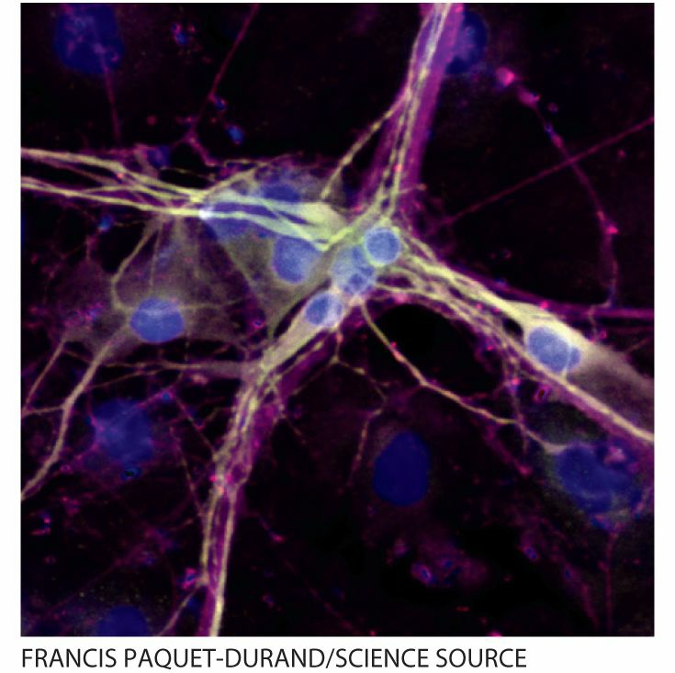
Neurons Growing Even in adulthood, dendrites grow (pale yellow in this photo). Here the cells are in a laboratory and the growth is cancerous, but we now know that healthy neurons develop many new connections in adulthood.

