Module Assignment 1
Assignment for week 1: In week one of this class, you will describe your organization and identify an issue or concern you would like to change/improve. The essay is between 500–700 words.
In week two, you begin using Kotter’s steps in his change model to develop a plan for the successful implementation of your initiative. You will not actually implement the initiative in the organization. This process using Kotter’s model is an exercise in project development, implementation, and management.
Reminders
Make certain to use APA format, including a title page ( see below) an introduction ( you need to tell me what your essay is about), a conclusion, and a reference list. You will need to
- Describe the health system, the history, and developmental phases of your organization. Include the number and types of people who work in this system, for example, the number of employees and the number of patients served. Include a brief introduction of your identified issue or concern.
- What are the mission, vision, and values of your system?
- How are these things demonstrated to their clients and the community?"
- How is the health system evaluated, and what standards are they measured against?
The essay should be set up something like this: Include the due date of the assignment, not the submission.
Title page
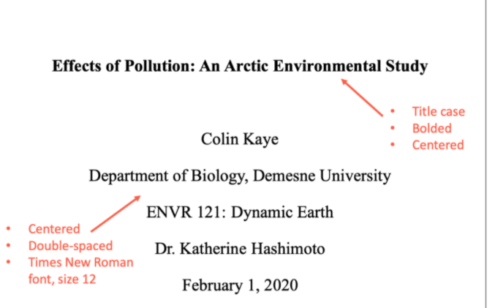
Health System, History, and Development Phases ( include a heading above the first sentence).
In this essay, the author will discuss...please be sure to briefly discuss your selected topic in the introduction.
Mission, Values, and Values
Evaluation of the Health System
Clients and the Community
Conclusion
References

Kotter's 8-stage model is a useful, comprehensive, step-by-step approach for making change. It applies systemic thinking to any change project:
· Stage 1: Establishing a Sense of Urgency
· Stage 2: Creating the Guiding Coalition
· Stage 3: Developing A Vision and Strategy
· Stage 4: Communicating the Change Vision
· Stage 5: Empowering Employees for Broad-Based Action
· Stage 6: Generating Short-term Wins
· Stage 7 Consolidating Gains and Producing More Change
· Stage 8: Anchoring New Approaches in the Culture
