Maslow’s Theory of Personality
Some scientists are convinced that there is something hopeful, unifying, and noble in humans. People seek love, then respect, and finally, if all goes well, everyone will become quite wonderful in their own way. This is the central idea of humanism, a theory of personality developed by Abraham Maslow (1908–1970) and many others.
humanism
A theory that stresses the potential of all humans, who have the same basic needs, regardless of culture, gender, or background.
Maslow witnessed the Great Depression, the rise of the Nazis, the power of fascism, World War II, the atom bomb, and then the eventual decline and defeat of all of those horrors. He concluded that traditional psychological theories underrated humans by focusing on evil, not the potential for good. He wrote Toward a Psychology of Being (1962/1998), challenging

1412
psychoanalytic and behaviorist theories of personality.
Maslow believed that all people—no matter what their culture, gender, or background—have the same basic needs, eventually striving for appreciation of themselves and of everyone else. He arranged these needs in a hierarchy, often illustrated as a pyramid (see Figure 13.1):
- Physiological:needingfood,water,warmth,andair
- Safety:feelingprotectedfrominjuryanddeath
- Loveandbelonging:havingfriends,family,anda community (often religious)
- Esteem:beingrespectedbythewidercommunityaswellas by oneself
- Self-actualization:becomingtrulyoneself,fulfillingone’s unique potential while appreciating all of life
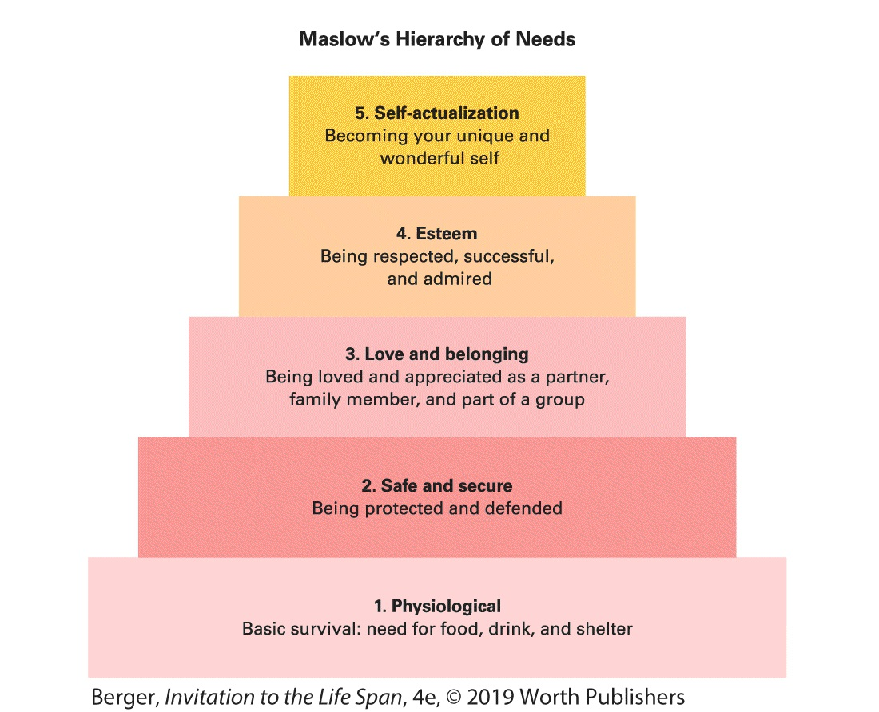
FIGURE 13.1 Moving Up, Not Looking Back Maslow’s hierarchy is like a ladder: Once a person stands firmly on a higher rung, the lower rungs are no longer needed. Thus, someone who has arrived at step 4 might devalue safety (step 2) and be willing to risk personal safety to gain respect.
This pyramid caught on almost immediately; it was one of the most “contagious ideas in behavioral science” because it seemed insightful about human psychology (Kenrick et al., 2010, p. 292). This theory is not a developmental theory in the traditional sense, in that Maslow did not believe that the five levels were connected to a particular stage or age. However, his hierarchy is sequential: Lower needs must be met before higher needs can be.

1414
Thus, every person needs to have basic physiological needs satisfied, and to feel safe, before being able to seek love, respect, and finally self-actualization. At that highest level, when all four earlier needs have been met, people can be fully themselves—creative, spiritual, curious, appreciative of nature, able to respect everyone else.
A UNIVERSAL THEORY?
Humanists emphasize what all people have in common, not their national, ethnic, or cultural differences. Maslow contended that everyone, universally, has the same needs, which can lead to the unique self-fulfillment of each person.
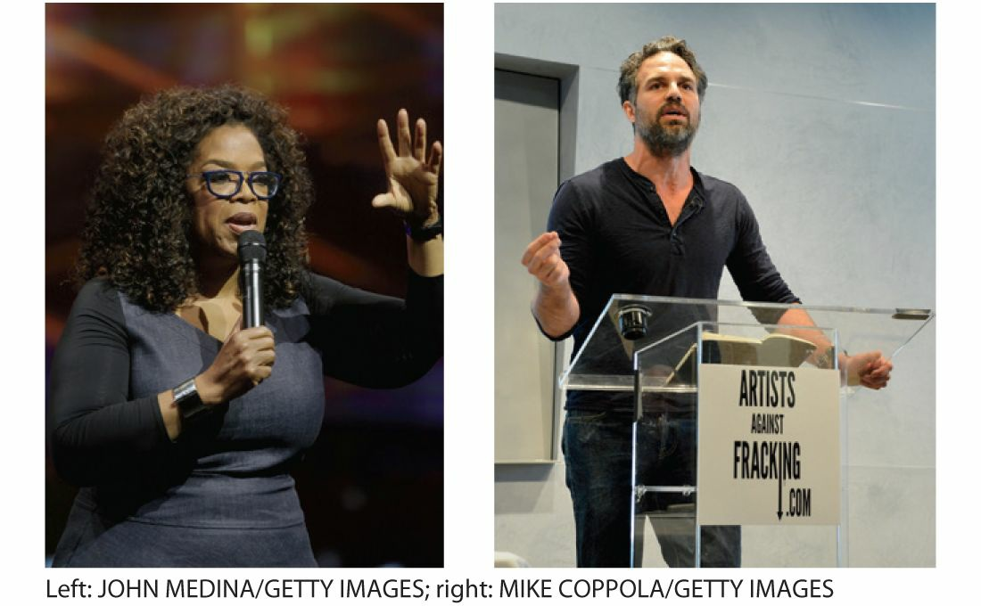
After Fame Why did Oprah (left) quit her popular TV show to pursue other projects? Why did Mark Ruffalo (right) donate his time to stop fracking? Perhaps Maslow was right. Self-actualization is the highest level in his famous hierarchy, when respect and esteem allow people to move past selfish concerns to care for
1415
the rest of humanity and nature. This applies to less famous adults as well.
A starving man, for instance, may not be concerned for his own safety when he seeks food (level 1 precedes level 2). Likewise, woman who feels unloved might not care about self- respect because she needs love (level 3 precedes level 4).
Maslow proposed that people who seem mean-spirited, or selfish, or nationalistic feel insecure. Destructive and inhumane actions may be the consequence of unmet lower needs. When those needs are met, self-actualization becomes possible.
This theory is relevant for life-span development. Babies seek food and comfort, children seek approval, emerging adults seek love, older adults seek respect, and all people have an inner drive to self-actualize.
Early experiences can impede human growth: People may become thieves or even killers, unable to reach their potential, to self-actualize, if they were unsafe or unloved as children. Ideally, people get past those lower levels. Then each person can become their unique, best self, with all the diversity of humankind.
1416
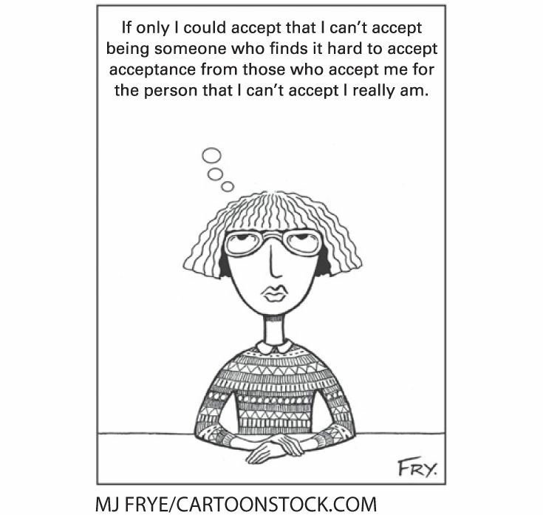
Maybe Next Year Self-acceptance is a gradual process over the years of adulthood, aided by the appreciation of friends and family. At some point in adulthood, people shift from striving to fulfill their potential to accepting their limitations.
It does seem that adults tend to be more generous to others if they themselves feel secure. For instance, especially for single mothers (who may have many needs), having a steady, adequate income correlates with better parenting (Berger et al., 2017).

1417
APPLICATIONS
Humanism is prominent among medical professionals because they recognize that illness and pain are connected to the psychological needs of the patient (Felicilda-Reynaldo & Smith, 2018; J. C. Jackson et al., 2014). Even the very sick need love and belonging (never left alone) and esteem (the dying need respect). As a medical team from the famed Mayo Clinic states, “Solely addressing physiological recovery in the ICU, without also placing focus on psychological recovery, is limiting and not sufficient for recovery of the entire patient—both body and mind” (Karnatovskaia et al., 2015, p. 210).
Echoes of humanism are also evident in education and sports: The basic idea here is that people are motivated to achieve their “personal best”—that is, to reach the peak of their own potential—by challenging themselves to improve on their own past performance. If, instead, the competition is to be the only one to earn an A+ or to be the most valuable player, then most people will quit trying (Ravizza, 2007).
In their careers, too, self-actualization may be the reason people strive for success (Fernando & Chowdhury, 2015). Crude competition—which produces winners and losers—is antithetical to the core belief of humanism, that everyone is uniquely wonderful.
Trait Theories
Many contemporary psychologists contend that adult 1418

personalities are too varied to be described by any grand theory, such as the ones proposed by Maslow and Erikson. Instead, they contend that each person has hundreds of traits, each comprising one pixel of the distinct picture of personality.
THE BIG FIVE
One prominent theory is that all traits can be clustered on five dimensions, with each person relatively high or low on each. This has been called the Big Five. (To remember the Big Five, the acronym OCEAN is useful.)
Big Five
The five basic clusters of personality traits that remain quite stable throughout adulthood: openness, conscientiousness, extroversion, agreeableness, and neuroticism.
Openness: imaginative, curious, artistic, creative, open to new experiences
Conscientiousness: organized, deliberate, conforming, self- disciplined
Extroversion: outgoing, assertive, active Agreeableness: kind, helpful, easygoing, generous Neuroticism: anxious, moody, self-punishing, critical
Each personality is somewhere on a continuum on each of these five. The low end might be described, in the same order as above, with these five adjectives: closed, careless, introverted, hard to please, and placid.
1419
According to trait theory, adults choose their contexts, selecting vocations, hobbies, health habits, mates, and neighborhoods to reflect their personality. Those high in extroversion might work in sales, those high in openness might be artists, and so on. International research confirms that human personality traits (there are hundreds of them) can be grouped on these five dimensions (Carlo et al., 2014; Ching et al., 2014).
Among the actions and attitudes linked to the Big Five are education (conscientious people are more likely to complete college), cheating on exams (low on agreeableness), marriage (more often extroverts), divorce (more likely for neurotics), IQ (higher in openness), verbal fluency (again, openness and extroversion), smoking cigarettes (low in conscientiousness), recovery from a stroke (low on neuroticism), and even political views (conservatives are less open) (Dwan & Ownsworth, 2017; Gerber et al., 2011; Silvia & Sanders, 2010; Giluk & Postlethwaite, 2015; Zvolensky et al., 2015).

1420
Active Brains, Active Personality The hypothesis that individual personality traits originate in the brain was tested by scientists who sought to find correlations between brain activity (shown in red) and personality traits. People who rated themselves high in four of the Big Five (conscientiousness, extroversionagreeableness, neuroticism—but not openness) also had more activity in brain regions that are known to relate to those traits. Here are two side views (left) and a top and bottom view (right) of brains of people high in neuroticism. Their brain regions known to be especially sensitive to stress, depression, threat, and punishment (yellow bullseyes) were more active than the same brain regions in people low in neuroticism (DeYoung et al., 2010
Of course, all of this may reflect the values and prejudices of the community as well as the personalities of the individuals. Everyone agrees that personality is influenced by many factors beyond temperament. The paragraph above notes tendencies,
1421

