Please review the following pages regarding page requirements that can lead to lower scores.

Let’s please recall that it is important to follow the instructions regarding the presentation of your thoughts. The page requirements are critical to follow. When you earn an MBA and move upwards career wise (or maybe even now), you can be asked to prepare a report, a brief report, a one-page summary, and so forth on any topic. This assignment, as well as the others, also serve to help students practice possible future tasks.

Format: Please make sure your Word document margin set up is as follows.

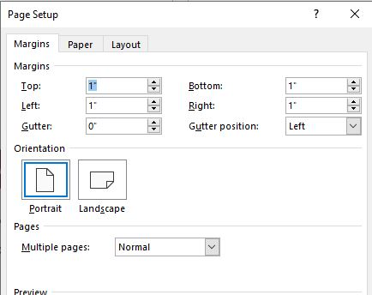

Font: Times New Roman – please make sure your page numbers, headings, title page, contents and so forth are in the same font.

Double Spaced – Please do not double space between paragraphs.

Grammar/Spelling check

Title Page (APA Style) in each assignment, beginning of the document.

Additional Requirement: use as many terms as possible in your responses in all assignments. Please bold one term, one time used in your content in each reply.

