Thanh Truong
Professor Andrew Moore
MKT G157
December 05,2021
Marketing Strategies
Introduction
The marketing strategies are the main determinants of how the customer responds to the ascertained product. Some strategies may be perfect to market some products and not to others. Therefore, it's necessary to identify the one to use and neglect for a positive outcome. The study's marketing plan is designed for cosmetic companies and beauty products for both genders. The research was specifically conducted to identify the marketing strategies for improving loyal customers in the beauty industry.

Research method and procedure
The study has included the primary quantitative analysis with survey questionnaires and literature review. In the literature review, we referred to various scholars' views concerning the various marketing strategies such as internet marketing, digital media marketing like mobile devices, and influencers. We developed the questionnaire targeting a sample of 200 customers. The data collected through questionnaires were analysed with Ms excel and SPSS software.

Data analysis and findings.
Literature review finding
I believe that internet technology is among the most important technologies in the 20th century. Thinking about it today, no one can imagine a life without the internet. We literally live on the internet. Even today, most marketing efforts are made online, making giant companies that we see today. Consumers spend about 33% of their day online (Nusei, 230). Due to this reason, he considers the internet as the significant channel the beauty industry can use to connect with loyal customers. (Leung et al. 52) also, confirm that online channels like online shopping websites and platforms are important in attracting loyal customers to shop online. Most scholars argue that internet marketing is the best strategies to improve loyal customers.
Survey questionnaire finding;
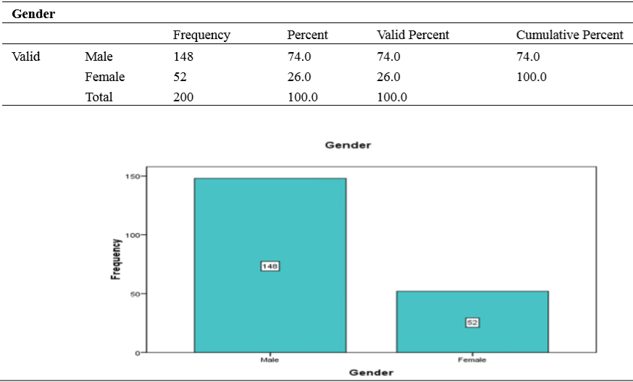
Table A. sample characteristic
The table above displays that 148 were male and 52 were female respondents out of 200 respondents (Nusei, 232). The female respondents concluded 26% of the population and male respondents 75% of the sample.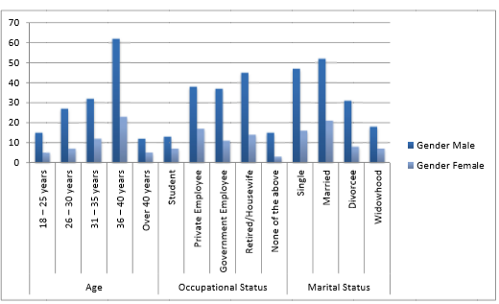
The above chart represents the respondent's demographic characteristics to the survey questionnaire. The occupation status factor shows that most participants are retired/housewife groups, consisting of 14 females and 45 male respondents (Nusei, 233). The aged sector implies that most respondents ranged from 36-40 years; around 85 respondents, 62 were males, and females were 23. Lastly, According to the survey conducted in the marital status section, most participants were married. From the chart, among 73 married respondents, 21 were females, and 52 were male respondents.
Table B. Does internet marketing influence and make you purchase beauty products?
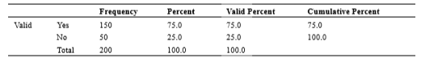
Table B. shows that 150 participants agreed, and 50 participants denied being influenced by internet marketing (Nusei, 233). The results show that 75% of participants agree to be influenced by internet marketing to make a purchasing decision.

Table C. Do you use the internet for beauty product information?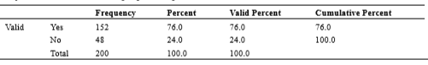
Table C. implies that out of the 200 participants, 152 respondents agreed to use the internet to acquire product information, and 48 denied (Nusei, 234). Based on the results, it’s clear that 76% of respondents rely on the internet to acquire product information.
Therefore, the majority part of our society buys online. I tend to think there is some convenience that comes from buying online. The internet is the biggest store that we can find, and people can compare prices and specifications of different products at the comfort of their homes or office. Also, people can monitor when the prices are low and buy. I believe that majority of the global population is conversant about these advantages and ultimately tend to depend on that.

Conclusion and recommendation
This study indicates that the majority of the respondents allow internet marketing to influence them and encourage them to buy. Also basing the sample of 200 participants, many agree that they use interment to acquire information about the product. This means that my loyal customers are online shoppers. Therefore, improving them, I should concentrate more on internet marketing strategy. Using social media influencers to market the product and create social media platforms account such as YouTube, where I can post beauty products enhance connection with ideal customers.
Works cited
Leung, Polly PL, et al. "Customer loyalty enhancement of online-to-offline marketing in beauty industry." 2016 4th International Conference on Enterprise Systems (ES). IEEE, 2016.
Nuseir, Mohammed T. "Exploring the use of online marketing strategies and digital media to improve the brand loyalty and customer retention." International Journal of Business and Management 11.4 (2016): 228-238.

