Case study primavera

1. Read and examine the Primavera Systems (Links to an external site.) case study thoroughly. (https://www.pmi.org/learning/library/project-management-agile-scrum-asd-8021)
- Take notes, highlight relevant facts, and underline key problems.
2. Focus your analysis:
- Identify two to five key problems that Primavera was experiencing.
- Why do the problems exist?
- How do they impact the organization and stakeholders?
- How was utilizing Agile and the Scrum process a benefit to Primavera?
3. What were your key takeaways from the Case Study?
4. What similar challenges does your company, department, or team face?

Class Project Part One
3 3 unread replies. 4 4 replies.

Project Overview
You have just purchased a newly constructed house. This house is finished but is completely empty, unfurnished, unpainted (white walls), and undecorated. For the next seven weeks, you will be utilizing what you have learned in each week's module to turn this house into a home with the goal of completing the task within six months.

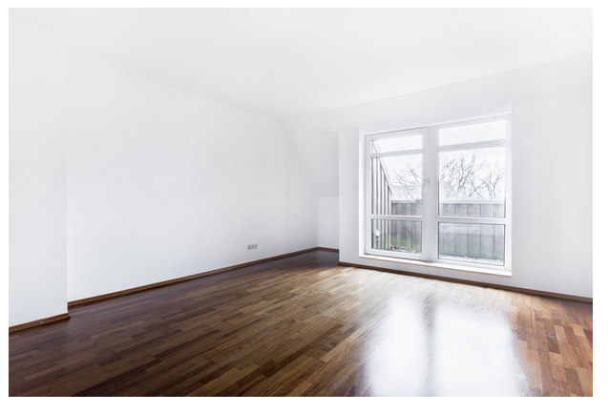
Part One Tasks
- Assign the three Scrum roles.
- Create the initial product backlog of the items that need to be executed based on the highest value items at the top of the list.
- Define the optimal sprint duration to execute the project.
- Define what will occur at each of the Scrum events at a high level for this specific project.
Submit your response to this discussion, and respond to two classmates' posts. Initial posts should be 250 words

Class Project Part Two
4 4 unread replies. 4 4 replies.

Project Overview
You have just purchased a newly-constructed house. This house is finished but is completely empty, unfurnished, unpainted (white walls), and undecorated. For the next seven weeks, you will be utilizing what you have learned in each week's module to turn this house into a home with the goal of completing the task within six months.
Part Two Tasks
- Detail the roles and responsibilities a Product Owner might specifically perform on this team's project.
- Detail the role and responsibilities a ScrumMaster might specifically perform on this team's project.
- Identify the team members required for a cross-functional team.
- Discern the authority needed for each of the three Scrum roles.
- Identify project stakeholders.
- Describe the concerns of the stakeholders.
Submit your response to this discussion, and respond to two classmates' posts. Initial posts should be 250 words.

Class Project Part Three
2 2 unread replies. 2 2 replies.

Project Overview
You have just purchased a newly constructed house. This house is finished but is completely empty, unfurnished, unpainted (white walls), undecorated. For the next seven weeks, you will be utilizing what you have learned in each week's module to turn this house into a home with the goal of completing the task within six months.
Part Three Tasks
- Estimate the size of each of the tasks in the Product Backlog (XS, S, M, L, XL).
- Create an initial Sprint Backlog based on the capacity of the Sprint Timebox.
- Highlight some of the topics that may be discussed at the Daily Scrum or Daily Standup meeting.
- Highlight some of the topics and accomplishments that may be discussed at the Sprint Review meeting.
- Highlight some of the successes and challenges that may be discussed at the Sprint Retrospective meeting.
- Discuss the roles each team member plays during each type of meeting.
- Describe some techniques for good planning that will set the foundations for success in all your Scrum meetings.
Submit your response to this discussion, and respond to two classmates' posts. Initial posts should be 250 words.

Project Overview
You have just purchased a newly constructed house. This house is finished but is completely empty, unfurnished, unpainted (white walls), undecorated. For the next seven weeks, you will be utilizing what you have learned in each week's module to turn this house into a home with the goal of completing the task within six months.
Part Four Tasks
- Align project objectives to the Minimal Marketable Features (MMFs) that will make your house liveable.
- Define Project Deliverables that add value to the home's comfort and functionality.
- Use frequent feedback from stakeholders and users to improve results.
- Apply continuous process improvement practices to increase the quality and value of deliverables. How can we do what we just did faster, less expensively, and with exceptional quality?
Submit your response to this discussion, and respond to two classmates' posts. Initial posts should be 250 words.

Class Project Part Five
1 1 unread reply. 1 1 reply.

Project Overview
You have just purchased a newly constructed house. This house is finished but is completely empty, unfurnished, unpainted (white walls), undecorated. For the next seven weeks, you will be utilizing what you have learned in each week's module to turn this house into a home with the goal of completing the task within six months.Part Five Tasks
Explain the significance of each Scrum artifact to the success of transforming the house into a home:
- The Product Backlog
- The Sprint Backlog
- The Definition of Done
- Burndown Charts
- Burn-Up Charts
- The Product Increment
Submit your response to this discussion, and respond to two classmates' posts. Initial posts should be 250 words.

Class Project Part Six
No unread replies. No replies.

Project Overview
You have just purchased a newly constructed house. This house is finished but is completely empty, unfurnished, unpainted (white walls), undecorated. For the next seven weeks, you will be utilizing what you have learned in each week's module to turn this house into a home with the goal of completing the task within six months.
Part Six Tasks
Apply various Agile tools when estimating and planning your project deliverables:
- Expert opinion estimating: What can be estimated by past experience?
- Affinity estimating: What can be estimated by sizing the tasks relative to each other?
- Disaggregation estimating: What complex task can be broken down into smaller sub-tasks?
- Planning Poker: Use the group to come to a consensus of the complexity and resources needed to complete each task.
- Use velocity to create a release plan or completion forecast.

Project Overview
You have just purchased a newly constructed house. This house is finished but is completely empty, unfurnished, unpainted (white walls), undecorated. For the next seven weeks, you will be utilizing what you have learned in each week's module to turn this house into a home with the goal of completing the task within six months.Part Seven Tasks
- Establish a clear vision for your project that can be shared with all stakeholders utilizing a Vision Statement.
- Create a Product Roadmap to describe the overall execution estimate of the project.
- Define Team Working Agreements to ensure efficient and effective project execution.
- Detail how the Product Backlog Grooming plays an important role in consistently delivering maximum value.
Submit your response to this discussion, and respond to two classmates' posts. Initial posts should be 250 words.

