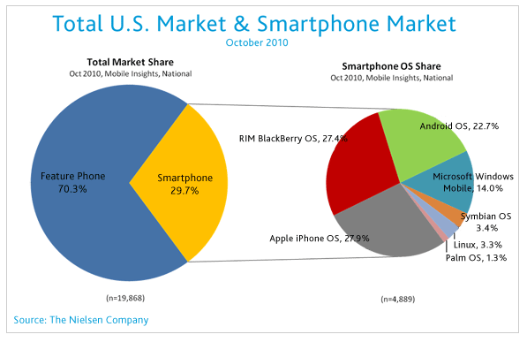

Graphs, Charts, and Tables are very important to research reports. They visually tell the story of data collected.
For this homework assignment #4, you will need to include at least two charts for your data. You can include more, but you should at least have a bar graph and a pie chart.
You can use charts, tables, and graphs from secondary data you have collected, AS LONG AS...you reference them. In fact, I encourage you to do so, when they are available.
See the lecture on chapter 13 for examples.
Hello writer, I will attach my draft and so you know what kind of products I wrote. Also chapter 13 lecture. Please using simple/easy ( to understand ) words to write. Thank you

