Analysis of The Annal Report and the Audit Report

Analysis of The Annal Report and the Audit Report
Question 1
Pepsi
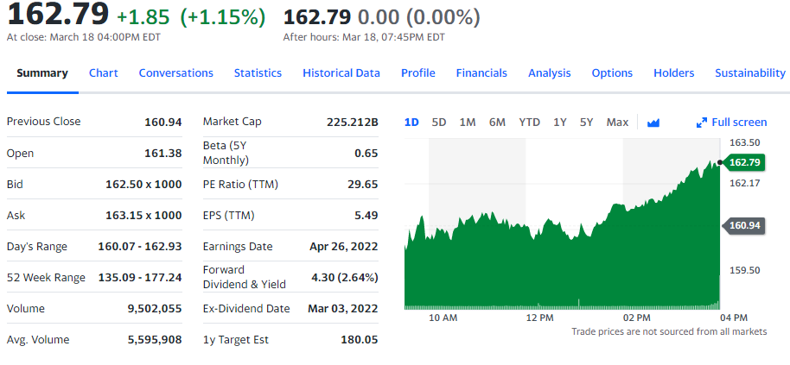
Earning estimate
Pepsi has an earnings estimate of 1.23 which means that the annual quarterly earing of the company is high due to the high total net income of the company with relation to the number of outstanding shares. The revenue estimate for this case means that the company is currently at a steady-state with a production rate. The total revenue of the company is 79,474,000. This is a positive increase in the total revenue since 2020. On the other hand, the cost revenue has shown a positive increase up to the year 2021; this is due to the increase in the company's total revenue. The company's operating expense is also showing a positive increase because the company is increasing in revenue and production; therefore, more expenses are needed to sustain such operations. The operation income, expenses, tax provision, net income on common shareholders, and the diluted national income available to common stocks have shown a positive trend, implying that the company operational value is on track. Therefore, it gains a positive profit margin.
The company's sustainability is 16 at total ESG risk score, 4.9 at environment risk score, 6.6 at social risk score, 4.6 at governance risk score. This implies that the company is in a sustainable state. Its functionality is smooth. The Pepsi company has a market capability of 225.212 billion, a PE ratio of 29.65, and a forward dividend yield of 4.30.
Question 2
Balance sheet
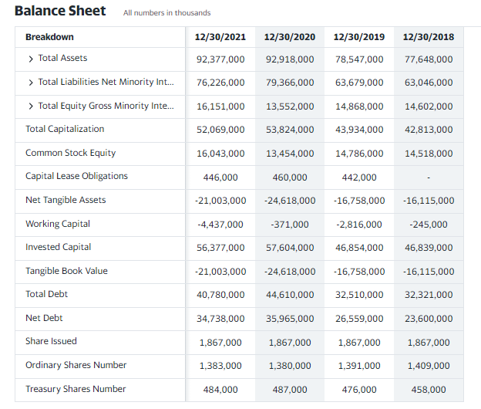
The working capital with the variable of -371,000 in 2020 and -4 437,000 in 2021 causes changes to the balance sheet because the company might have purchased more fixed assets, decreasing the company's cash flow. On the other hand, the working capital could have decreased since the cash portion of the current assets might have been reduced whereas the current liabilities remain unchanged because it would be long-term debt.
Income statement
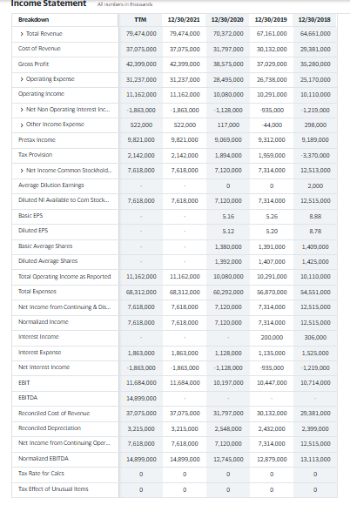

The factors that cause changes in the income statement are revenue with an initial value value of 70,372,000 in 2020 and in 2021, 79,474,000. Revenue of the company which is regarded as the priority of the company, changes due to the extensive changes on the company's demand. This is because in 2021, there is a high demand for the company's product, leading to high sales and high income.
Auditors' opinion.
The audit opinion is that the company should increase its earnings to meet the revenue mark, reducing expenses incurred due to business expansion. The components are found in the balance sheet. The accounting standard used is the AS4 which involves the contingencies and events occurring after the balance sheet.

