Economic Events & Activity Analysis, Economic Concentration Evaluation

Part 1: Economic Events & Activity Analysis
Rapid price increases, such as caused by the 1973 oil embargo or the aftermath of a major hurricane
When an organization, company, or country bans the exports of a certain product to a specific country, the phenomenon is called an embargo (Cohen, 2021). There are various causes for an embargo, including a conflict with a neighboring country, a disagreement over a specific topic of debate, or a lack of trust between the two countries. There was a global oil crisis in 1973, and several nations were hit hard. The Organisation of Arab Petroleum Exporting Countries restricted oil flow to those nations that appeared to support Israel during the Yom Kippur War. OAPEC also put an embargo on the United States, one of the nations it targeted. Due to a lack of local oil production, the United States is forced to import oil from Arab countries. The United States felt the effects of this oil supply disruption. As a result of the embargo, the short-run aggregate supply (SRAS) curve shifted to the left, causing a decrease in aggregate demand in the United States.
As a consequence, the price level rises as a result of a decrease in supply. Demand for products and services falls, and a new equilibrium is reached at B, where the price level is P.' National production is Y.' When manufacturing activity in the country decreases, the overall supply of products and services drops dramatically (Cohen, 2021). The effects are shown in the figure below; 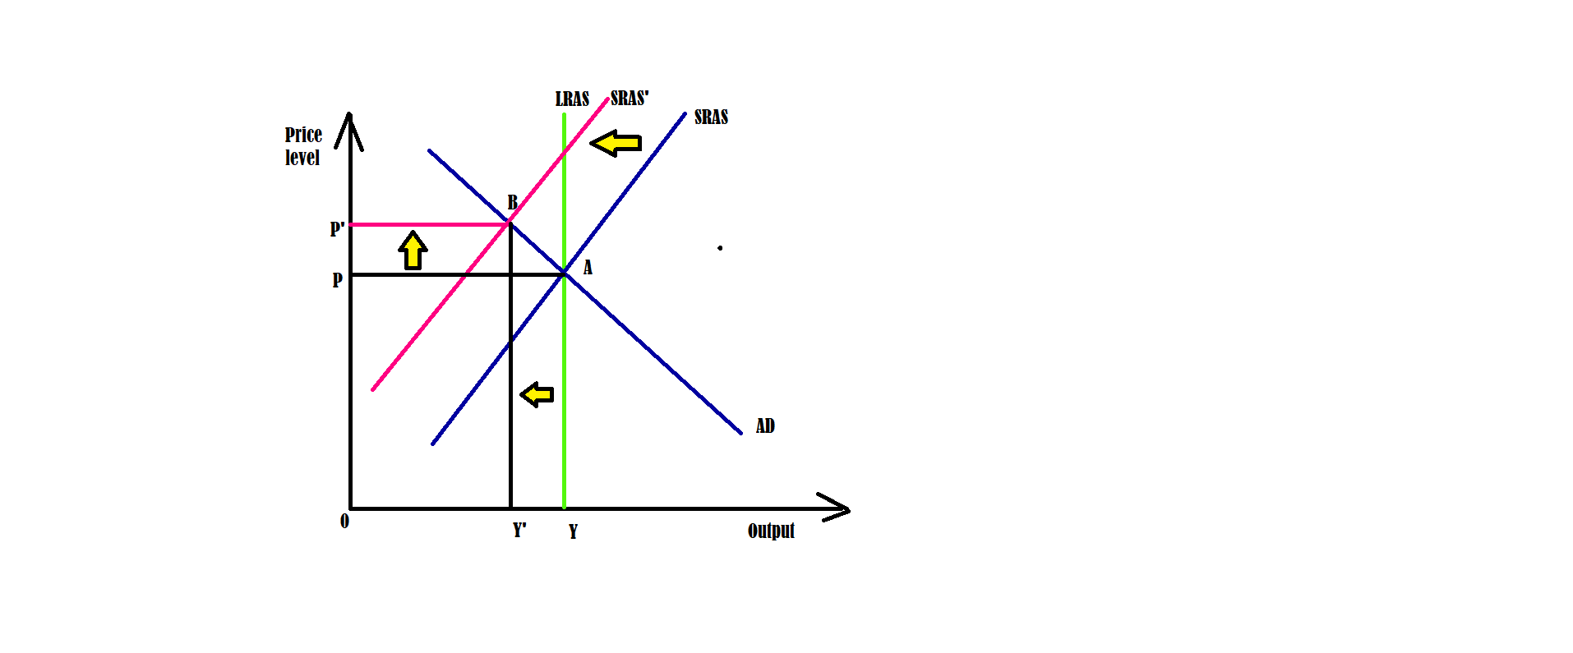

The Dot-Com Bubble from 1994 to 2000 and the Subsequent Dot-Com Crash
During the late 1990s and early 2000s, the United States had a financial bubble in the technology sector known as the "Dotcom Bubble." There was a lot of media interest and investors' prediction that dot-com firms would make a lot of money. The NASDAQ Composite Index's stock prices for Internet-based firms increased 400% between 1995 and 2000 (Moshenskyi, 2018). However, in 2002, the stock market bubble burst, resulting in a 78% drop in stock values. The collapse significantly impacted the U.S. economy, with many businesses going out of business temporarily or entirely.
The rise of the Internet as a medium of communication led to the emergence of the dot-com bubble. However, it wasn't until the 1990s that it became widely available to the general public. Some technological start-ups with ".com" suffixes began to provide commercial opportunities in that new and expanding market. The difficulty was that they did not do so with an effective business strategy and generating cash flow. The dot-com boom caused an economic downturn, but it also impacted a new sector, which had a long-lasting influence. Even well-established enterprises that had been in operation for a long time were affected.
For instance, Intel's stock dropped from a high of $73 to a low of $20 to $30. However, due to its lack of direct linkage, this firm was damaged by the dot-com bubble. At this point, prices are greater than they were in the 2000s, but it has taken a long time to recover. Overall, the impact on investors was much more severe than on the businesses (Moshenskyi, 2018). About 48 percent of all dot-com companies survived the crisis, although most lost a considerable amount in value. When new technology businesses, such as GameStop, issued IPOs, and several technology equities reached all-time highs in 2021, many investors were worried about a possible economic bubble.
However, a similar occurrence may be anticipated with a little forethought and planning. As a result, you should realize that every bubble follows a basic rule: they are all about the hype. By thoroughly investigating each organization, one may avoid being swept up in the hoopla and wasting money. Also, rather than putting money into a company's future, one should pay attention to how well it is doing right now instead.
Continue to the Part 2: Economic Concentration Evaluation
Introduction
The term "market concentration" refers to the situation in which a relatively small number of enterprises control a significant portion of the overall market. It assesses the degree to which one or more companies dominate the sales of a specific product or service in a given market. The concentration ratio is the metric used to measure the market concentration ratio. The market concentration ratio is a method for calculating the total market share held by the most successful companies in an industry. The term "Market Share" is used here in the equations as a reference. It might be the number of sales, the number of employees, the number of customers who use the company's services, the number of locations, etc. There is a possibility that the worth of top businesses, or top 'n' enterprises, might be three or five. If the leading companies continue to increase their market share, we may argue that the sector as a whole has reached a highly concentrated state. Let's start with the basics of concentration before we go on to discussing market concentration. The degree to which a small number of companies account for the whole output available on the market is what we mean when we talk about concentration within an industry. If there is a low concentration, this only indicates that the top n enterprises are not affecting the market output; hence, the sector is seen as having a high degree of competitiveness. On the other side, if there is a high concentration, this indicates that the top n businesses have a significant amount of control over the products or services offered on the market; hence, we refer to the industry as being either oligopolistic or monopolistic.
Central California Winemaking Industry
The concentration of the California Winemaking Industry is a notable example of economic concentration in the United States. Most of the wine's history is confined to a few nations and areas. The discovery of fruits and methods by American winemakers only happened during the past century, owing to the efforts of California wines in a global competition. There is now a $220 billion wine business in the United States (Wine Industry Network Advisor, 2017). The wine business generates more than $36 billion in taxes and employs more than a million people throughout the country, making it a strong economic force in the United States (Wine Industry Network Advisor, 2017).
Evolution of Central California Winemaking Industry
Since the early 1800s, Americans have been creating wine. The Catawaba grape was discovered in Ohio in 1830, and the state's first winery was established as a result (Baiocchi, 2011). New York's first winery opened in 1930, followed by a second in the next two decades (Baiocchi, 2011). During the 13 years of prohibition, the wine industry suffered greatly, where around 2,500 wineries operated in the United States before the ban. Only 4% of wineries were still in business after prohibition (Baiocchi, 2011). At a wine competition in Paris 40 years later, the world finally realized that California was the new wine capital (Baiocchi, 2011). America's winemaking business was elevated to a new level after California's victory in the Paris competition.
Influence on Competition and Pricing
It is no secret that wine has become a staple of American culture. Regarding alcohol, wine has always been more costly than other options since it is either imported or difficult to get due to the small number of domestic wineries. The wine was formerly considered a status symbol for the well-to-do. Although technology has advanced and transportation methods have become more efficient since the early 20th century, the rise of vineyards and their products has contributed to the economies of many nations, including the United States. According to the graph below, wine exports from the United States have grown dramatically since 1986, indicating that wine consumption inside the United States helps the national economy (Silverman et al., 2000). The state of California has emerged as the leading producer of wine in the world.
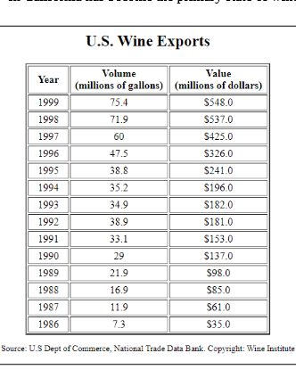
There is a lot of rivalry among wineries in the sector (Silverman et al., 2000). Because winemaking is still a relatively new phenomenon in the United States, it faces the same level of global rivalry as any other new industry. Even though the wine business generates billions of dollars for the U.S. economy, the world's leading wine producers are still located in smaller nations, as seen below (Silverman et al., 2000). Currently, vendors are offering lower-cost wines at levels that everyone can afford and higher-cost wines at cheaper costs due to the global glut of wineries.
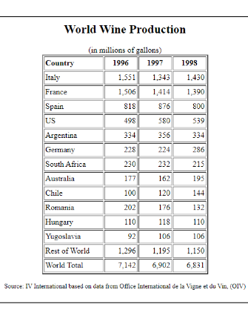

Supply Chain
Since the days of pricey imports, a small number of vineyards, and prohibition, the wine business has come a long way. As the number of wineries in the United States has grown, so has the diversity of products and the speed they may be produced. An increase in supply and demand for a short period helped the economy. Wine goods have been overflowing onto the market in recent years. With intense competition and the 2020 Covid-19 effect, winemakers cannot sell their products at the higher prices previously accepted as the industry standard. As a consequence of shifting consumer preferences, wineries are using innovative marketing approaches to attract new, more affluent clientele (Mileham, 2020).
Factors of Production
Land, labor, capital, and entrepreneurial initiative make up the four pillars of production. Everything that goes into creating wine has a significant impact on the final product. Entrepreneurship was equally crucial as land, labor, and money in the early days of winemaking in the United States. Since wineries proliferated, the need to start your own business faded away, as winemaking has become pretty similar, barring variations in the grape variety or accessible technology (Huyghe, 2019). Growing your grapes has always been a major consideration for winemakers. Many lands are required for growth and harvesting, and the acreage is needed to create and store wine while it ferments. Because so many vineyards have been handed down through generations of the same family, capital and labor are less of a role. Labor demands are generally fulfilled by family members or foreign laborers (Baiocchi, 2011).
Prediction of Changes
The wine business is expected to experience considerable changes because of rapidly shifting supply and demand. Marketers and manufacturers are already adapting their strategies to meet the new needs of consumers and producers alike (Mileham, 2020). The lower-priced wine manufacturers will have a tougher time competing, while the higher-priced winemakers have to decrease their prices to remain in business (Mileham, 2020). More vineyards will close, and customers will have more inexpensive access to formerly out-of-reach items (Mileham, 2020).
Conclusion
The production of wine has seen several shift shifts throughout history. The wine was formerly only available to the wealthy due to the limited production processes and distribution options available. Because of advances in technology and distribution methods and increased competition levels, items that were formerly regarded as luxury goods are now within the financial reach of almost anybody who has a stable income. Because of the economic concentration within the wine sector, the production of wine in Central California has increased.

References
Baiocchi, T. (2021). Vintage America: a brief history of wine in America
Cohen, J. (2021). The First Oil Shock? Nixon, Congress, and the 1973 Petroleum Crisis. The Middle East and Africa Journal, 12(1), 49-68.
Huyghe, C. (2019). What's ahead for entrepreneurship in the wine business: a snapshot of millennial behavior.
Moshenskyi, S. Z. (2018). Boom and crisis of the «dot-coms» in the USA (1995–2000).
McConnell, C. R., Brue, S. L., & Flynn, S. M. (2018). Economics: Principles, Problems, and policies (21st ed). McGraw-Hill Education: New York, NY.
Mileham, A. (2020). Supply chain 'stuffed' as us consumers see lowest wine prices for 20 years—competition in the global wine industry: a U.S. perspective.
Pugel, T. A. (2020). International economics (17th ed.). McGraw-Hill Education.

