Analyse and discuss the impacts and effects of colonisation on First Nations Australian Peoples through the analysis of the chosen question. Research essay are expected to be no more than 1500 words (+/- 10%) in length and provide 10-12 references in the Harvard referencing style. 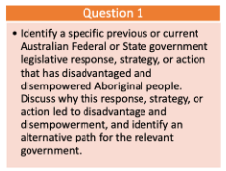
Marking Rubric: 