PSY-402 Cognitive Neuroscience
Topic 6 – Introduction to Psychology and Role of Biology
Cognitive Mapping Worksheet

Directions: Conduct research using scholarly internet sources, library sources, and the textbook to explore the application and use of cognitive mapping as a memory strategy.
*Option resources: Simple Mind: https://simplemind.eu/how-to-mind-map/

Then create a cognitive map that you can apply to your academic experience using bubbl.us.
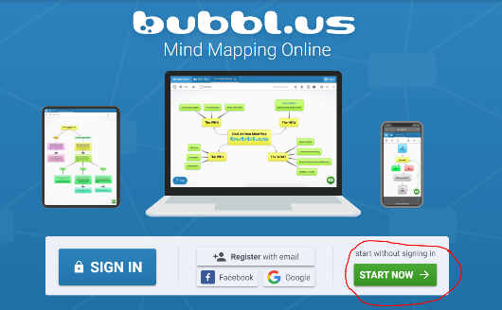
- Click on the bottom right to create a cognitive map without creating an account.

- Screenshot or screengrab the completed map. Copy and paste the map below to complete Part 2 of the assignment. You may also draw the map or copy and paste a photo of the map to the worksheet.

While APA style is not required for the body of this assignment, solid academic writing is expected, and documentation of sources should be presented using APA formatting guidelines which can be found in the APA Style Guide, located in the Student Success Center. Each question should be between 75-100 words per response.

Part 1: Using your research thoroughly answer the questions below:

- Explain what cognitive mapping is?

- Provide at least two positive effects of using cognitive mapping in daily life.

- Based on what you have learned about this memory strategy, who might benefit from using this memory strategy? Justify your answer.

References:

Part 2: Cognitive Mapping is an excellent memory strategy in all areas of life, especially in academics. How could you apply a mind map to enhance your academic experience at GCU?

Create a mind map as it relates to your own academic journey by choosing a topic that would personally benefit you. Choose an overarching concept that will be the center of your map and branch out from there. Be specific and intentional in your choices.

Topics may include:
- Time management
- The use and application of technology
- Study skills and the use of study guides to prepare for tests
- Utilizing a rubric effectively to enhance writing skills
- Note-taking and effective reading strategies to complete the required readings

Insert Picture: A picture of the map created must be inserted below. If the map is a drawing, then the student must be included in the picture holding the final product or credit will not be awarded (Only the instructor will be able to see the picture added).

