Columbian Exchange
The four world zones became connected for the first time in 1492, and a new era in human history began. For the first time, humans had created a truly global network.
Now, plants and animals were moving in all directions across the Atlantic Ocean and the Pacific Ocean. Historians call this movement back and forth across the Atlantic the Columbian Exchange.
To understand the consequences of the Columbian Exchange, I'm going to investigate the impact of the movement of plants, animals, and people across the Atlantic between 1492 and 1850.
I want to look at these new global networks. What effect did they have on the different peoples and regions of the Earth?
What was exchanged between 1492 and 1850?
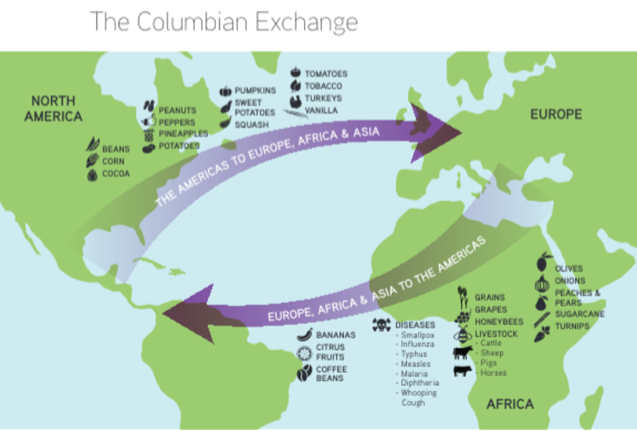
I'll start my historical investigation by asking questions about what actually happened: What was exchanged on the new Atlantic networks? What things moved east or west across the Atlantic?
I can begin to answer these questions by gathering information from a number of history and science books. I created the map and chart below using information from two of these sources.

Plant and animal exchange surprises
I was surprised by the things that were introduced to the Americas by European travelers: horses, sheep, honeybees, earthworms, sugarcane, wheat, fruits, coffee plants, and diseases.
All of these things have been common in the Americas for a long time. I assumed they had always been here! It's hard to imagine North America without horses, cattle, honeybees, earthworms, or coffee.
I was also surprised to learn what items traveled from the Americas to Europe after 1492: corn, potatoes, and turkeys, for example.
The sources I consulted gave more examples. They said that before the Columbian Exchange, foods like potatoes, tomatoes, chili peppers, and cocoa didn't grow in Europe, Africa, or Asia. There is no evidence that Afro-Eurasian people knew about or used these foods.
Today, I can't imagine Italian food without tomatoes or Indian food without chili peppers.
Some of the exchange that went on was intentional — Europeans planned to introduce new crops and animals into the Americas. For example, Spanish explorers brought olive trees on board their ships in order to plant them in the New World.
The Europeans also brought over crops such as sugar, coffee, cotton, and ginger, hoping these would grow well in the Americas so they could sell them back in Europe.
Those crops did grow quite well in Brazil, the Caribbean, and in North America. Tobacco, a crop that was native to South America, joined sugar, coffee, and various spices to become very important commodities that Europeans traded around the world.
Historians J.R. McNeill and his father, William McNeill, argue in their book, The Human Web, that the movement of these plants "was often a very deliberate affair, organized by royal authorities" with the goal of making as much money as possible or advancing the cause of science.
However, some exchange was unintentional. Seeds sometimes traveled as "secret passengers" in other food sources. For example, historian Luis Martin claimed that in 1535, Inés Muñoz, (sister-in-law of the explorer and conqueror Francisco Pizarro and one of the dozen or so European women who lived in Lima, Peru, at the time) introduced wheat to Peru by accident!
Munoz got a barrel of rice from Spain. In the barrel, she found a few grains of wheat and wondered if the wheat would grow in Peru. She planted a few grains of wheat in a flowerpot and soon, healthy spikes of wheat appeared from those first few grains. Munoz began to replant the wheat in the soil of Peru. According to Martin, the wheat crop grew so well that within three or four years, people began to produce bread in Peru.
In addition to these new crops, Europeans also introduced new animals to the Americas: horses, pigs, goats, sheep, and cattle. Some historians argue that these animals were far more important to the indigenous (native) people of the Americas than the new crops were.
I can imagine how valuable the horses were for labor and transportation, and how riding horses helped people to keep control over herds of cattle or sheep.
New diseases also traveled to America, including microorganisms that carried smallpox, measles, and malaria. The natives had never been exposed to the diseases that Europeans unintentionally carried with them. I learned that the spread of these new diseases was catastrophic for the native peoples.
Now that we know what crossed back and forth between Eurasia and America, we can began to investigate the consequences of these new plants, animals, and microorganisms on the people of the different regions of the world.

Analyzing the exchanges
Plants from the Americas quickly had a positive impact in Europe, Asia, and Africa. According to the McNeills, maize (corn), cassava (manioc) and potatoes had a large effect on people's diets in Africa, Europe, and Asia.
These crops grew fast, withstood droughts well, were easy to store, and provided a large number of calories. For these reasons, people in Europe, Africa, and Asia were able to grow them effectively. These people now had a larger variety of food to eat and were able to get more calories from these crops than other plants.
Maize, cassava, and potatoes, along with other American plants such as peanuts, tomatoes, and beans, soon spread throughout the world.
World population and the Columbian Exchange
With improved diets, I expected population to grow. But was population growing equally everywhere?
I wondered if the indigenous people experienced a growth in population, particularly with new diseases coming into the Americas. We must remember that before 1492, the civilizations of the Americas were highly successful. Like most agrarian civilizations, they had cities, monumental architecture, labor specialization, and vast populations. How, then, were such a relatively small group of Europeans able to conquer and control these civilizations?
In the Big History Project video Re-creating Pangaea, historian Charles Mann argues that there are two main reasons why small groups of Europeans were able to dominate and essentially conquer vast numbers of native people in the Americas in a relatively short period of time. One of the reasons, Mann argues, were the biological factors that led to what we now call "the great dying."
For the first time, natives were exposed to new infections, which had a catastrophic impact on their population. Exactly how many people actually died? And how can we possibly know who died? What sources would we need to study?
To begin this part of my research, I found two different estimates for population: The first was published in 1954 (M.K. Bennett's The World's Food: A Study of the Interrelations of World Populations, National Diets, and Food Potentials) and the second was published in 1979 (J.R. Biraben's "Essai sur l'évolution du nombre des hommes," which David Christian quotes in Maps of Time: An Introduction to Big History). I put information from each source in the chart below.
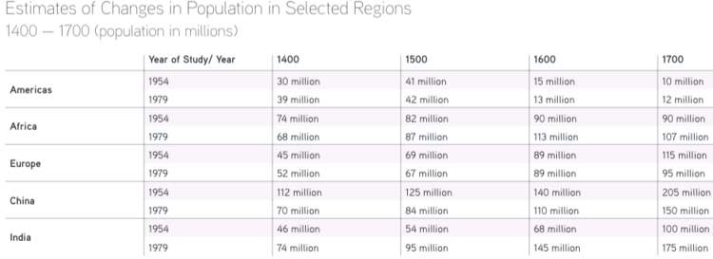
Let's ignore the difference between the numbers the demographers used in 1954 and 1979 for a few minutes. Instead, let's look at the trends in each region.
What happened to the population in the Americas between 1400 and 1700? What happened to the population in Africa between 1400 and 1700? How about Europe, India, and China? Were there any dramatic increases or decreases in population in any of the regions?
The figures for the Americas between 1500 and 1700 really stand out. This region of the world had a very significant decline in population, losing somewhere around 30 million people during that time. There is no other region of the world that had such a dramatic drop in population. China, India, and Europe had dramatic growth in population over that time. Africa either had very modest growth, or possibly even a small decline.
Two questions about these figures come to mind: Why are there differences in population estimates? What explains the decline in population in the Americas?
Analyzing the numbers
Why did historians from 1954 and 1979 come up with different numbers for historical populations? My guess is that they were looking at different sources of evidence.
In general, Europeans and the Chinese kept track of their own population numbers through census data — counting the population — which I'm guessing they did mainly for financial reasons. They had to keep track of who needed to pay taxes to the government. This type of tracking may have extended to the areas they traded with, namely India and Africa.
However, the difference in numbers in India and China are really striking. It appears that the population of China was greatly exaggerated in 1954, while the population of India was greatly underestimated. In 1954, both India and China were in political turmoil. This may have made it difficult to get accurate numbers from reliable records. By 1979, things had settled down a bit in both countries.
I already learned about the "great dying" that occurred among the native population of the Americas due to lack of resistance to European diseases.
The historian Robert McCaa agrees that "a demographic disaster occurred and that epidemic disease was a dominant factor." However, McCaa adds that it was more than just disease that had such a catastrophic impact on these people.
To understand why there was such a huge population decline, we must also consider other factors. One factor was "massive harsh treatment." This included "forced migration, enslavement, abusive labor demands, and exorbitant tribute payments," like taxes.
In addition, there was the "ecological devastation accompanying Spanish colonization." The Europeans introduced new plants and animals to the Americas — including weeds, pathogens and rats — which wrecked local species of plants and animals. Many animals were also killed in the widespread fur trade.
So actually, it's the combination of disease, harsh treatment and the destruction of their food sources that led to an almost 55 percent decline in the native people living in Mexico.
Historians often work from partial evidence and must make educated guesses based on that evidence. Regardless of exactly how many native Americans died over that 200-year period, two things seem to be clear:
First, the loss of human life was devastating and must have destabilized the agrarian civilizations that had been thriving in the Americas.
Second, the diseases that Europeans brought with them must have contributed to their ability to conquer these civilizations.
Conclusion
So what were the consequences of the Columbian Exchange?
Looking at the charts above, I can conclude that the world's separate regions were truly connected for the first time. This happened through an exchange of goods across the oceans.
The historians J.R. and William McNeill believe these are some of the main consequences of the exchange:
—It made the world slightly richer. There were more goods on the move, more cash changing hands.
—More crops were spread over larger portions of the globe.
—It made the disease pools more homogeneous: more and more people were exposed to the same diseases and developed new resistance to them.
— It made the world more unequal because some populations were better able to take advantage of the new connections than others.
Still, the pace of change was still relatively slow. Crossing the Atlantic by ship took a month. It still took over a year for people, goods, and information to spread over the Earth. While the networks had become global, stuff was still moving rather slowly.

