Career Match Exercise – Activity Two: Discover New Career Options
- Clear/Backspace the Search Careers box and any other filters you may have applied so that all of your original job matches reappear.

- Narrow your results by checking the Associates Degree, Bachelor’s Degree, and/or Graduate Degree boxes on the left column of the page.
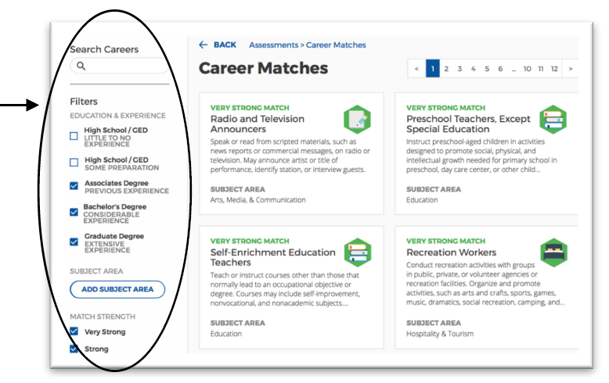

- Scroll through all of your Very Strong and Strong career matches. You can filter your results to display very strong and strong matches by selecting those filters on the left.

- Be sure to scroll to the bottom of each page to view all career tiles.
- As you read your Very Strong and Strong career matches, stop to read any careers that you are unfamiliar with. If the description is interesting or unclear to you, click the career to read the detailed description.

- On the next page, list three careers (from your Very Strong and Strong career matches) that you had not previously considered.

- After reading the more detailed job description, what facts about it were interesting to you? Do you feel this career is something you’d enjoy?

REMEMBER! Your very strong and strong matches will cover a wide variety of fields. If you have a
wide variety of interests and passions you can still pursue them outside of your career/major
choice. For example, if you are passionate about serving in your church, it might be listed as a
very strong match for you. You might choose to pursue that as a major or profession. If you
choose one of your other strong matches for your career, you can still fulfill your passion for serving in your church by pursuing it on a volunteer basis.

Career Match Exercise – Activity Two: Discover New Career Options

Job/Career Name | Thoughts and Observations
Marketing & Events Coordinator | Link
Marketing Coordinator | Link
Marketing Manager | Link

