1. Take the PTB Personality Survey BEFORE doing anything else in this module.

psyc 102 | Tue, Sep 28, 11:08 PM (11 hours ago)
This is my PTB result.

- You prefer a certain amount of change and variety and become dissatisfied when hemmed in by restrictions and limitations. At times you are extroverted, affable, sociable, while at other times you are introverted, wary, and reserved. You have a great deal of unused capacity which you have not turned to your advantage. You have a tendency to be critical of yourself. You have a strong need for other people to like you and for them to admire you. You have found it unwise to be too frank in revealing yourself to others. You pride yourself on being an independent thinker and do not accept others' opinions without satisfactory proof. At times you have serious doubts as to whether you have made the right decision or done the right thing. Disciplined and controlled on the outside, you tend to be worrisome and insecure on the inside. Some of your aspirations tend to be pretty unrealistic. Your sexual adjustment has presented some problems for you. While you have some personality weaknesses, you are generally able to compensate for them.

  - On a scale of 0-10, how accurate would you say the results of the survey describe you. Answer only with one number. (Don't ignore this -- there is a reason for this)

Example:
9
==================================================
==================================================

2. Before reading the rest of the questions below, describe your personality. Also, list four adjectives that describe you.

3. Take the Myers Brigg Personality Test (Jung Typology Test) here: http://www.humanmetrics.com/cgi-win/jtypes2.asp
- Post your score (four letters and four number) My Score; I N F J

Example:
I S T J
0 14 3 0
- On a scale of 0-10, how accurate would you say the results of the survey describe you. Answer only with one number.
Example:
7
- Post your personality type
Example
ISTJ
Introverted Sensing Thinking Judging

- Describe your personality type, according to the link site or other reputable source. You may copy and paste, but you MUST cite your source
- Explain how your personality matches the personality type. Give a specific example.
- Name two famous people (real or fictional) with the same personality type as yours and post their pictures (cite your source)

4. Take the Big Five Personality Test (16 personalities) here: https://www.16personalities.com/free-personality-test. MY PERSONALITY TYPE IS
LOGISTICIAN
ISTJ-T

- Post your score (four letters and four number)
- On a scale of 0-10, how accurate would you say the results of the survey describe you. Answer only with one number.
- Post your personality type
Example
Your personality type is:
Adventurer
ISFP-T

- Describe your personality type, according to the link site or other reputable source. You may copy and paste, but you MUST cite your source.
- Explain how your personality matches the personality type. Give a specific example
- Name two famous people with the same personality type as yours. Post their pictures (cite your source)

4. Which of the personality scores do you believe are the most accurate and describe your personality best? Explain.

5. Respond to someone with the same (or similar) personality score to yours. Explain how your personalities are similar. Find out if your backgrounds are similar too. (please look for student sample post below and use as a guide and Please write a response to that.

Notes:
Check formatting -- should be readable and inside margins. If you can't format it properly, just write "Blackboard Sucks" somewhere in your post.
Use full sentences, in context (except personality scores and accuracy rating)
Don't ignore instructions highlighted in yellow (5 points off!)

Student sample post.
RE: Personality Assessments [20]
Collapse

1. Take the PTB Personality Survey BEFORE doing anything else in this module. (Link to PTB is at beginning of personality notes if this doesn't work )

  - On a scale of 0-10, how accurate would you say the results of the survey describe you? Answer only with one number. (Don't ignore this -- there is a reason for this)
10
2. Before reading the rest of the questions below, describe your personality. Also, list four adjectives that describe you.
I would say that I am a loving, likable, trustworthy, and generous person. I love to make people laugh no matter what mood I am in that day, and no matter how rude or mean someone is to me I can never be rude or mean to that person. I also believe that I am one of those amazing friends that would do anything for a friend that needs help no matter the situation or the place they are in.
3. Take the Myers Brigg Personality Test (Jung Typology Test) here: http://www.humanmetrics.com/cgi-win/jtypes2.asp
- Post your score (four letters and four numbers)
I N F J
28 12 31 31
- On a scale of 0-10, how accurate would you say the results of the survey describe you. Answer only with one number.
8
- Post your personality type
I N F J
Introverted iNtuitive Feeling Judging

- Describe your personality type, according to the linked site or other reputable source. You may copy and paste, but you MUST cite your source
According to https://www.personalitypage.com/html/INFJ.html
INFJs are gentle, caring, complex, and highly intuitive individuals. Artistic and creative, they live in a world of hidden meanings and possibilities. Only one percent of the population has an INFJ Personality Type, making it the rarest of all the types.
INFJs place great importance on havings things orderly and systematic in their outer world. They put a lot of energy into identifying the best system for getting things done, and constantly define and redefine the priorities in their lives. On the other hand, INFJs operate within themselves on an intuitive basis which is entirely spontaneous. They know things intuitively, without being able to pinpoint why, and without detailed knowledge of the subject at hand. They are usually right, and they usually know it. Consequently, INFJs put a tremendous amount of faith into their instincts and intuitions. This is something of a conflict between the inner and outer worlds and may result in the INFJ not being as organized as other Judging types tend to be. Or we may see some signs of disarray in an otherwise orderly tendency, such as a consistently messy desk.
- Explain how your personality matches the personality type. Give a specific example.I would say that the personality type matches my personality very well. I am very gentle and caring even with people I do not know. Sometimes I ask myself why I care so much but it is just my nature. As much as I love to care for people I keep my friendship circle very small and it works very well for me.
- Name two famous people (real or fictional) with the same personality type as yours and post their pictures (cite your source)
Benedict Cumberbatch
Nelson Mandela
Source: https://www.sosyncd.com/infj-famous-people/
4. Take the Big Five Personality Test (16 personalities) here: https://www.16personalities.com/free-personality-test
- Post your score (four letters and four numbers)
I N F J
64 68 74 78
- On a scale of 0-10, how accurate would you say the results of the survey describe you. Answer only with one number.
I would say 9
- Post your personality type
Your personality type is:
Advocate
INFJ-T
- Describe your personality type, according to the linked site or other reputable source. You may copy and paste, but you MUST cite your source.
According to https://www.16personalities.com/infj-personality
Advocates are the rarest personality types of all. Still, Advocates leave their mark on the world. They have a deep sense of idealism and integrity, but they aren’t idle dreamers – they take concrete steps to realize their goals and make a lasting impact. Advocates’ unique combination of personality traits makes them complex and quite versatile. For example, Advocates can speak with great passion and conviction, especially when standing up for their ideals. At other times, however, they may choose to be soft-spoken and understated, preferring to keep the peace rather than challenge others.
- Explain how your personality matches the personality type. Give a specific example
My personality matches this personality type so well. Speak when I need to speak, stand up for my rights, also communicate with people in deep ways but most times I rather stay quiet than challenge a person even when I know I am right.
- Name two famous people with the same personality type as yours. Post their pictures (cite your source)
Pharrell Williams
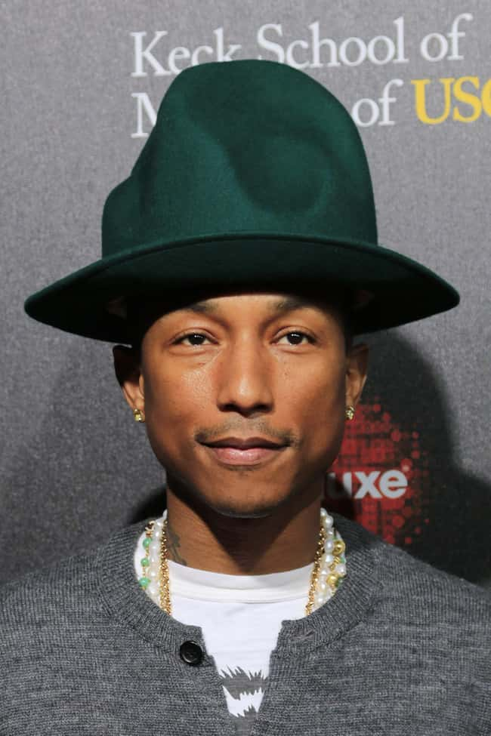

Oprah Winfrey
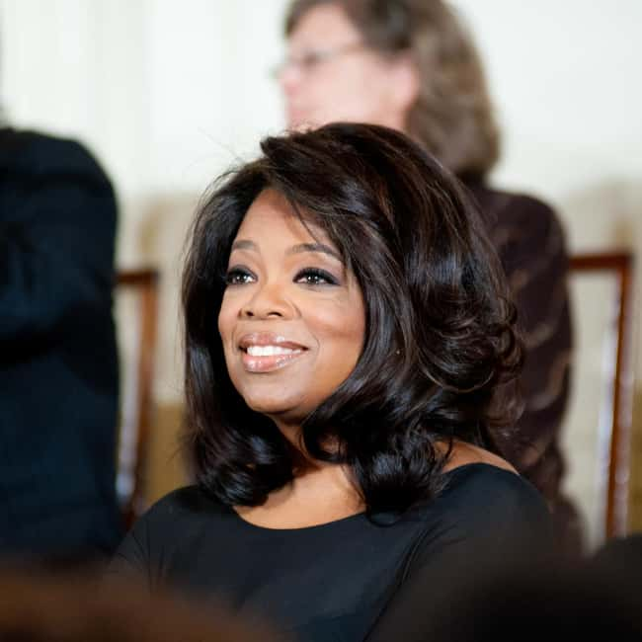

Source: https://www.ranker.com/list/famous-infjs/celebrity-lists
4. Which of the personality scores do you believe are the most accurate and describe your personality best? Explain.
I suppose both of my personality tests are correct and accurately represent my personality because I received the same category on both, which is exactly how I see myself fitting into this personality type.

