Career Match Exercise – Activity One: Search a Specific Major or Career
- In the first column of the chart below, list three possible jobs/careers you are interested in for your future or that you have considered previously.
- When people ask you why you want to go to college, what you want to do
after college, or what you want to major in…what do you tell them?
- What did you say as a child when people asked what you wanted to be
when you grew up?
Job/Career Name | Match Strength | Thoughts and Observations
Head of People of Operations | Strong | Link
Sales Operation Mangers | Very Strong | Link
Assistant Marketing Manager | Strong | Link

- Use the search bar in the top left corner to search each of the three careers you listed in Step One.
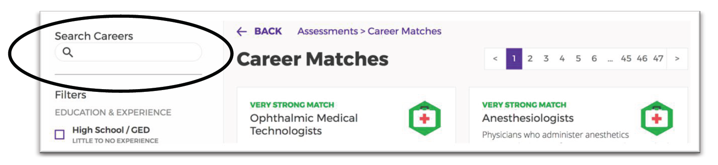
- You might have to search a few related names of a career. For example, “doctor” does not find any results, but “physician” will pull up a variety of options for medical professions. If your search does not yield any results, try a more general or specific name.
- If you had to search for a different job name to find the career you are interested in, list that under the job/career name box as well.

- In the above chart, list the Match Strength for each of the three careers you searched.
- Click on each career tile to read more about the jobs. Based on what you have learned, provide your thoughts and observations. Is this career still one you would consider?

Remember! Enjoying a career is not about how much money you make. It is about pursuing a career that is a right fit for your personality and interests. You might discover a career you were planning to pursue isn’t the best fit for you. Take into consideration the results that are a stronger fit even if you had not considered them before.

