Research Essay
Words : 2000

Essay Question :
What dangers does climate change present to Australia and is Australia doing enough to address these?

In this piece of assessment must write a research essay answering one question
A research essay is an essay that answers a question using information gathered from scholarly research. The two most important things to remember when working on this essay are to answer the question in a direct, systematically developed and meaningful way, to make an argument in other words, and to make your argument based on substantive scholarly research (at least six sources)

Essays must be referenced fully and correctly, using the current Harvard.
Please be sure to present your response as an essay not a report. This means you should:
- include the set question in full, not an interpretation of this.
- write an introduction, not an executive summary.
- do not use numbered subheadings.
- use complete paragraphs of about 10-15 lines, not dot points.

Essay Question :
What dangers does climate change present to Australia and is Australia doing enough to address these?
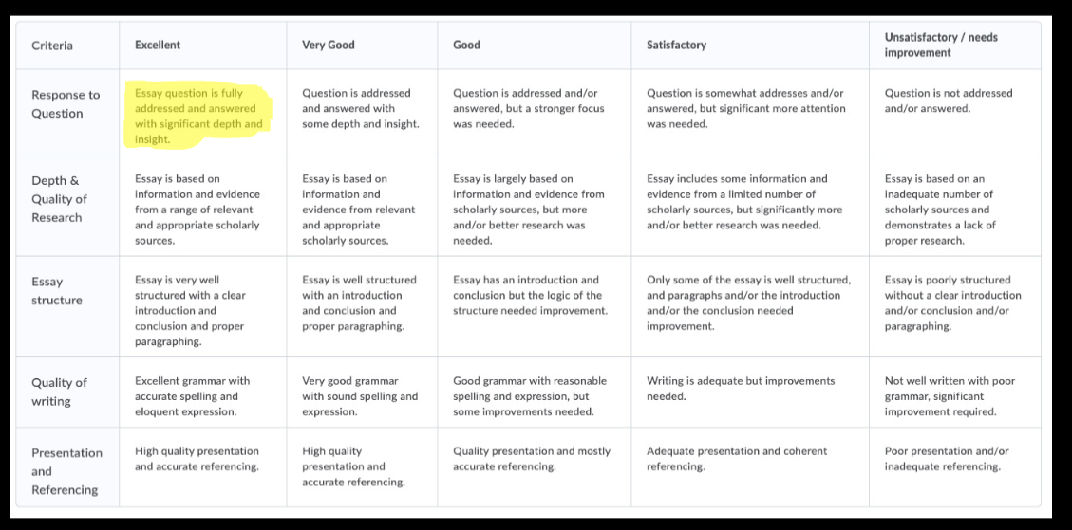

Always include the full essay question in its exact wording at the beginning of your essay.

Essay structure :
Excellent essays tend to have excellent introductions, so here is what is suggested for the important opening paragraph, these three things in any order.
1) Orient the reader to the topic.
2) Highlight your main assertion which encapsulates your argument; and
3) Indicate the three or four main points which will form the basis (even topic sentences) of your following paragraphs.
This is how you establish the terms of your analysis. For best results, you should try to do this in no more than 15 concise but detailed and well drafted lines.
Paragraphing
•Make sure all paragraphs are complete paragraphs, using TEEL for example (Topic, Example, Elaboration, Link)
•Keep your paragraphs to a standard 10-15 lines with one main assertion (and supporting evidence) per paragraph
•Link back. Don't forget to directly link each of your paragraphs to the key assertions established in your introduction. This situates your evidence within a robust analytical structure.

Conclusion
•The conclusion should restate the substance of your overall argument, using fresh language to highlight your main assertions and offering some final thoughts on the topic. The conclusion and introduction serve as the bookends of your work and need to directly address the thesis question.
•This is your final opportunity to convince the reader that your
interpretation is compelling and accurate so don’t waste it!

