Hanzhe Fang
Professor Clancy Tripp
ENGLISH 1110.01
June 23. 2021
Process Post 4
So far, I have learned that society has evolved in terms of its perception of sexual orientations. While traditionally, societies only considered heterosexual relationships morally right, queer behaviors are being embraced. It was particularly interesting to learn that the process of embracing and even providing constitutional protections to queer individuals has not been easy. At some particular point, it has been considered morally and sexually harmful (DiVA). However, it seems that with proper education and scientific research, queer behaviors will be perceived as normal, and most problems are solved.
Among the secondary sources chosen, the article titled Policies on Homosexuality in the Swedish Parliament Between 1933-2010 seems particularly important to my analysis. It addressed an important topic that is presented in my primary sources. The sexual orientation issue is a theme that the primary source addresses. I believe that affirmative actions need to be taken to address issues around this topic. The author’s ideas are similar to my initial ideas in that it presents information about homosexuality. According to the author, the development of transexual policy evolved from criminalization to the legalization and protection by the constitution (DiVA). The author, just like I, holds that scientific insights should provide a basis for handling sexual orientation issues.
My ideas about the primary sources are evolving because the secondary sources are adding new perspectives to them. In the beginning, I just took the information provided to the surface. For instance, I initially perceived that everyone should embrace those engaged in queer behavior without any restriction. However, one of the pictures changed my perception. As society embraces homosexuality, for example, there will be a need to consider its risk. All individuals, regardless of their sexual orientation, need to curb sexually transmitted infections.
Images
Figure 1. While the image shows the love between two lesbians, it shows that in relationships between individuals of the same sex, one has to have a masculine body while the other should be feminine in their physique. This image may indicate that the traditional perception of sexual relationships lingers despite embracing queer relationships. Retrieved from https://www.healthline.com/health-news/how-stress-from-homophobia-affects-the-mind-and-body-of-lgb-people
Figure 2: This image depicts how microaggressions affect individuals who may have sexual orientations that may be considered abnormal. While the little comments people make may seem harmless, the targets perceive them to be significant, affecting them. Retrieved from https://www.scarymommy.com/how-to-deal-microaggressions/

Figure 3: This image shows that the health of the LGBTQ community is a significant consideration that stakeholders should pay attention to. Healthy habits, such as the use of protection and enhanced access, should be promoted. Retrieved from https://batonrougeclinic.com/lgbtq-people-are-more-at-risk-for-these-health-issues/
Figure 4: The flag in this picture is meant to celebrate queer individuals. However, instead of celebrating, different forces are pointing fingers at a queer individual, causing shame, which results in the individuals not celebrating their pride. Retrieved from https://www.outsmartmagazine.com/2021/06/developing-a-real-sense-of-pride/

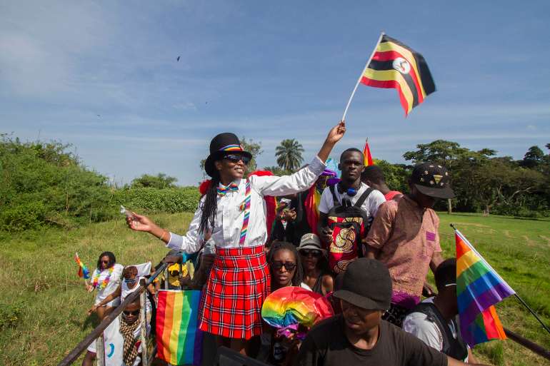
Figure 5: Image showing that even Blacks who may be highly reluctant to embrace queer individuals are slowly accepting them. Retrieved from https://www.aljazeera.com/opinions/2021/6/19/the-ugandan-government-pernicious-use-of-anti-lgbtqi-policies

