Hanzhe Fang
Professor Clancy Tripp
ENGLISH 1110.01
May 26, 2021
Presentation of Heterosexuality
The Two Primary Sources Summaries
The primary sources that I want to work with are published books and artifacts. The reason for choosing books is because they contain comprehensive and reliable information about heterosexuality or the image of boys and girls relationship for many years. Therefore, it will contain a wide variety of information and perspectives that have been developed over the years regarding the relationship between boys and girls. That means that collecting the different views of boy and girl relationships across different cultures will be possible. Additionally, it will provide how heterosexual relationships are viewed based on religious, social, political, and social perspectives. However, the problem is searching for the right kind of books written by professional and qualified authors using sufficient and creditable evidence.
The reason for choosing artifacts is that they present significant themes, ideas, beliefs, and strategies relating to the definition of heterosexual relationships across different cultures. Artifacts provide a concrete material culture that is tangible and in support of the texts provides in books. In other words, artifacts provide tangible and physical evidence that complement the text-based evidence provides about the relationships between boys and girls of a specific culture. It helps ease the process of finding the difference in the beliefs and perspectives about boy and girl relationships between different cultures. For example, there is a big difference between artifacts representing the heterosexual relationship between whites and blacks.
The Final Primary Source Chosen
The primary sources that I opted to continue working on researching about the topic of heterosexual presentation in society are books. An example of a book that I would pursue and analyze more on the topic is "The Invention of Heterosexual Culture" by Louis-Georges Tin, published in 2012. The book contains information on first-hand opinions and views of people from different cultures about their beliefs and views about heterosexuality. The author then provides his opinions and views on heterosexuality based on his experience and opinions of people across different cultures. The author provides an in-depth description of his view on the origin and issues related to heterosexual relationships across different cultures and religions. The author is cautious about the demographical factors influencing or shaping up the belief and attitudes of heterosexual relationships in society. The author also reveals the importance of addressing the issue regarding LGBTQ relationships that have developed over time and how society has received it to highlight the heterosexual relationship culture. The book is connected to several themes learned throughout the course, like homophobic beliefs and sexual orientation issues. That is why it is an ideal primary source that I would like to pursue more throughout the course.

Images
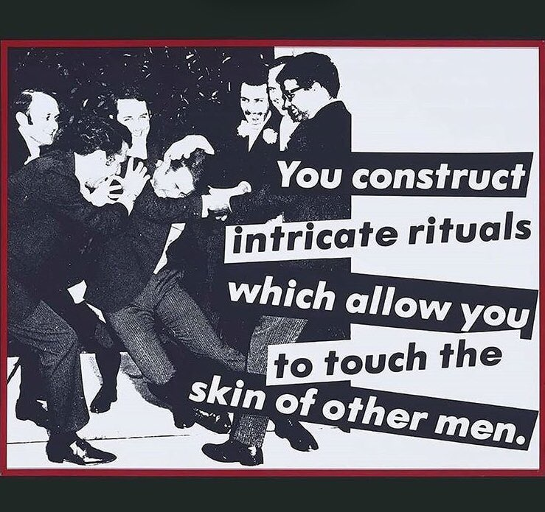
Figure 1. A representation of the heterosexuality development in the society, Credit to Dr. William Ryan Force
Figure 2. Image depicting different concepts and issues that led to the development of heterosexual relationships in society (Fidolini).
Figure 3.A heterosexual relationship that is broken (Naftulin)

Work Cited
Fidolini, Vulca. "The Making of Heterosexuality." Hypotheses, 2019. Retrieved from https://sms.hypotheses.org/21459
Force, R. William. 2020. Retrieved from https://twitter.com/ProfessorForce/status/1224339007741534216/photo/1
Naftulin, Julia. "Why heterosexual relationships are so bad for us, according to a sex researcher." Insider, 2020. Retrieved from https://www.insider.com/why-straight-relationships-are-doomed-according-to-sex-researcher-2020-12
Tin, Louis-Georges. The Invention of Heterosexual Culture. Cambridge, MA: MIT Press, 2012. Print.

