ACTIVITY 4
MH688 Health Care Economics and Financial Management

Lesson 4: Financial Statement Development

Activity 4: Financial Statement Development (100 points)

You are presented with the following information for Black Hawk Memorial Hospital, a for-profit hospital with a standard stockholder’s equity structure, as outlined in the Lecture and Readings. Please answer each part as directed below. Your Activity responses should be both grammatically and mechanically correct, and formatted in the same fashion as the Activity itself. If there is a Part A, your response should identify a Part A, etc. In addition, you must appropriately cite all resources used in your response and document in a bibliography using APA style. (100 points) (A 3-page response is required.)
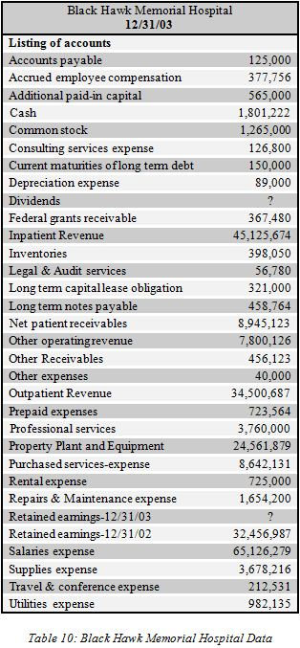
Part A | For each account stated above, classify it as an asset, liability, owner’s equity item, revenue, or expense. In addition, describe which financial statement it belongs to in the worksheet presented below. (64 points)
 | 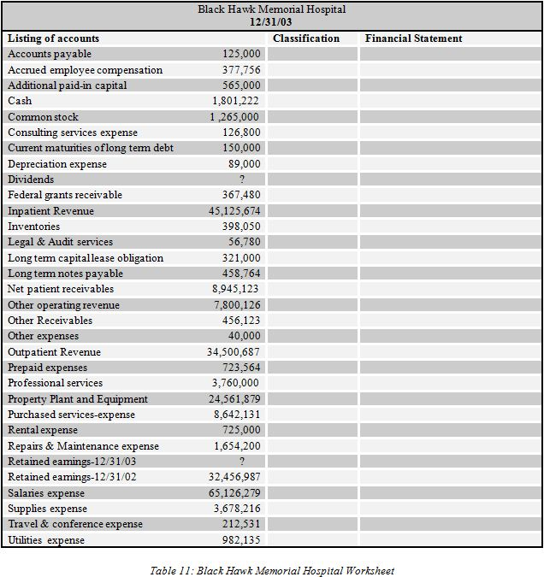
Part B | First, prepare the following financial statements: Income Statement, Statement of Retained Earnings, and the Balance Sheet. Keep in mind the articulation principle and the accounting equation. Also, make sure that you are preparing a “classified” balance sheet. In order to complete all financial statements, you must calculate the dividends and retained earnings figures. Show your calculations. (36 points)

