Hanzhe Fang
Professor Clancy Tripp
English 1110
May 21, 2021
Presentation of Heterosexuality
Step 1 & 2: Videos
PechaKucha- https://www.pechakucha.com/presentations/gender--sex-and-sexuality-828
TED- https://www.ted.com/talks/lindsay_amer_why_kids_need_to_learn_about_gender_and_sexuality
Ignite- http://www.ignitetalks.io/videos/be-a-boss-not-a-bitch
Step 3 & 4: Topics & Primary Sources
The primary sources that I want to work with are published books, artifacts, and speeches. The reason for choosing books is because they contain comprehensive and reliable information about heterosexuality or the image of boys and girls relationship for many years. Therefore, it will contain a wide variety of information and perspectives that have been developed over the years regarding the relationship between boys and girls. That means that collecting the different views of boys and girls relationships across different cultures will be possible. Additionally, it will provide how heterosexual relationships are viewed based on religious, social, political, and social perspectives. However, the problem is searching for the right kind of books written by professional and qualified authors using sufficient and creditable evidence.
The reason for choosing artifacts is that they present significant themes, ideas, beliefs, and strategies relating to the definition of heterosexual relationships across different cultures. Artifacts provide a concrete material culture that is tangible and in support of the texts provides in books. In other words, artifacts provide tangible and physical evidence that complement the text-based evidence provides about the relationships between boys and girls of a specific culture. It helps ease the process of finding the difference in the beliefs and perspectives about boys and girls relationship between different cultures. For example, there is a big difference between artifacts representing the heterosexual relationship between whites and blacks.
The third primary source will be speeches because they contain a lot of information regarding going stereotypes held by individuals about relationships of boys and girls. The majority of speeches regarding human sexuality are either informative or persuasive. In the speeches, people provide their beliefs and issues relating to the boy and girl relationships. The speech themes and information reveal or confirm the claims and issues raised on solid sources like books and artifacts.

Step 5: Images
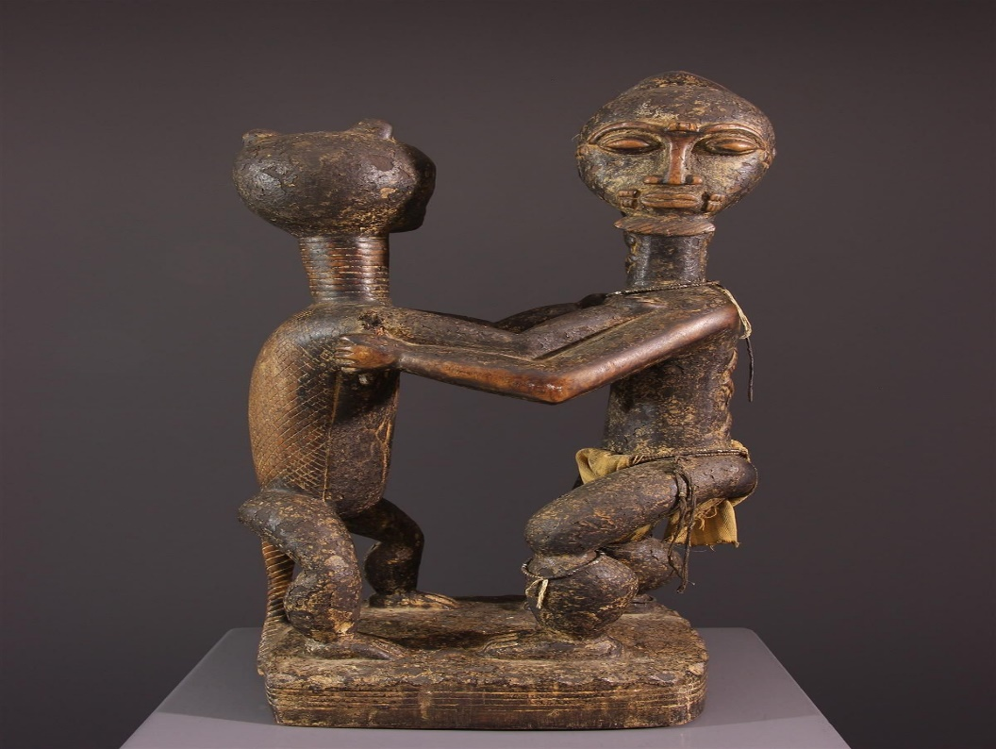
Figure 1.Figure Baoulé anthropo-zoomorphic (N ° 12583)
Link: https://www.galerie-art-africain.com/Art-africain/Statues-statuettes/Figure-Baoule-anthropo-zoomorphe/12583
An artifact representing an intimate relationship between a man and a woman. It presents a possible perspective about the expected relationship between a man and a woman in a specific culture.
Figure 2. The image represents a book written by James Joseph Dean.
Link: https://www.google.com/url?sa=i&url=https%3A%2F%2Fwww.timeshighereducation.com%2Fbooks%2Fstraights-heterosexuality-in-post-closeted-culture-by-james-joseph-dean%2F2016558.article&psig=AOvVaw1hZYl5FVWUt_L_y-uGMuzO&ust=1621690313676000&source=images&cd=vfe&ved=0CAIQjRxqFwoTCJjB2q-H2_ACFQAAAAAdAAAAABAD
It a book that contains a comprehensive analysis of the perception of homophobia across different cultures.

