PSY-362 Social Psychology and Cultural Applications
Implicit Prejudice – Implicit Association Test (IAT)

The Implicit Association Test (IAT) is a popular and respected method for measuring implicit attitudes and beliefs. In this exercise, you are to try an IAT (one on racial bias and one on gender bias) for yourself. There are many possible tests available at the Project Implicit website; however tests named "Racial Bias Black/White Adults" and "Gender Bias" will be the most pertinent to this week's module.

Go to the website: https://implicit.harvard.edu/implicit/

You may register to take the test; our suggestion is that you use the guest setting
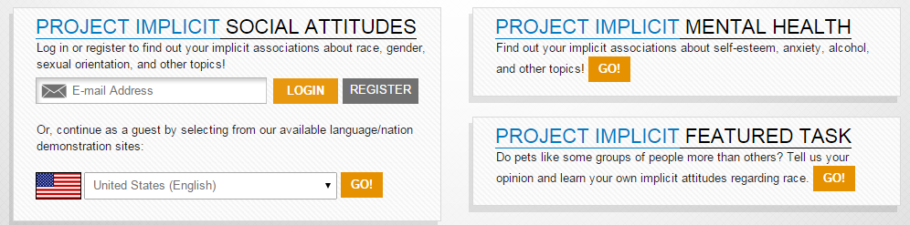

Click on “I wish to proceed” at the end of the paragraph.
Continue following the directions on the screen. If you encounter any concerns please let your instructor know.
Once you have completed a test return to the assignment directions to finish the assignment for this topic.

