Marketing Expenses versus Rival Firms
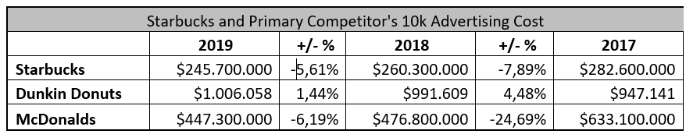

Diagramming Existing and Proposed Organizational Chart

