Remembering Allan McDonald: He Refused To Approve Challenger Launch, Exposed Cover-Up
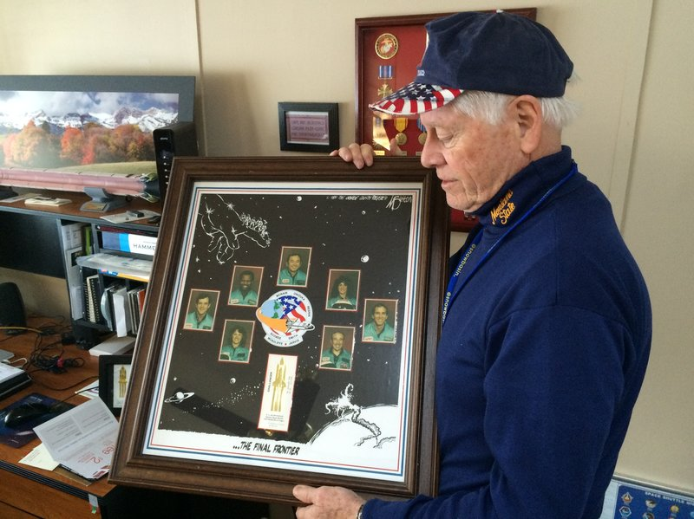
Allan McDonald in 2016 holds a commemorative poster honoring the seven astronauts killed aboard the space shuttle Challenger.
Howard Berkes/NPR
On Jan. 27, 1986, Allan McDonald stood on the cusp of history.
McDonald directed the booster rocket project at NASA contractor Morton Thiokol. He was responsible for the two massive rockets, filled with explosive fuel, that lifted space shuttles skyward. He was at the Kennedy Space Center in Florida for the launch of the Challenger "to approve or disapprove a launch if something came up," he told me in 2016, 30 years after Challenger exploded.
His job was to sign and submit an official form. Sign the form, he believed, and he'd risk the lives of the seven astronauts set to board the spacecraft the next morning. Refuse to sign, and he'd risk his job, his career and the good life he'd built for his wife and four children.
"And I made the smartest decision I ever made in my lifetime," McDonald told me. "I refused to sign it. I just thought we were taking risks we shouldn't be taking."
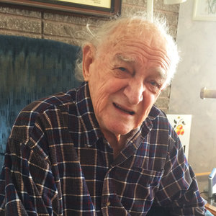
The Two-Way
Your Letters Helped Challenger Shuttle Engineer Shed 30 Years Of Guilt
McDonald persistently cited three reasons for a delay: freezing overnight temperatures that could compromise the booster rocket joints; ice forming on the launchpad and spacecraft that could damage the orbiter heat tiles at launch; and a forecast of rough seas at the booster rocket recovery site.
He also told NASA officials, "If anything happens to this launch, I wouldn't want to be the person that has to stand in front of a board of inquiry to explain why we launched."
Now, 35 years after the Challenger disaster, McDonald's family reports that he died Saturday in Ogden, Utah, after suffering a fall and brain damage. He was 83 years old.
"There are two ways in which [McDonald's] actions were heroic," recalls Mark Maier, who directs a leadership program at Chapman University and produced a documentary about the Challenger launch decision.
"One was on the night before the launch, refusing to sign off on the launch authorization and continuing to argue against it," Maier says. "And then afterwards in the aftermath, exposing the cover-up that NASA was engaged in."
Twelve days after Challenger exploded, McDonald stood up in a closed hearing of a presidential commission investigating the tragedy. He was "in the cheap seats in the back" when he raised his hand and spoke. He had just heard a NASA official completely gloss over a fundamental fact.
McDonald and his team of Thiokol engineers had strenuously opposed the launch, arguing that freezing overnight temperatures, as low as 18 degrees F, meant that the O-rings at the booster rocket joints would likely stiffen and fail to contain the explosive fuel burning inside the rockets. They presented data showing that O-rings had lost elasticity at a much warmer temperature, 53 degrees F, during an earlier launch.
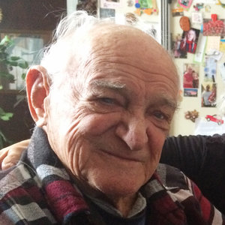
The Two-Way
Challenger Engineer Who Warned Of Shuttle Disaster Dies
The NASA official simply said that Thiokol had some concerns but approved the launch. He neglected to say that the approval came only after Thiokol executives, under intense pressure from NASA officials, overruled the engineers.
"I was sitting there thinking that's about as deceiving as anything I ever heard," McDonald recalled. "So ... I said I think this presidential commission should know that Morton Thiokol was so concerned, we recommended not launching below 53 degrees Fahrenheit. And we put that in writing and sent that to NASA."
Former Secretary of State William Rogers chaired the commission and stared into the auditorium, squinting in the direction of the voice.
"I'll never forget Chairman Rogers said, 'Would you please come down here on the floor and repeat what I think I heard?' " McDonald said.
The focus of the commission's investigation shifted to the booster rocket O-rings, the efforts of McDonald and his colleagues to stop the launch and the failure of NASA officials to listen.
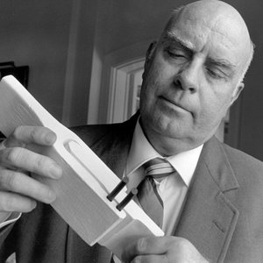
The Two-Way
Remembering Roger Boisjoly: He Tried To Stop Shuttle Challenger Launch
Morton Thiokol executives were not happy that McDonald spoke up, and they demoted him.
That alarmed members of the presidential commission and members of Congress. Rep. Edward Markey, a Massachusetts Democrat, introduced a joint resolution in the House that threatened to forbid Thiokol from getting future NASA contracts given the company's punishment of McDonald and any other Thiokol engineers who spoke freely.
The company relented, and McDonald was promoted to vice president and put in charge of the effort to redesign the booster rocket joints that failed during the Challenger launch.
In 1988, the redesigned joints worked successfully as shuttle flights resumed.
McDonald continued to work at Thiokol until 2001 and retired after 42 years. He later co-authored one of the most definitive accounts of the Challenger disaster — Truth, Lies, and O-Rings: Inside the Space Shuttle Challenger Disaster.
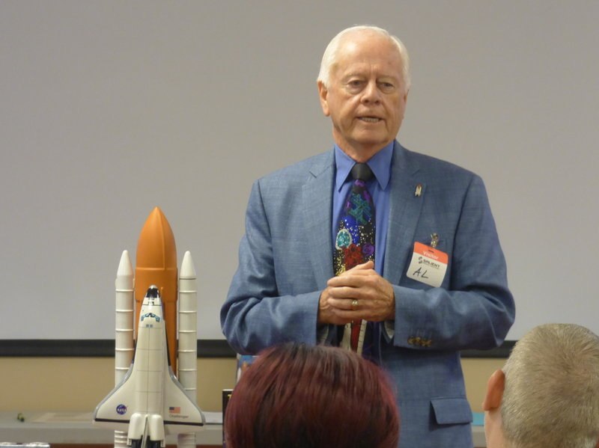
In 2018, Allan McDonald reviewed the Challenger launch decision during a series of seminars about leadership and ethical decision-making to managers at U.S. Space Command.
Mark Maier
In retirement, McDonald became a fierce advocate of ethical decision-making and spoke to hundreds of engineering students, engineers and managers. He and Chapman University's Maier held leadership and ethics seminars for corporations and government agencies, including U.S. Space Command.
Maier says that one of McDonald's key moments in his talks helps explain his ability to reconcile his brush with history.
"What we should remember about Al McDonald [is] he would often stress his laws of the seven R's," Maier says. "It was always, always do the right thing for the right reason at the right time with the right people. [And] you will have no regrets for the rest of your life."
"It's really that simple if you just keep it focused that way," McDonald told me in 2016.
Challenger: Reporting a Disaster's Cold, Hard Facts Jan. 28, 2006
He also framed regret another way, paraphrasing a favorite quote from the late journalist Sydney J. Harris.
"Regret for things we did is tempered by time," McDonald said, his expression firm. "But regret for things we did not do is inconsolable." McDonald then paused and added, "That's absolutely true."
He seemed inconsolable immediately after the Challenger explosion in tearful calls home. He recalls the painful conversations in his book. "I feel like it's my fault," he told his daughter Lisa, a nursing student in Boston at the time. "Don't blame yourself, Dad," she said, also crying.
Maier believes McDonald lived out his life with neither blame nor regret. "He died with serenity and equanimity," he says. "I will miss him dearly."
Allan McDonald leaves behind his wife, Linda, and four children — and a legacy of doing the right things at the right times with the right people.

Your Letters Helped Challenger Shuttle Engineer Shed 30 Years Of Guilt

• • • February 25, 20169:07 AM ET
Heard on All Things Considered
Howard Berkes
Facebook Twitter
8-Minute Listen

- Transcript
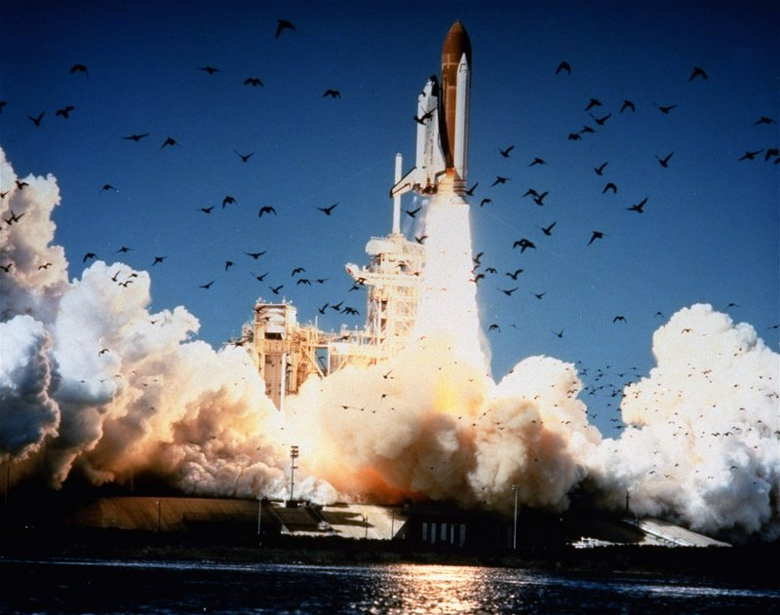
The space shuttle Challenger lifts off from Kennedy Space Center in Florida on Jan. 28, 1986. The entire crew of seven was lost in an explosion 73 seconds into the launch.
NASA/AP
When NPR reported Bob Ebeling's story on the 30th anniversary of the explosion of the space shuttle Challenger, hundreds of listeners and readers expressed distress and sympathy in letters and emails.
On Jan. 27, 1986, the former engineer for shuttle contractor Morton Thiokol had joined four colleagues in trying to keep Challenger grounded. They argued for hours that the launch the next morning would be the coldest ever. Freezing temperatures, their data showed, stiffened rubber O-rings that keep burning rocket fuel from leaking out of the joints in the shuttle's boosters.
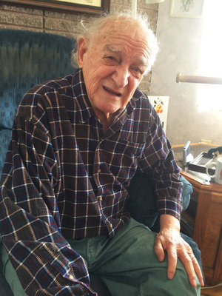
Bob Ebeling, now 89, at his home in Brigham City, Utah.
Howard Berkes/NPR
But NASA officials rejected that data, and Thiokol executives overruled Ebeling and the other engineers.
"It's going to blow up," a distraught and defeated Ebeling told his wife, Darlene, when he arrived home that night.
And it did, 73 seconds after liftoff. Seven astronauts died. Cold weather and an O-ring failure were blamed, and Ebeling carried three decades of guilt.
"That was one of the mistakes God made," Ebeling, now 89, told me three weeks ago at his home in Brigham City, Utah. "He shouldn't have picked me for that job. But next time I talk to him, I'm gonna ask him, 'Why me? You picked a loser.' "
Jim Sides listened to the NPR story in his car in Jacksonville, N.C.
Related NPR Stories
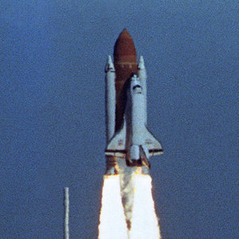
The Two-Way
30 Years After Explosion, Challenger Engineer Still Blames Himself
The Two-Way
Remembering Roger Boisjoly: He Tried To Stop Shuttle Challenger Launch
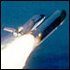
Space
Challenger: Reporting a Disaster's Cold, Hard Facts
"When I heard he carried a burden of guilt for 30 years, it broke my heart," Sides, an engineer, says. "And I just sat there in the car in the parking lot and cried."
Like many engineers who responded to Ebeling's story, Sides knows what it's like to present data and face resistance. He's also certain about who bears responsibility for the decisions that result.
"He and his colleagues stated it very plainly. It was a dangerous day for the launch," Sides says. "But [Ebeling] was not the decision-maker. He did his job as an engineer. He should not have to carry any guilt."
Sides wrote Ebeling a letter that mentioned Roger Boisjoly, a former Thiokol colleague who died in 2012 and rallied the engineers opposing the Challenger launch. Boisjoly addressed his own depression and guilt by making the Challenger experience a case study in ethical decision-making.
Many of the engineers who also wrote Ebeling credited him and Boisjoly for engineering school discussions that focused on the Challenger decision.
Did The White House Force The Challenger Launch?
Many readers and listeners responded to our Challenger anniversary story by repeating claims that the White House, under President Ronald Reagan, pressured NASA to launch Challenger on Jan. 28, 1986.
The State of the Union address was scheduled the same day.
"It is the most vicious and distorted rumor I ever heard," said White House spokesman Larry Speakes, in disclosing the rumor publicly a month after the Challenger tragedy.
The Presidential Commission on the Space Shuttle Challenger Accident concluded "there was total lack of evidence that any outside pressure was ever exerted on those who made the decision to launch."
The commission also found no evidence of a planned satellite link to the space shuttle during the State of the Union speech.
Commission member and skeptic Richard Feynman, who issued a separate Challenger report, conducted his own "surreptitious" investigation. He said he found no evidence of any outside pressure.
"They had an absolutely unrealistic launch schedule," says James Oberg, who spent 22 years at Mission Control at the Johnson Space Center before becoming an outspoken critic of NASA's safety culture.
Oberg cites earlier launch delays, two upcoming launches with planetary probes dependent on precise planetary alignment, and competition from a military space program.
"Your efforts show that your care for people comes first for you," Sides wrote to Ebeling. "I agree with your friend Roger Boisjoly. You and he and your colleagues did all that you could do."
Sides describes himself as a religious man and says Ebeling was wrong about God.
"God didn't pick a loser," he says. "He picked Bob Ebeling."
Ebeling's eyesight is so poor he can't read the letters himself. So his daughter Kathy read them aloud, including the note from Sides.
"That's easy to say," Ebeling responded. "But after hearing that, I still have that guilt right here," he said pointing to his heart.
This was a week after the Challenger anniversary story, and Ebeling sat in a wheelchair at his kitchen table, wearing a flannel shirt and pajamas. Letters and printed emails were stacked in front of him. Kathy picked another letter from the pile and tried again.
"You presented the correct data and blew the whistle," another listener wrote. "You are not a loser. You are a challenger."
Again, Ebeling wasn't moved. So I asked him if there's something more he wanted to hear.
"You aren't NASA. You aren't Thiokol," he said. "I hadn't heard any of those people."
Kathy noted that neither Thiokol nor NASA had contacted her dad since deep depression prompted his retirement shortly after the Challenger disaster.
"He's never gotten confirmation that he did do his job and he was a good worker and he told the truth," Kathy said.
Thiokol has since been absorbed by another company. There isn't anyone there or at NASA today who was likely involved in the launch decision.
Statement From Kathy Ebeling
I just want to thank NPR listeners on behalf of my dad, Robert Ebeling. He has appreciated all the emails, letters and notes from all of you. He has had a turnaround in his feelings of guilt about the deaths of the Challenger astronauts. We, as his family, love all of you and are grateful that you have contacted us. I have read every one of your messages to my dad. He is letting go of the guilt that he has held for 30 years. It is a miracle from God and from all the people who have written to us. I thank all NPR listeners for this amazing gift. My dad does not have much time left and your words are easing his mind.
But some retired participants in that decision are still alive, including 78-year-old Allan McDonald, who was Ebeling's boss at the time and a leader of the effort to postpone the launch. He called Ebeling right away.
McDonald told Ebeling that his definition of a loser is "somebody that really doesn't do anything. But worse yet, they don't care. I said, 'You did something and you really cared. That's the definition of a winner.' "
McDonald also reminded Ebeling that he first raised the alarm by calling the Kennedy Space Center, where McDonald was Thiokol's launch representative. That call prompted the 11th-hour teleconference in which the engineers told NASA it was too risky to launch.
"If you hadn't have called me," McDonald told Ebeling, "they were in such a go mode, we'd have never even had a chance to try to stop it."
McDonald also responded to some NPR listeners who were not sympathetic to Ebeling and the other Thiokol engineers. They said the engineers should have done more, including last-ditch calls to NASA's launch director or even the White House.
"You just don't do that," McDonald said. "They'd probably send a van out with some white coats and picked you up. ... The launch director doesn't take those outside calls either."
Another key participant in the launch decision was Robert Lund, who was Thiokol's vice president for engineering at the time. He was one of the company executives who approved the Challenger launch despite objections from Ebeling, Boisjoly, McDonald and others.
Lund wouldn't agree to a recorded interview, saying, "I don't want to relive it." He was reassigned by Thiokol and so "shamed by the neighbors" that his family was forced to move, he said. "It was a bad dream."
But Lund said he phoned Ebeling and told him, "You did all that you could do."
A former NASA official involved in the Challenger launch also declined to be interviewed. George Hardy was a deputy director of engineering at the Marshall Spaceflight Center, which supervised Thiokol's production of the shuttle's booster rockets. He famously said he was "appalled" when Ebeling and the other engineers argued that Challenger shouldn't fly in temperatures so cold.
Hardy now says he's gone over that night many times.
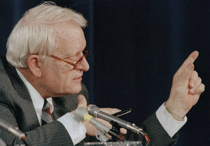
George Hardy speaks during Challenger explosion hearings in Washington, D.C., on Feb. 26, 1986.
Charles Tasnadi/AP
"I've concluded that's of no great value to me or anyone else," he said.
But he did see value in writing to Ebeling.
"You and your colleagues did everything that was expected of you," Hardy wrote. "The decision was a collective decision made by several NASA and Thiokol individuals. You should not torture yourself with any assumed blame."
Hardy closed with a promise to pray for Ebeling's physical and emotional health. "God bless you," he wrote.
The note from Hardy and the phone call from McDonald seemed to be a turning point. It was two weeks now after the Challenger story, and Kathy had been reading letter after letter every day. Sitting in his big easy chair in his living room, Ebeling's eyes and mood seemed brighter.
"I've seen a real change," his daughter explained. "He doesn't have a heavy heart like he did."
Statement From NASA Acting Press Secretary Stephanie L. Schierholz:
We know spaceflight always has been, and will be, risky. Every year, we in the NASA community, including civil servants and contractors, pause to reflect and honor those who gave their lives for the benefit of all humanity. We honor them not through bearing the burden of their loss but by constantly reminding each other to remain vigilant and to listen to those like Mr. Ebeling who have the courage to speak up, so that our astronauts can safely carry out their missions. NASA has changed in many ways as a result, including a more robust management process with more oversight, and more opportunities for independent assessments. A direct recommendation resulting from the Presidential Commission following Challenger was that NASA should establish a separate office to address safety that reports directly to the NASA Administrator. Today NASA not only has the Office of Safety and Mission Assurance but also has independent advisory boards to help ensure we minimize what spaceflight risks we can.
The crews of Challenger and Columbia embraced the risk in a shared pursuit of exploration and discovery. We honor them by making our dreams of a better tomorrow reality and taking advantage of the fruits of exploration to improve life for people everywhere. Mr. Ebeling is part of the NASA community. We encourage him to join us in honoring their sacrifice and recognizing the differences their lives made, especially in NASA's approach to safety. We would welcome him at any of our Day of Remembrance activities.
Ebeling then jumped in.
"I know that is the truth that my burden has been reduced," he said. "I can't say it's totally gone, but I can certainly say it's reduced."
The night before, NASA had sent a statement and Ebeling hadn't heard it yet. The statement was emailed by a spokeswoman for NASA Administrator Charlie Bolden, a former astronaut. He flew on the shuttle flight just before Challenger, and later led the effort to resume shuttle flights safely.
"We honor [the Challenger astronauts] not through bearing the burden of their loss, but by constantly reminding each other to remain vigilant," the statement read. "And to listen to those like Mr. Ebeling who have the courage to speak up so that our astronauts can safely carry out their missions."
After hearing that, Ebeling clapped long and hard, and shouted, "Bravo!"
"I've had that thought many, many times," he said.
Ebeling is now more buoyant than at any time I've seen or talked to him in the past 30 years. It's been a rough three decades, and it hasn't gotten any easier. He's near the end of his predicted life expectancy for prostate cancer and has hospice care at home. He said he'll pray for God's assessment once our interview ends.
I asked him one more question. "What would you like to say to all the people who have written you?"
"Thank you," he said. "You helped bring my worrisome mind to ease. You have to have an end to everything."
Ebeling then smiled, raised his hands above his head and clapped again. Kathy Ebeling called that a miracle.
- challenger disaster
- space shuttle
- NASA

• • •

