Introduction
Design encompasses many disciplines and sub-disciplines: brand design, product design, graphic design, design thinking, design management, interaction design, etc. Fundamentally, the designer must understand what the users/users need, even anticipate his behaviors. Unlike art, design is not an aesthetic without function. If the interest in design is so obvious, it is because of the competition between products and services. As Dieter Rams pointed out in a speech (New York, 1976), the buyer differentiates products based on design. The link between good design and business then becomes obvious. This is not about aesthetics or creativity because the purpose of the object conditions its aesthetics. Indeed, the design process includes technical know-how and rationality (Kirk, 2016).
2- Good design makes a product useful.
Good design makes a product useful. The bestselling point of a product has to be its usefulness. Too often, a design product refers to an object where aesthetics has been put forward to the detriment of its usefulness and its ergonomics. For Dieter Rams, a design object should not be content to be beautiful or beautiful to the detriment of its usefulness; it must have a function to which its design is put. This is one of the reasons why a design product is not a work of art. Anything that can potentially reduce the usefulness of the object is irrelevant.
3- Good design is aesthetic.
Good design looks good. This quality is important because it affects both the utility of the object and its design mode. Thus, an object must be aesthetic because objects affect our person and our well-being by being an integral part of our daily life. And, to meet this criterion, the object must be well-executed, which refers to an idea of ​​quality and know-how. Aesthetics, here, does not designate beauty as a quality distinct from other criteria. The aesthetic dimension arises from the quality of the design. It is beautiful in all aspects of the design. For example, the usability of the product contributes to its beauty. In opposition to the rise of the consumer society, one of the major concerns of the German designer, throughout his career, was to create sober, utilitarian and above all sustainable design products. To do this, Dieter RAMS has drawn up a list of 10 principles that an object must meet in order, according to him, to be "good design". This ideology of utility and sustainability is more relevant than ever in the face of the ecological concerns of our society. And even if these principles can certainly be improved, it remains interesting to know their consistency.
10- Good design is a little design as possible.
Good design is minimalist. On this point, it is important to stress that it is not the “less is more” principle that prevails but rather “less, but better”. Dieter RAMS reminds us that quality takes precedence over quantity and that a good design will concentrate on the essential aspects by excluding “gadget” functions (Telea, 2014).
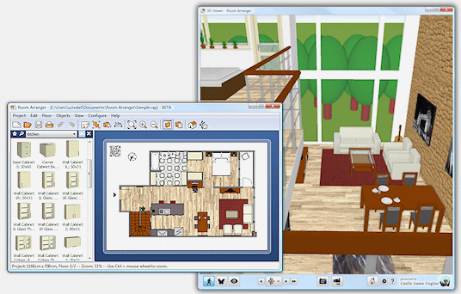
By focusing his work on the primary utility of the object, the designer will avoid the development of accessories subject to variations in fashions and more ephemeral, both technically and aesthetically. In case of implementing the three design principles of a simple example of making a room, it must be aesthetic means it must be as per the taste of the habitats, and there can be the use of the strong foundation of the room as it must be strong and long-lasting. The designing which must be as little as possible. It will be useful if it must have all the features of the room like windows and walls (The power of good design, 2021).
Conclusion
In conclusion, Dieter RAMS '"good design" is anchored in an ecological ideology by promoting the design of sustainable objects. This durability will result from the fact that the product will be well designed, sober, clean, simple, and functional. Anyone attempting to communicate in a new language must first acquire the basics - definitions, functions, and use. These fundamentals are intended for both experienced and new designers, as many people enter the profession without first figuring out what it is. Unfortunately, most believed that design was art, but this is not the case since design form is subject to function, while in art, the goal is aesthetic.

References
Kirk, A. (2016). Data visualization: A handbook for data-driven design. Sage.
The power of good design. 2021. Vitsoe. Retrieved on July 6, 2021, from https://www.vitsoe.com/gb/about/good-design
Telea, A. C. (2014). Data visualization: principles and practice. CRC Press.

