Discourse #17/Jazz
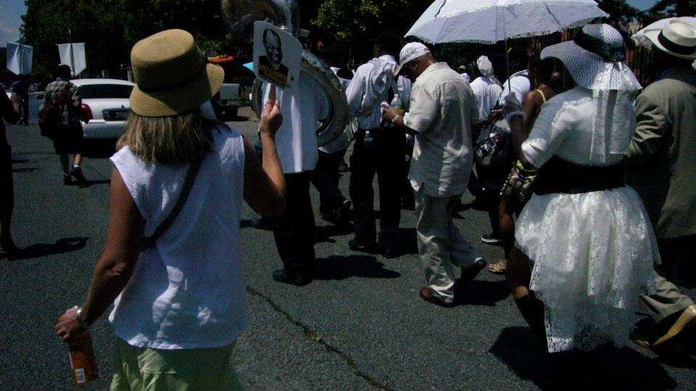
Dona Syman Preservation Brass Band (at the head of the line)

One summer I was lucky enough to travel to New Orleans, the home of Jazz. While I was there, I attended, the annual “Summer Satchmo Festival”. I stayed right in Storyville across the street from the French Quarter where Jelly Roll Morton played his piano in the brothels, and where Louis Armstrong stopped King Oliver on the street to ask him for some quick coronet lessons. I stood right there at the foot of the Louis Armstrong sculpture in the park named after him, and also in Congo Square, the only place where the slaves were allowed to dance to the beat of their native rhythms. I also attended a “Jazz Mass” at Saint Augustine, and danced behind the Preservation Brass Band in a “Second Line” down the streets of Treme, past Brad and Angelina’s house; the 96 degree temperatures did not dissuade me from having one of the best times of my adult life I couldn’t help posting the smile. Once “Pops” captures your heart, and Jazz gets in your blood, there is no turning back.
Read about Jazz in your textbook. Review the links below, then answer the questions below in brief responses. Jazz has a long rich history including many styles, musicians (legends), and dances. I am merely giving you a smidge and some vocabulary in one assignment. Remember this is not a course in Jazz, but a survey art and music appreciation course, a humanities course.

“When the Saints Go Marching In” Danny Kaye and Louis Armstrong
Describe this Jazz performance with Danny Kaye and Louis Armstrong using the link below and the vocabulary definitions for scat, call and response, syncopation, and improvisation. Basically, you are going to tell me where you see and hear scat, improvisation, call and response, and syncopation. Use the definitions found in the link below, then tell me where you see and hear them.
https://www.youtube.com/watch?v=vnX2HxCiGb4
Vocabulary: scat, improvisation, call and response, syncopation
https://ccnmtl.columbia.edu/projects/jazzglossary/archives.html

Briefly answer the questions below using the links provided.

- What was the first Jazz song ever to be recorded?
- What is a Second Line Parade?
- Why was Louis “Satchmo” Armstrong one of the most influential Jazz musicians?
- Why is the Savoy Ballroom famous?
- Why is The Village Vanguard famous?

Second Line Parade:
https://www.neworleans.com/things-to-do/music/history-and-traditions/second-lines/

Louis Armstrong:
https://music.si.edu/story/louis-armstrong
https://www.biography.com/news/louis-armstrong-biography-facts
https://riverwalkjazz.stanford.edu/?q=program/tribute-original-dixieland-jazz-band-live-stanford-jazz-workshop
Louis Armstrong was a popular and much beloved Jazz musician. I am including this link of Armstrong performing “What a Wonderful World”. I really miss him, and so do a ton of other people who were lucky enough to be alive at the same time as “Pops” (another of his affectionate names).
https://www.youtube.com/watch?v=qfuw3CZQuwk
And I have added a live performance with Armstrong playing his Trumpet.
https://www.youtube.com/watch?v=4l3sqspXlao

Savoy Ballroom
https://bluesjazzbookclub.com/2017/12/27/a-brief-introduction-to-savoy-walk/

The Village Vanguard
https://www.npr.org/2008/08/27/94034531/the-village-vanguard-a-hallowed-basement

Additional Reading of some important Jazz Musicians who made significant contributions to Jazz.
Billie Holiday
https://www.youtube.com/watch?v=0MWRheQtvmA
http://blackhistorynow.com/billie-holiday/
Duke Ellington
https://www.youtube.com/watch?v=qDQpZT3GhDg
https://www.songhall.org/profile/Duke_Ellington
Benny Goodman
https://www.youtube.com/watch?v=GwPvLMlGWPI
https://www.pbs.org/wnet/americanmasters/benny-goodman-about-benny-goodman/615/

