Discourse #15

Read about the 19TH century Realist Movement in your textbook and in this link from the Metropolitan Museum of Art https://mymodernmet.com/ . Define Realism, then examine the painting, Third Class Carriage by the French Realist painter, Honore Daumier. Describe it, then explain why it is considered a Social Protest/Realist painting. Make sure you back up your assertions with visual information from the painting. (One page)

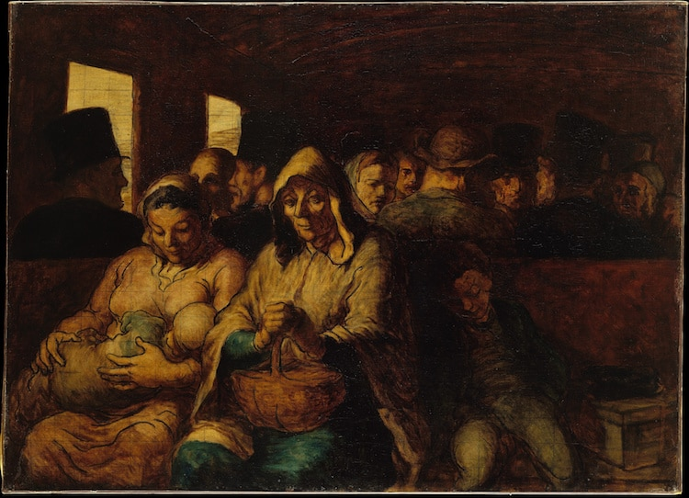
Third Class Carriage

