Saudi Electronic University
College of Administrative and Financial Sciences
Assignment of MIS201- Management Information System
MIS201 - Project
2020/2021

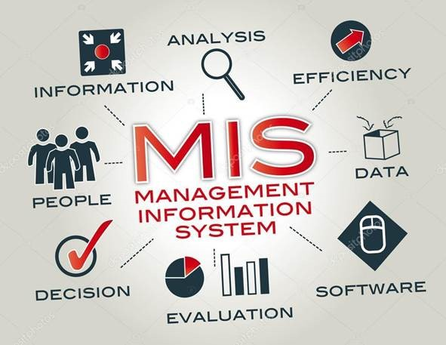

Assignment Details
The project involves studying the IT infrastructure of a relevant information system (IS)/ information technology (IT) used by selecting any organization of your choice locally or internationally
The idea is to investigate the selected organization using the main components of IT (Hardware, software, services, data management and networking). Infrastructure Investigation, which is in a selected industry, should be carried out by using articles, websites, books and journal papers and /or interviews. In the report, you are expected to discuss:

Project Report Structure: Part 1
Submission: Marks: 12
- Cover Page This must contain topic title, student names and Students ID, section number and course name. (you can find the cover page in the blackboard)
- Table of Contents (0.5 mark). Make sure the table of contents contains and corresponds to the headings in the text, figures, and tables.
- Executive Summary (1.5 marks). What does the assignment about, briefly explain the distinct features
- Organizational Profile (2 marks). Brief background of the business including organization details, purpose, and organizational structure.
- Strategies (3 marks). Discuss different types of strategies for competitive advantages and then select and discuss the most appropriate strategies to improve the performance of the organization.
Hint: You can discuss any points that you learned in this course and its related to your selected organization
- Technology Involved (5 marks). How is the organization set up in terms of its IT infrastructure? Discuss the hardware, software, telecommunication, information security, networks, and other elements.
Hint: You can discuss any points that you learned in this course and its related to your selected organization
Project Report Structure: Part 2
Submission: Marks: 8
- Analysis of Existing System (5 marks). Analyze the key problems of the existing system used by the company. Also discuss the Information Systems used within the company for example:
- Transaction processing systems (TPS)
- Enterprise Resource Planning (ERP) Systems
- Functional Area Information Systems
- Business intelligence
- DSS
Hint: You can discuss any points that you learned in this course and its related to your selected organization

- Possible Solutions and Suggestions for the company (1 mark). What are your suggestions to help the organization in solving the key problems.
- Conclusion (1.5 mark).
Summarize your report

- References (0.5 mark).
Use APA referencing style format.

Part 3: Presentation
Submission: Marks: 7
Make a power-point presentation of your Project work mentioning all the above contents and present in a group. There must be minimum 10 slides in the presentation with a good background design, readable font size and style with appropriate color.

Presentation must have the following format:
- First slide: Group members name and Student id & Title of the Project
- Company Profile
- Strategies
- Technology Involved
- Analysis of Existing System
- Possible solutions and suggestions
- Conclusion
- References

Guidelines for the assignment:
- It requires effort, research, and critical thinking.
- Use font Times New Roman, 12 font size
- Use 1.5 line spacing with adjust to all paragraphs (alignment).
- Use the footer function to insert page number.
- Ensure that you follow the APA style in your project and references.
- The minimum number of required references is 5.
- Your project report length Part 1 & Part 2 should be between 2500 to 3000 words in total.
- You must check the spelling and grammar mistakes before submitting the assignment.
- Up to 20% of the total grade will be deducted for providing a poor structure of assignment. Structure includes these elements paper style, free of spelling and grammar mistakes, referencing and word count.
- Assignment must be in Word format only no PDF

