Evidenced-Based Research
Within a professional work environment, you may have heard in response to someone questioning a current methodology or way of doing something, “We do that because that’s the way it’s always been done and has always worked.” Decisions are often made based on past practice and what has been known to have previously worked. Yet do you have a mindset that everything can potentially be enhanced provided there is data to support a change? And how about those that will be involved and impacted by a decision regarding their willingness to adapt and embrace a new way of doing things?
Educational practitioners who have worked many years in the field have a great deal of practical experience from which others can learn. However, what can be lacking by educators when making educational, programmatic decisions that will affect students and teachers is evidence to support a given approach/practice. Is it possible to integrate experience with relevant research using sound methodology? Evidence is not the be-all, end-all; but it can certainly enhance objectivity during the decision-making process that seeks to make a change.
When gathering information (Step 2 – Decision-Making Framework identified in Week 1), an evidence-based practice approach should entail (a) a review of the best research, (b) educator expertise/experience, (c) stakeholder/community values/preferences, and (d) policy adherence.
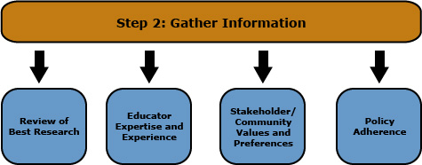
Through engaging in discourse that honors these four components, decision-making will be further enhanced. Such a process is more likely to result in decisions being left unchanged for a sustained period of time.
Be sure to review this week's resources carefully. You are expected to apply the information from these resources when you prepare your assignments.
Spotlight on Skills: Literature Review
To view the Spotlight on Skills, go to the Course Resources module in the table of contents and click on Spotlight on Skills.
WE need these links
http://methods.sagepub.com.proxy1.ncu.edu/project-planner/reviewing-the-literature
https://fod-infobase-com.proxy1.ncu.edu/p_ViewVideo.aspx?xtid=114671

