Project Management
Student’s Name
Institution Affiliation
Date

Risk Management Plan
Introduction
Risk management describes the systematic process of managing risk through various activities, such as identification of risks, analysis, and risk monitoring. A risk management plan document will discuss techniques used to identify, analyze, and manage risk in a virtual project management office project. The document discusses in detail how activities related to risk management will be conducted and monitored throughout the entire virtual PMO services project’s lifecycle. The various stakeholders interested in the document are the institution’s administrator, project owner, the PMO project manager, the project sponsor, the students, alumni, and the community.

Risk Identification
The risk identification process describes the process of identifying the different risks associated with the virtual project management office and designing of a risk register. Various techniques will be used to help identify possible risks associated with the repository site project. They include the Delphi technique, the SWOT analysis, interview, and document review. The Delphi technique refers to the anonymous consultation of the project’s experts to help arrive at a consensus (Van Rijn,2016). The different experts involved in the repository site project include system administrators, data analysts, and software experts. The experts are approached and given questionnaires that they are required to fill. The different responses are collected, compiled, and evaluated. The results are sent back to the identified experts for review. The consultation process will be continuous until an agreement is reached. The second technique is the SWOT analysis technique which will involve a critical evaluation of the project’s strengths, weaknesses, opportunities, and threats. The findings of the analysis will help to identify the different threats that will affect the project. The interview method will entail conducting the oral or written interview from the different stakeholders. The written interview can be in the form of filing questionnaires, where interviewers will be required to note down their answers. Document review describes the review of documents that are related to the repository site project.
A risk register will be a necessary tool in the documentation of the risks.

A Risk Register

Risk Analysis.
Risk analysis refers to the method of analysis of the identified risks. A variety of techniques are applied to help analyze the risks. They include the Delphi technique, SWIFT analysis, decision tree analysis method (Aydin & Dilan 2017). The SWIFT analysis method applies an organized, team-based method conducted in a workshop. The team examines the effects of certain changes from a design by applying a series of ‘’What if’’. The decision tree method will be used to decide mitigation action in cases of uncertainty. The risk register will document the different types of risks that have been identified from the analysis process.

Qualitative Risk Analysis

Qualitative risk analysis is a method, which will help identify threats, the likelihood of occurring, and their impacts in case they occur (Aydin & Dilan 2017). The process will be achieved by conducting several steps. They include:

Select a team to help identify the possible risks.

Categorize potential risks

Rating and prioritizing of each risk

Establish strategies meant to solve the risks based on their different priorities.

Monitor and re-evaluate each risk.

Ranges for probability and impact

Label Probability Cost
Very low 1 out of 100 < 5 %
Low: 2 1 in 50 5-10%
Medium: 3 1 in 10 10-20%
High: 4 1 in 2 20%-25
Very high: 5 > 1 in 2 > 25%

High-level risk

Medium level risk

Low level

Probability and Impact Matrix

High

probability

Low
Low-risk impact high
Impact

Different types of actions will be taken to help manage the identified risks. For example, threats with whose impact and probability are low will be accepted. On the other hand, risks characterized by low impacts and a high likelihood of occurrence will be accepted. However, measures should be put to help reduce the likelihood of their occurrence. Risks associated with high impact and low chance of occurrence should be shared. Measures to reduce the impact should also be developed. Risks with high impacts and high probabilities should be avoided.

Quantitative Risk Analysis
.
Quantitative risk analysis is a process which will be used for analysis of the highest priority risks. The process includes assigning numerical rates to establish a probabilistic analysis of the repository site project (Aydin & Dilan, 2017). A longitudinal survey will be conducted in different time periods, such as months. The survey will be used to examine the habit of the frequency of students using the repository site. Certain actions will be undertaken depending on the findings of the survey. For instance, if it is observed that the frequency of the number of students using the repository site to share templates is low, an investigation should be conducted to find the reasons.

Risk Response Planning
The risk response planning will describe the methods used to eliminate or reduce the risks. The methods to be used include qualitative and quantitative analysis. Risks with a high probability of occurring should be eliminated (Van Rijn, 2016). High Impacts risks should be transferred to a third party while low minimum risks should be accepted. Risks with high probability and high impact should have a response plan. The risk register will help in identifying the pact of each type of risk.

Risk Monitoring and Reporting
Risk monitoring is the process that will be used to identify and manage any new risks within the project ((Van Rijn, 2016). The activities used to monitor risks will verify compliance with the set risk response and highlighting any changes that impact the different responses to risks. The management should be willing to accommodate changes that are a result of risk monitoring.

Roles and Responsibilities of key stakeholders
The key stakeholders in the project include project managers, executives, project sponsors, students, and alumni. The roles and responsibilities of the project manager include the overall planning, control, and management of different resources and activities involved in the project (Philbin, 2016). The role and responsibility of the project owner are to ensure the entire project delivers maximum value. The executives are tasked with the responsibility of ensuring that the project achieves its goals and the creation of a project charter. The project sponsor will be responsible for the evaluation of the project against actual progress and what was planned. The entire project team will be assigned the responsibility of creating a WBS, and completion of the various activities that define the project.
Budgeting
Budgeting is an integral activity in project planning. It will include the budgeting for risk by prioritizing risks with the highest impacts (Van Rijn, 2016). The time taken by the team to do risk work will be included in the management costs. The budget for different actions to address the risks such as avoidance, transfer, and mitigation will be covered in the management costs.

Timing
The timing of the risk work will require the management to keep reviewing the risk management plan and scheduling risk management activities in the virtual PMO services project. For example, the risk management plan should be reviewed any time a risk occurs to allow for the discussion of the best strategy for mitigating the risk (Van Rijn, 2016). The timing for review and updates to the register should be conducted as soon as a new risk is identified to allow for the analysis of its impact, severity, owners, and methods of mitigation. Risks will be tracked by using Delphi techniques.

Risk Categories
The different categories of risks include strategic risks, financial risks, and operational risks. Strategic risks are those risks that occur due to changes in the organizational structure. The risk may affect the planning, control, and management of resources in the project. Financial risks are the risks that relate to access to cash and funding cycles (Van Rijn, 2016). Operational risks relate to the change in value as a result of losses incurred due to shortcomings in the internal process. The types of risks will be used in assessing the impact ad probability of occurrence of each where they will later be documented in the risk register.

Stakeholder Risk Tolerance
Based on the stakeholder’s analysis, the project's stakeholders will be willing to accept only low-level risks. Low-level risks are the risks whose impacts are low but have a high probability of occurring.

Communication
The outcomes of the risk management process in the project will be communicated using the risk register (Aydin & Dilan, 2017). The risk register documents different details of the risks in its different columns. They include the identification number, the risk description, the impact, the severity, and the mitigation methods for each risk. The risk register is stored in the institution's database, where any stakeholder interested can access it.

Approval Section
The stakeholders mentioned below acknowledge they have examined the risk management plan for the Virtual PMO services project. Any variations to the document will be approved by the named stakeholders or their representatives.
\
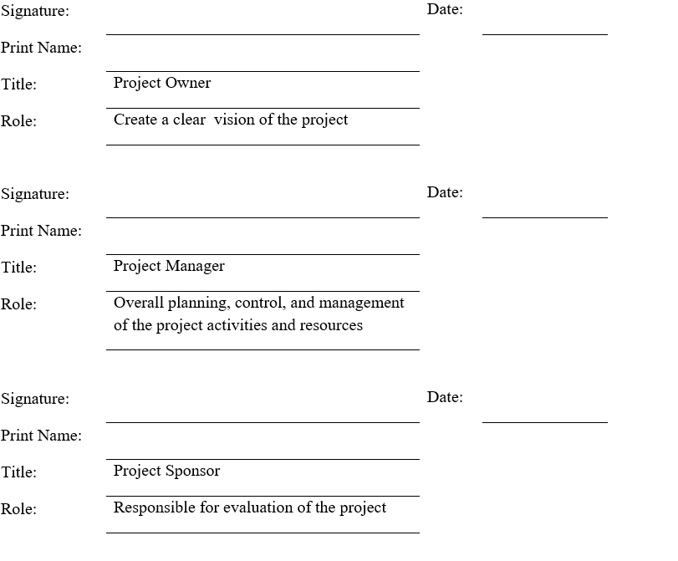

APPENDIX A: References
.
Name of the document | Description of the document | Physical location
risk register | Documents in risk management planning used to record all information about a particular risk.
Probability and impact matrix | a risk management tool used to record the different probabilities, impacts, and levels of a risk

APPENDIX B: Key terms
The table below contains definitions for terms used in the Risk Management Plan.
Term | Definition
Project | An activity within an institution undertaken with an aim to achieve a certain goal
Risk | The chance of occurrence of a certain outcome whose consequences are likely to be negative.
Project’s stakeholder | Any party with interest in the completion and benefits of a project

References
Aydin, M. N., & Dilan, E. (2017). Project management method adoption: A service industry case study. International Journal of Information Technology Project Management (IJITPM), 8(2), 17-33.
Van Rijn, J. (2016). Part 4: risk management plan: project management. IMIESA, 41(8), 74-76.

