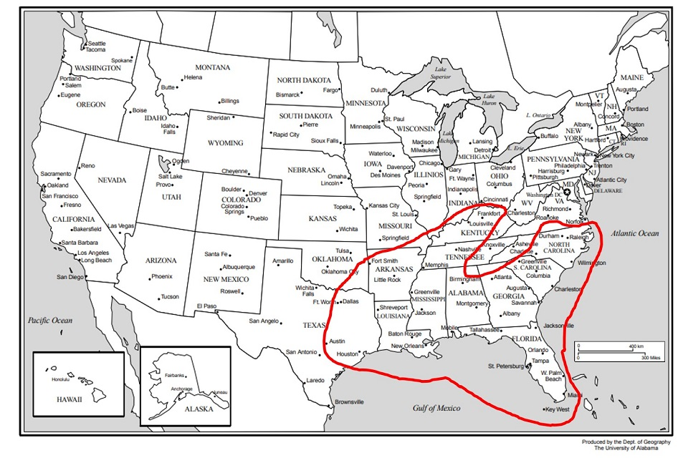
ASSIGNMENT -- CREATING REGIONS
In our earlier discussion of perceptual regions, I asked you to identify which states of the U.S. belong in a region we call ‘The South.’ Once you have completed this task, and have decided which states are in the region of ‘The South’ and which states are not part of the region of ‘The South’, please answer the following questions:
- Why do you consider some of the states you chose to be part of a region of ‘The South’, and why did you exclude others?
- What is it that makes the region you created ‘The South’?
- What criteria do the states you chose share or not share?
- What did you decide about Florida, Virginia, and Texas? Are they part of the South? Why or Why Not?
- Thinking about Florida, Virginia, and Texas, is it possible for regional boundaries to divide states rather than following state boundaries? Explain the reason(s) for your answer.

