Comparative Analysis of the Oil Industry in the Middle East

International Business

Table of Contents
Executive Summary 2
The Impacts of Political and Cultural Differences on the International Oil Business 3
Key International Economic and Financial Issues and the Implications of the International Oil Business 5
Foreign Exchange Mechanism and International Monetary System and their Implications for Currency Management 9
Global Competitiveness in the Areas of Marketing, Manufacturing, and Human Resource Management 10
The Role of Technology in Changing International Trade 12
Conclusion 14
Reference 16

Executive Summary
International business involves conducting trade beyond the boundary of a country or a region. These businesses are influenced by socio-economic and technological factors. This report conducts a comparative analysis of the oil industry in the Middle East. The oil industry is one of the best practices in socio-economic development in the Middle-East, especially in Kuwait country. The selection of Middle East countries for this report is based on their endowment of natural resources, especially oil. The benefits gained from this natural wealth are dependent on their competitiveness in the global market (Virine & McCoskey, 2019, March). The rate of work remittances, trade, and capital flow obtained from oil products in Kuwait, for instance, is dependent on the prices of the oil products in the global market. Besides, economic development that results from oil products is influenced by monetary policies adopted by countries. Kuwait adopted the indirect monetary policy instruments as well as the liberalization of the trade regimes to maximize the benefits obtained from the trade, thereby meeting the unexpected increase in the unemployment rate. For many years Qatar has been the highest earner from oil production in the Middle East countries since 2002, with an estimated high per capita GDP of US$60,500. The oil business in the Middle East has been experiencing trends that have positively and negatively impacted on the domestic and global economy of these regions. Besides, international economic and financial issues such as monetary policies have also influenced how this type of business is conducted. The Middle East countries endowed with oil faces the challenge of cultural differences as well as an uneconomical exchange mechanism that has resulted in reduced gains from the business. The study compares and understands the existing trends, cultural differences, the foreign exchange mechanism, and competitiveness of these countries as they trade in the oil business.

The Impacts of Political and Cultural Differences on the International Oil Business
The impacts of political and cultural differences on international business can be examined by comparing its impacts in different countries. The economic benefits of the oil business have been influenced by the political and cultural difference that exists in the Middle East countries. The impact of political pressure can be seen in the difference in the per capita GDP rates between Kuwait and Asia. Kuwait has had a decreasing rate of per capita GDP generated from the oil business compared to Asian due to continuous instances of conflict within the country. Besides, Kuwait’s rate of participation in the regional market is extremely lower compared to other countries such as Asia that experiences little impacts from political pressure. The amount of per capita GDP obtained from the oil business has also been reduced due to constant social unrest and revolutionary politics within the region. Kuwait, for instance, has had continuous social unrest since 1975, which has resulted in decreased gains from the international oil business as compared to Asia, which has enjoyed a long period of political goodwill. The Middle East countries can improve their participation in the international oil business by providing political goodwill to create a favorable macro environment.
Other than the influence of political differences, cultural factors have also played a role in influencing the supply of oil from the Middle East countries. The impacts of cultural differences have been witnessed in the imposition of investment or trade sanctions against the Middle East countries for their association with terrorist activities. This has imperatively undermined their participation in the global oil markets and mainly focused on the domestic markets. The inability to effectively participate in the global oil markets has undermined countries like Kuwait to transform their natural resources into adequate economic development. The Islamic culture has negatively impacted on the amount of revenue received from the oil trade. In Kuwait, for instance, the Islamic culture views the oil trade as a mechanism for inviting western penetration and hegemony. Besides, the region views the international oil business as a corrupting force, thereby affecting the participation of the oil industries in the international markets. Middle East counties need to practice cultural tolerance to create a favorable macro environment climate for their participation in the international oil business.
The rate of oil production in the Middle East countries has been largely determined by the availability of political goodwill. Saudi Arabia was the highest producer of oil, according to the 2018 report. The highest rates of oil production in these two countries are based on their political goodwill. A Lower oil production rate was, however, witnessed in Kuwait despite its huge endowment with oil as a natural resource. The constant conflict experienced can be applied in explaining the low production rate of oil in Kuwait. The figure below demonstrates the comparison of oil production rates within the Middle East countries as of 2018.
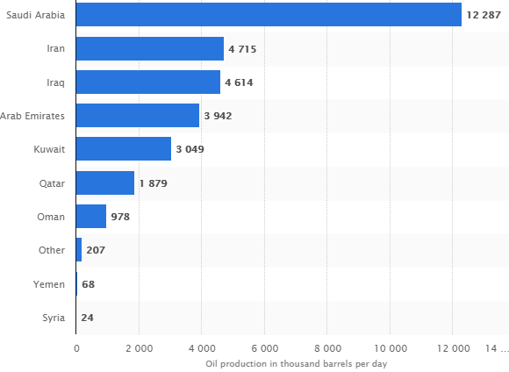
Figure1: Rate of Oil Production in the Middle East countries (Al-Enezi et al., 2018)
Key International Economic and Financial Issues and the Implications of the International Oil Business
This section examines the impacts of both economic and financial issues faced by the Middle East countries and their implications in the international oil business. The microeconomic environment plays an imperative role in international business. Favorable macroeconomic environment favors international business, while unfavorable macro environment conditions undermine international trade. Kuwait compares unfavorably with other Middle East Countries due to its deteriorated macro environment. The unfavorable macro environment experienced by Kuwait is a result of low prices in its oil products compared to those produced in Middle East countries. Apart from the macro environment, the fiscal balance is also an imperative player in international business. Countries with high fiscal balance are more competitive compared to those with fiscal deficit balance. Kuwait, for instance, has had unfavorable fiscal balance losing up-to 1.4 percent of its GDP due to its increased volume of depts. The high level of fiscal imbalance experienced in Kuwait is also due to its low innovation and lack of technological readiness as compared to Saudi Arabia. Kuwait needs to improve the fiscal balance policies through extensive innovation to increase its competitive power in the international markets.
The constant fluctuation in oil prices is one of the economic and financial issues affecting the participants in international business. The drastic drop in the prices of oil products has negative consequences on the per capita income obtained from the oil business. Figure1 illustrates the fluctuation in oil prices since 1960 among countries in the Middle East. Based on the illustration below, the oil prices dropped sharply since 2014, resulting in negative consequences on various aspects of key development indicators.
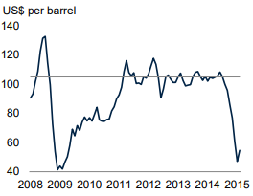
Figure 2: Fluctuation in oil prices (Budhwar et al., 2019)
The high fluctuation in oil prices can be explained by analyzing the impacts of supply and demand, changes in the OPEC Objectives, and the effects of geopolitical developments, Speculative Demand, and inventory management. The fluctuating prices of oil in the Middle East countries can be explained by the increased supply of oil products in the international markets (Budhwar et al., 2019). In 2014, the oil supply from the United States sharply increased, thereby influencing the prices of oil for the Middle East countries. Besides, the increased use of technology in countries like Kuwait resulted in reduced cost of exploration and extraction, increasing the supply of oil into both domestic and international oil market businesses. The sharp decline in the prices can also be explained by relating it to the decline in the global demand for oil produced in the Middle East countries. The sharp drop experienced in 2014, as illustrated by figure1 above was a result of a drop in the demand for the product. The figure below illustrates how the sharp decrease in demand for oil products resulted in a sharp decline in the prices for the oil commodity.
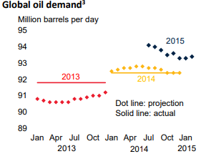
Figure3: Impacts of demand on Oil prices (Shukla, 2016)
Geopolitical advancement has also played a role in fluctuation in the prices of oil produced in the Middle East countries. The impacts of geopolitical development on the sharp decline in oil prices can be explained by narrowing the focus to the constant conflicts experienced in Kuwait countries. Since 2013, the country has experienced conflicts resulting in trade sanctions that contributed to the drastic decrease in price for oil in 2014. Other contributing factors include the appreciation of the U.S. Dollar. The value for the U.S. dollar appreciated raising the local currency cost of oil for the Middle East states (Shukla, 2016). For instance, the rise in the current cost of oil in countries in the Middle East decreased their rate of oil supply into the international business while increasing the supply rate from other countries, Canada. Surplus oil from the United States resulted in a drop in oil prices for countries participating in the oil business from these regions of the world. The Middle East countries need to adjust their exchange rates in the face of inflation to remain competitive in both domestic and international business.
The economic and financial issues affecting the international business can be explained by comparing its implications in countries endowed with oil in the Middle East. For instance, the investment and consumption of durable goods in Kuwait reduced significantly with a sharp drop in the prices in the international oil markets. The above implications can be represented, as shown in the graph below.
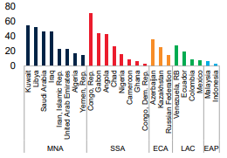
Figure4: The impacts of drop in oil prices on the investment (Penrose, 2019)
The impact of the drop in oil price in the international markets was greatly felt in Kuwait compared to Yemen, as illustrated in the graph above. This resulted in a sharp drop in the consumption of durable goods and the rate of investment as compared to Yemen found within the same region. The difference in the impacts experienced between Kuwait and Yemen can be analyzed by the Phillips curve model and a simple vector autoregression model (VAR) (Penrose, 2019). The Phillips curve theoretical model and simple vector theoretical model relates the drop in the oil price to the rate of inflation. The inflation rate is directly proportional to the price of oil. Based on the model, Yemen experiences a low rate of inflation from the decline in the price of oil in the Middle East market as compared to Kuwait, resulting in a high rate of decline in the demand for durable goods and the rate of investment. The relationship between the drop in oil price and the inflation rate in the Middle East can be represented, as shown in the graph below.
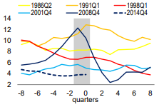
Figure5: Fluctuation in Price versus Inflation rate (Shahbaz et al., 2017)
As the price for oil drops, so does the rate of inflation. In 2014, for instance, the rate of inflation dropped drastically with the sharp drop in prices for oil in the Middle East. Stud
Foreign Exchange Mechanism and their Implications for Currency Management
Foreign exchange mechanism and the International monetary system form important aspects in the international business. Most countries trading in oil products in the Middle East countries are faced with inappropriate exchange rate policy. The rate of economic growth derived from the international oil business is highly dependent on the level of globalization. The level of globalization, on the other hand, is dependent on the type of exchange rate policies. Oil-producing countries with the fixed exchange rate, more often than not, are less economically productive as compared to counties with a flexible exchange rate (Shahbaz et al., 2017). Kuwait, for instance, is relatively economically productive from oil trade due to its adoption of the flexible exchange rate policy. The exchange rate can either be in the form of real exchange rate overvaluation or misaligned exchange rates. This type of exchange rate occurs when the real exchange rates receive the late adjustment. It is imperative to note that inflation often results in fluctuation in the exchange rate to ensure the reduced impact of fluctuation oil prices in the global markets; the exchange rate needs to be adjusted. A real exchange rate becomes overvalued when it is not adjusted in the face of a high rate of inflation. Countries that adopt this type of exchange rate are often experiences distorted local prices and slow growth rate. Kuwait is an example of the Middle East countries that adopted the real exchange rate overvaluation hence receiving a slow growth rate as compared to other Middle East countries, as illustrated in the chart below.
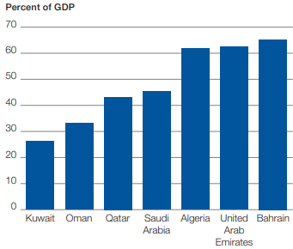
Figure 6: Impacts of Inappropriate Exchange Rate on Economic Growth Rate (Okoro, Nebo, & Okoro, 2017).
The Middle East countries, therefore, need to continuously readjust their oil prices in the face of the inflation rate.
Global Competitiveness in the Areas of Marketing, Manufacturing, and Human Resource Management
The level of competitiveness among the Middle East countries in the international oil market can be represented, as shown below, according to the global competitiveness Index 2017-2018.
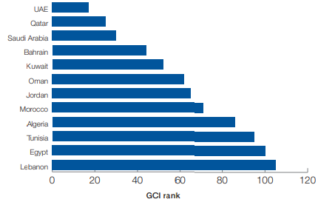
Figure 7: Global Competitiveness among the Middle East Countries (Cummins, Dowling, & Kearney, 2016)
Based on the global competitiveness index, Kuwait is the second most competitive country among the Middle East countries trading globally in oil products. The high competition power of Kuwait in the oil business compared to other Middle East countries can be explained in terms of the impact of conflicts experienced by these countries. Kuwait is least affected by constant conflict and violence as compared to other Middle East countries trading in oil globally, such as the United States Arab Emirates. Besides, Kuwait suffered less from the impacts of a sharp drop in oil prices in the global market. The 2007-2008 global financial crisis impacted the Middle East oil-producing countries negatively Rate (Okoro, Nebo, & Okoro, 2017). However, the impact of the crisis was felt differently among the oil-producing countries in the Middle East. Kuwait, for instance, received a lower impact of the crisis compared to other Middle East countries making it more competitive in the manufacturing sector. The competitiveness of the Middle East countries trading in the international oil business can also be viewed in terms of human resource management perspective. Kuwait is more competitive in terms of human resource management as compared to other Middle East countries due to the favorable macroeconomic environment and labor market efficiency. Besides, the competitiveness of this country is a result of their heavy investment in the youth as the majority of the workforce. Youth are more productive than the older group of the workforce, making Kuwait more productive and competitive in the global oil market.
The competitiveness of the Middle East countries has been undermined by their poor human resource management practices. Most of the Middle East countries overexploit foreign workers based on the policies implemented to govern labor relation issues. Saudi Arabia and Qatar are the most hit by poor human resources management policies that prevent the free movement of foreign workers in and out of the country. The labor laws even prevent switching of employers among foreign workers. Kuwait is more competitive in the management of its human resources compared to other Middle East countries due to its favorable macro environment and friendly labor laws that allow the free movement of foreign workers and their freedom to switch from one employer to another. Improved and better human resource management practices increase the competitiveness of countries producing oil in the Middle East countries such as Kuwait.
Competitiveness of the Middle East countries can be also be analyzed based on their level of market share, level of innovation, investment in infrastructure, business sophistication, and the macro-environment available for the oil trade. Kuwait has a larger market share, a greater level of innovation, and heavy investment in infrastructure, making it more competitive in its marketing strategies for the oil products compared to Yemen with a lower level of innovation. Kuwait faces a great challenge of poor infrastructure and technological readiness making them less competitive in the international market compared to other countries such as Saudi Arabia that have heavily invested in the use of technology. The ability to compete favorably in international markets depends on the level of connectivity and technological readiness. Kuwait has been the most hit in the international business due to its low rate of technological readiness. Kuwait can, therefore, improve its competitiveness in the international business by increasing its market share, level of innovation as well as heavy investment in infrastructure.
The level of government intervention in the international business also determines the level of competitiveness of the country in the global markets. Countries with lower government interventions are more competitive compared to those experiencing larger government interventions. Kuwait, for instance, a larger percentage of the oil production, is privatized with a lower government intervention making it more competitive in the oil markets compared to other Middle East countries. Kuwait can improve its level of competitiveness in the global market by reducing government intervention in the oil production process.
The Role of Technology in Changing International Trade
Technology plays a critical role in international business. This can be understood in terms of supply and demand in the market, sufficient technology aids in meeting the excess demand in the market. Taking the example of oil production in the Middle East, for many years, these regions have always lagged in terms of the rate of supply oil products in the market. This has always given the United States a large share in terms of supply of oil products in the international markets due to their application of innovation and technology in the production of oil, when technology is applied in the extraction process, the production rate increases. As the production rate increases, the supply into the market also increases, thereby meeting the unexpected demands from the consumers.
The situation is also similar in the Middle East, where the rate of supply of oil products is significantly determined by the rate of technology use. Kuwait, for instance, lags behind in the rate of supply of oil products due to its lack of priority in the technological application in oil production.
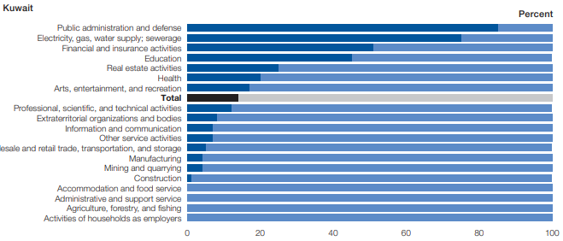
Figure 8: Country Expenditure Plan (Abdulrazaq & Shetty, 2020)
Based on the above chart, it is evident that Kuwait does not prioritize the use of technology in international trade. This explains its low supply of oil products in both domestic markets and international markets as compared to the United Arab Emirates and Saudi Arabia that extensively employ the use of technology in the production of oil. Technology enhances the diversification of the products produces to meet the varied needs of the customers in the international market. Abdulrazaq and Shetty (2020) conducted a comparative study to establish the role of technology in international trade. Based on a case study, the author found out countries that employ greater use of technology in their production process are more competitive than those that heavily relies on the manual production process. The authors further allude that the use of technology in the production of commodities results in diversification, which in turn meets the demands of customers' varied needs in the market.
The Middle East countries face a great challenge in terms of infrastructure and technological readiness making them less competitive in the international market compared to the developed world that produces oil. The ability to compete favorably in international markets depends on the level of connectivity and technological readiness. It is imperative to note that countries Yemen and Kuwait have been the most hit in the international business due to low connectivity and digital uptake. Middle East countries such as Kuwait need to invest in technology and innovation to diversify their production process to meet the varied needs of customers in the international business heavily.
Conclusion
The study satisfactorily compared the existing trends, cultural differences, the foreign exchange mechanism, and competitiveness of the Middle East countries trading in the international oil business. International business is extremely influenced by international economic and financial issues such as monetary policies, the level of technology, and innovation as well as the cultural difference among the Middle East countries. The ability of the Middle East countries to compete favorably in the international oil markets depends on the level of connectivity and technological readiness. The Middle East countries face a great challenge in terms of infrastructure and technological readiness making them less competitive in the international market compared to the developed world that produces oil. Middle East countries such as Kuwait need to invest in technology and innovation to diversify their production process to meet the varied needs of customers in the international business heavily. Kuwait can improve its level of competitiveness in the global market by reducing government intervention in the oil production process. Besides, Kuwait can improve its competitiveness in the international business by increasing its market share, level of innovation, as well as heavy investment in infrastructure. The Middle East countries need to continuously readjust their oil prices in the face of the inflation rate to remain competitive in the international business. Improved and better human resource management practices increase the competitiveness of countries producing oil in the Middle East countries such as Kuwait. Kuwait needs to improve the fiscal balance policies through extensive innovation to increase its competitive power in the international markets. Moreover, the Middle East counties need to practice cultural tolerance to create a favorable macro environment climate for their competitiveness in the global market. Also, the Middle East countries can improve their competitiveness in the global market by providing political goodwill to create a favorable macro environment.

Bibliography
Abdulrazaq, Y. M., & Shetty, S. (2020). Oil Sector Spillover Effects to the Kuwait Stock Market under Uncertainty. International Journal of Accounting & Finance Review, 5(1), 32-41.
Al-Enezi, D., Al-Mekhyal, A., Goswami, B., Adnan Muqaddes, Z., Al-Salamin, M., Takate, Y., ... & Al Najdi, F. (2018, November). First Successful 12.25-in. Openhole Whipstock Sidetrack Operation in a Complex Middle East Formation: A Kuwait Case Study. In Abu Dhabi International Petroleum Exhibition & Conference. Society of Petroleum Engineers.
Budhwar, P., Pereira, V., Mellahi, K., & Singh, S. K. (2019). The state of HRM in the Middle East: Challenges and future research agenda. Asia Pacific Journal of Management, 36(4), 905-933.
Cummins, M., Dowling, M., & Kearney, F. (2016). Oil market modelling: A comparative analysis of fundamental and latent factor approaches. International Review of Financial Analysis, 46, 211-218.
Okoro, C. B., Nebo, O. E., & Okoro, V. I. (2017). The Impact of Globalization on the World Economy in the Global Market and Production. International Journal of Advanced Academic and Educational Research, 13(2), 105-115.
Penrose, E. (2019). The growth of firms, Middle East oil and other essays. Routledge.
Singh, S., Budhwar, P., Mellahi, K., & Pereira, V. (2018). The state of HRM in the Middle East: Challenges and future research agenda.
Shahbaz, M., Sarwar, S., Chen, W., & Malik, M. N. (2017). Dynamics of electricity consumption, oil price and economic growth: Global perspective. Energy Policy, 108, 256-270.
Shukla, U. K. (2016). International Business-Competing in the global market place. St. Theresa Journal of Humanities and Social Sciences, 2(2).
Virine, L., & McCoskey, S. (2019, March). Comparative Analysis of Full-Cycle Cost of Oil and Gas Exploration, Development and Production World-Wide. In SPE Middle East Oil and Gas Show and Conference. Society of Petroleum Engineers

